**Area and Perimeter (H)**

Pre-Intervention Assessment

Name: _______________________________

Class: _______________________________

Date: _______________________________

|  |  |  |
| --- | --- | --- |
| **Question** | **Objective** | **RAG** |
| 1 | Calculate the area and perimeter of compound shapes |  |
| 2 | Calculate the area and perimeter of circles |  |
| 3 | Calculate the area and perimeter of sectors |  |

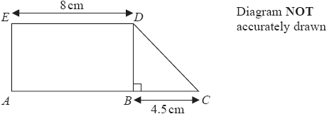**1.** Work out the area of the shape.

…………………………………………………cm2

**2**. Diagram NOT accurately drawn

A circle has a radius of 6.1 cm.  
Work out the area of the circle.

.......................................... cm²

**3**. Diagram NOT accurately drawn

The diagram shows a sector of a circle, centre *O.*The radius of the circle is 6 cm.Angle *AOB =* 120°.

Work out the perimeter of the sector*.*Give your answer in terms of π in its simplest form.

........................................................... cm

[Glue here]