Band 1 – Test 1 Answers

1. | $\frac{10}{300}$ $\frac{2}{6}$ $\frac{4}{12}$ $\frac{1}{30}$ $\frac{3}{10}$ | 1 mark for each correct answer | 2
2. | 0.03 0.036 0.36 0.603 0.63 | 1 mark lost for each incorrect answer | 2
3. | 2 : 3 | Correct answer | 1
4. | 2 - 24 | 1 mark for each correct answer | 2
5. | 5 thousand | Correct answer | 1
6. | A factor of 12 = 4  A multiple of 3 = 9  A prime number = 7 or 11 | 1 mark for each correct answer | 3
7. | 36 = 2 x 2 x 3 x 3 = 2² x 3² | 1 for one factor found  1 for all factors found  1 for expressed as a product | 3
8. | 4² = 16 √81 = 9 | 1 mark for each correct answer | 2
9. | 19 23 | 1 mark for each correct answer | 2
10. | A = ( 2, 4)  Coordinate labelled at (4, -2) | 1 mark for each correct answer | 2

11. | × 2, – 1  Input Output  1 1  2 3  3 5  5 9  8 15 | 1 mark for each correct answer | 3
12. | Isosceles Reflex | 1 mark for each correct answer | 2
13. | 3.7 ± 0.2 cm Angle drawn of 50º | 1 mark for each correct answer | 2
14. | 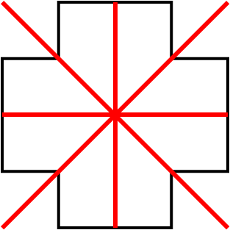 | 2 marks for all lines correct  1 mark lost for 1 extra line or for 1 line missed | 2
15. | Area = 3 x 5 = 15 cm²  Perimeter = 3 + 5 + 3 + 5 = 16 cm | 1 mark for each correct working  1 mark for each correct answer | 4
16. | 32 | Correct answer | 1
17. | 09 30  2 hours and 45 minutes  17 | 1 mark for each correct answer | 3

18. | 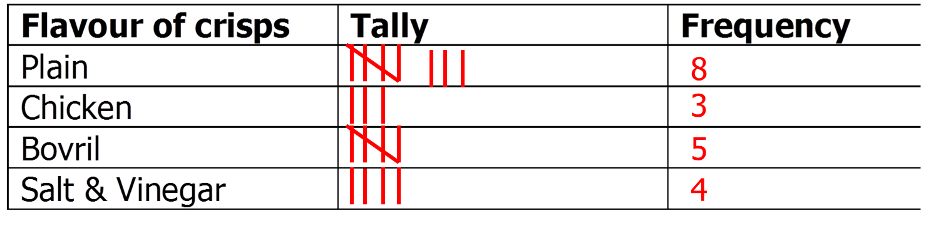 | 2 marks for all tallies correct  1 mark for all frequencies correct | 3
19. | Monday = 40 Wednesday = 50  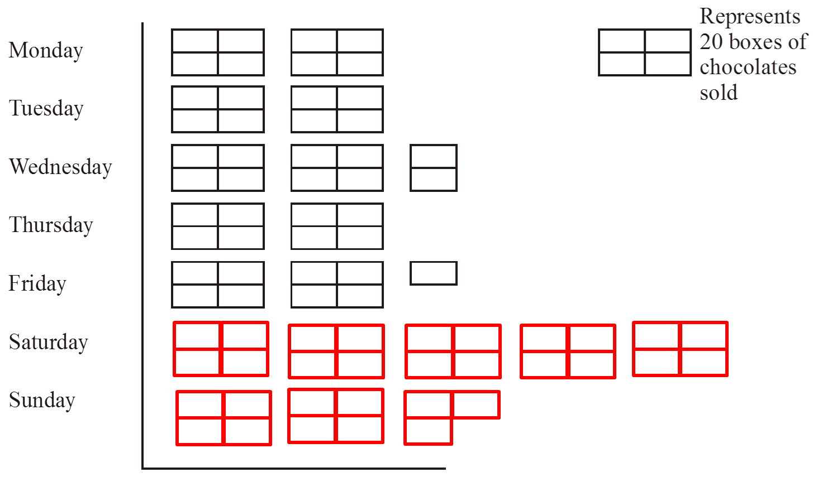 | 1 mark for each answer for Monday and Wednesday  1 mark for each row of pictogram correct | 4
20. | 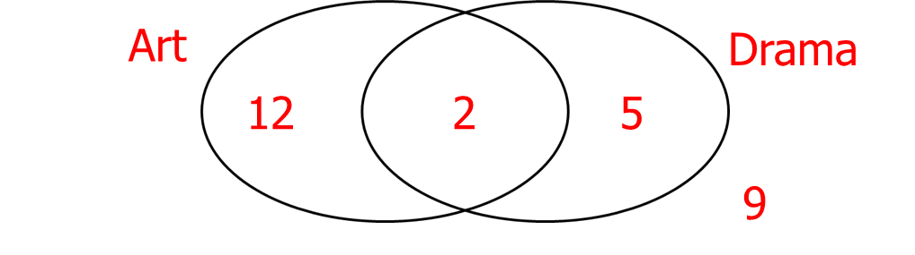  9 students | 1 mark for at least 2 numbers in Venn diagram  1 mark for correct answer | 2

21. | 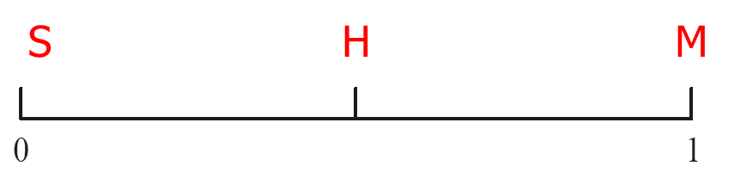 | 1 mark for each correct answer | 3
22. | (F , P) (F, A) (F, B)  (L , P) (L, A) (L, B)  (S , P) (S, A) (S, B) | 2 marks for all correct  1 mark lost for 1 doubled combination or for 1 combination missed | 2

