Surface Area of Cylinders GREEN

Question 1
Calculate the surface areas of the cylinders below. Give your answers correct to 1 decimal place.
a) b) c)
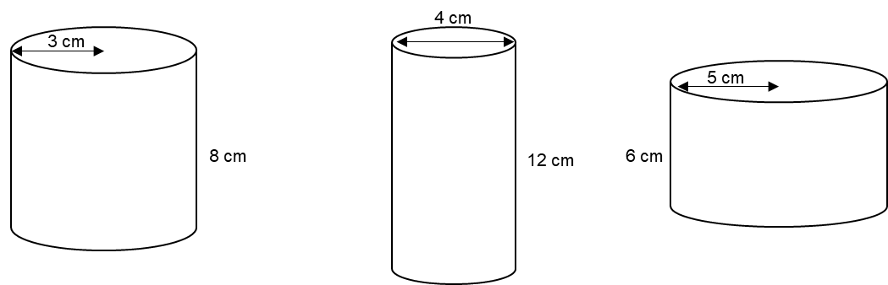

Question 2
On a farm, there is a grain silo.
The silo is cylindrical with a tile roof.
The silo has a diameter of 4 metres and is 6 metres tall.
The farmer wants to paint the curved surface of the silo.
Each can of paint will cover 30 m².
The paint costs £15.95 per can.
How much will it cost the farmer to paint the silo?

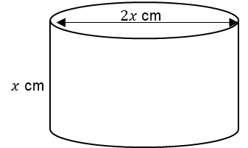
Question 3
This cylinder has a surface area of $400π$ cm².
Calculate the value of $x$.

Surface Area of Cylinders AMBER

Question 1
Calculate the surface areas of the cylinders below. Give your answers correct to 1 decimal place.
a) b) c)
Top:

Bottom:

Label:

Total:

Question 2
On a farm, there is a grain silo.
The silo is cylindrical with a tile roof.
The silo has a diameter of 4 metres and is 6 metres tall.
The farmer wants to paint the curved surface of the silo.
Each can of paint will cover 30 m².
The paint costs £15.95 per can.
How much will it cost the farmer to paint the silo?

Curved surface area:

Question 3
Set up an equation and solve it!
This cylinder has a surface area of $400π$ cm².
Calculate the value of $x$.

Surface Area of Cylinders RED

Question 1
Calculate the surface areas of the cylinders below. Give your answers correct to 1 decimal place.
a) b) c)
Top: $π×3^{2}=$ Top:

Bottom: $π×{_____}^{2}=$ Bottom:

Label: $π×_____×8=$ Label:

Total: Total:

Question 2
On a farm, there is a grain silo.
The silo is cylindrical with a tile roof.
The silo has a diameter of 4 metres and is 6 metres tall.
The farmer wants to paint the curved surface of the silo.
Each can of paint will cover 30 m².
The paint costs £15.95 per can.
How much will it cost the farmer to paint the silo?

Curved surface area: $π×_____×_____=$

Question 3
Set up an equation and solve it!
This cylinder has a surface area of $400π$ cm².
Calculate the value of $x$.

Radius: $x$ Diameter: $2x$ Height: $x$

Surface area: $400π=πx^{2}+πx^{2}+2πx^{2}$
$400π=4πx^{2}$

