End of Unit Test Name: ____________________________
Data – Interpreting Results – HIGHER

1. The table shows information about the pay per hour of 40 people.
 | Pay per hour, x (£) | Frequency
 | 5 < x ≤ 15 | 14
 | 15 < x ≤ 25 | 12
 | 25 < x ≤ 35 | 11
 | 35 < x ≤ 45 | 2
 | 45 < x ≤ 55 | 1
 |  | Total = 40
(a) Which group contains the median pay per hour? Circle your answer.

5 < x ≤ 15 15 < x ≤ 25 25 < x ≤ 35 35 < x ≤ 45 45 < x ≤ 55
(1)
(b) Work out an estimate of the mean pay per hour.

…………………………………………………………………………………………………

Answer £ .................................................................................
(4)
(Total 5 marks)
2. The table shows the marks of 50 students in a test.
 | Mark (m) | Number of students
 | 50 < m ≤ 60 | 2
 | 60 < m ≤ 70 | 3
 | 70 < m ≤ 80 | 20
 | 80 < m ≤ 90 | 16
 | 90 < m ≤ 100 | 9
(a) Draw a cumulative frequency diagram for the data. 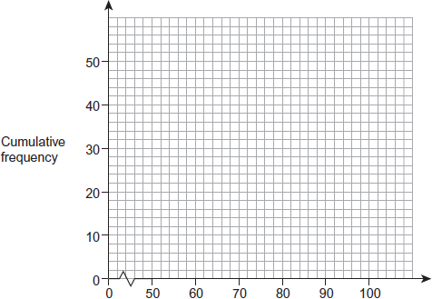
Mark (m)
(3)
(b) Students who scored between 72 and 85 marks are chosen for extra lessons. Estimate the number of students chosen.

…………………………………………………………………………………………………

…………………………………………………………………………………………………

…………………………………………………………………………………………………

Answer ......................................................................
(3)
(Total 6 marks)
3. The diagram shows a box plot.

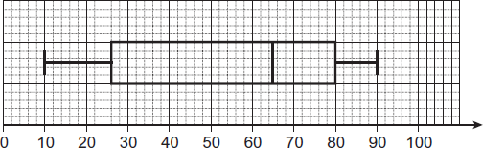

(a) Write down the median.
Answer ......................................................................
(1)
(b) Work out the interquartile range.

…………………………………………………………………………………………………

…………………………………………………………………………………………………

Answer ......................................................................
(1)
(Total 2 marks)

4. The grouped frequency table represents the birth weights of 1000 babies.

 | Birth weight, w (kilograms) | Frequency
 | 1.0 ≤ w < 2.5 | 45
 | 2.5 ≤ w < 3.5 | 490
 | 3.5 ≤ w < 4.5 | 270
 | 4.5 ≤ w < 6.0 | 195

(a) Show the data on a histogram.
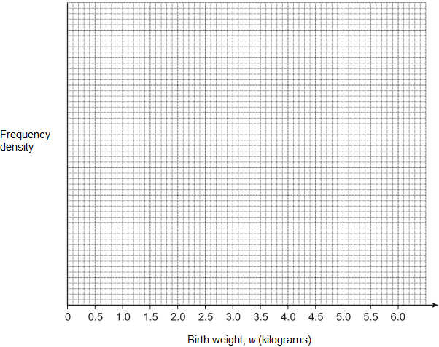
(4)

(b) Babies under 2.5 kg have a low birth weight. Two of the 1000 babies are chosen at random. Work out the probability that both babies have a low birth weight. You must show your working.

…………………………………………………………………………………………………

…………………………………………………………………………………………………

…………………………………………………………………………………………………

…………………………………………………………………………………………………

Answer ......................................................................
(3)
(Total 7 marks)
(Total for test = 20 marks)

