Band 3 – Test 1 Answers

1. | $\frac{6}{7}$ - $\frac{2}{5}$ = $\frac{30}{35}$ - $\frac{14}{35}$ = $\frac{16}{35}$  3 $\frac{1}{3}$ x 1 $\frac{3}{8}$ = $\frac{10}{3}$ x $\frac{11}{8}$ = $\frac{110}{24}$ = 4 $\frac{14}{24}$ = 4 $\frac{7}{12}$ | 1 mark for a correct common denominator  1 mark for correct answer  1 mark for correct improper fractions  1 mark for a correct multiplication of fractions  1 mark for correct answer | 5
2. | 53 x 94  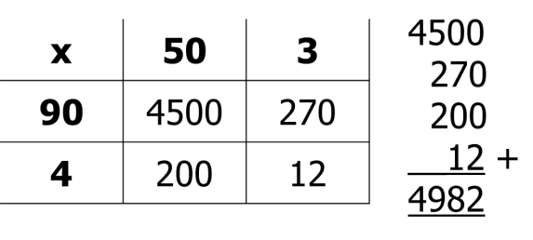  53 x 94 = 4982  5.3 x 0.94 = 4.982 | 1 mark for multiplying correct integers  1 mark for correct multiplication  1 mark for correct location of dp | 3
3. | 10% = £9.40  10% = £9.40  10% = £9.40  5% = £4.70  __1% = £0.94  36% = £33.84  £94 - £33.84 = £60.16 | 1 mark for calculating 36%  1 mark for subtracting 36% from £94  1 mark for correct answer | 3

4. | 53% $\frac{5}{8}$ 0.7 $\frac{2}{3}$ $\frac{3}{5}$  0.53 0.625 0.7 0.67 0.6  53% $\frac{3}{5}$ $\frac{5}{8}$ $\frac{2}{3}$ 0.7 | 1 mark for 3 correct equivalent FDPs  1 mark for correct order | 2
5. | 70g ÷ 5 = 14g  14 x 2 = 28g of cheese  14 x 3 = 42g of topping | 1 mark for calculating the value of one part  1 mark for each correct answer | 3
6. | 2.57 x 34 = 87.38 873.8 ÷ 2.57 = 340 | 1 mark for each correct answer | 2
7. | 1.240154521 1.24 | 2 marks for correct calculation  1 mark for correct rounding | 3
8. | t³ m² | 1 mark for each correct answer | 2
9. | ½ | Correct answer | 1
10. | mn² – m²n | Correct answer | 1
11. | 5p + 7 = 12 – 3p  8p + 7 = 12  8p = 5  p = 5/8 | 1 mark for 8p = 5  1 mark for correct answer | 2
12. | 2c + 4r | 1 mark for 2c  1 marks for 4r | 2
13. | 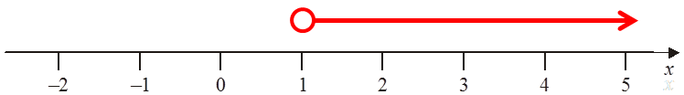 | Correct answer | 1
14. | x -2 -1 0 1 2  y -5 -1 3 7 11  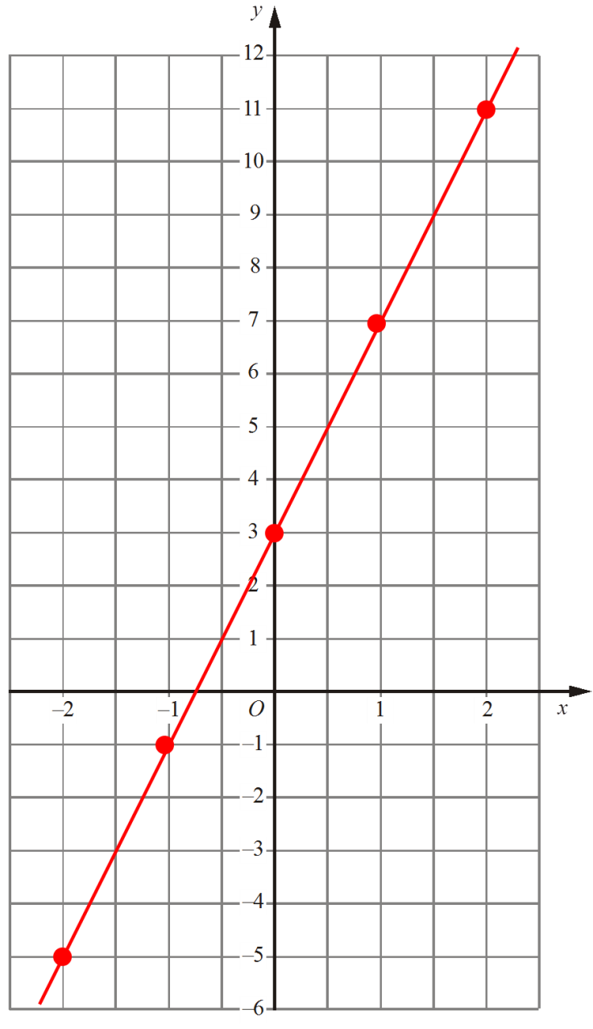 | 1 mark for at least 2 y values correct  Or 2 marks for all 3 values correct  1 mark for coordinates plotted correctly  1 mark for straight line segment through coordinates | 4

15. | 48º  Alternate angles are equal  30º  Corresponding angles are equal | 1 mark for each correct answer  1 mark for each correct reason | 4
16. |  | 1 mark for each correct angle  1 mark for C correctly located | 3
17. | (8 x 9) + (½ x 12 x 5) = 72 + 30 = 102 cm² | 1 mark for correct area of triangle  1 mark for correct area of rectangle  1 mark for correct total area | 3
18. | 8 x 3 x 4 = 96 cm³ | 1 mark for multiplying correct dimensions  1 mark for correct answer | 2
19. | 75 x 3 = 225 km | 1 mark for speed x time  1 mark for correct answer | 2
20. | Snack Frequency Angle  Burger 20 80º  Chips 45 180º  Hot dog 10 40º  Kebab 15 60º  Total 90 360º | 1 mark for measuring angles correctly  1 mark for ¼ or ÷4 seen  1 mark for 10 and 15 | 3
21. | Coin Dice  1 2 3 4 5 6  1 2 3 4 5 6 7  2 3 4 5 6 7 8  3 4 5 6 7 8 9  4 5 6 7 8 9 10  5 6 7 8 9 10 11  6 7 8 9 10 11 12  P(6) = 5/36 | 1 mark for correctly completing sample space diagram  1 mark for identifying 36 possible outcomes  1 mark for 5 6s. | 3

