Area of non-right-angled triangles - GREEN

Calculate the area of these shapes.

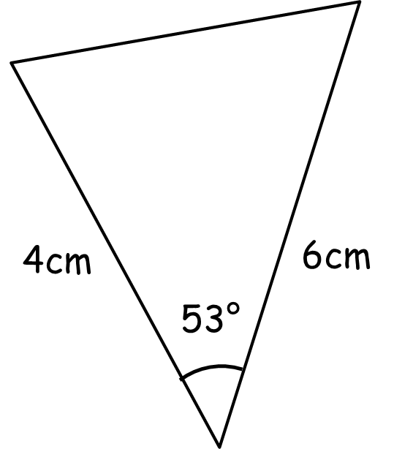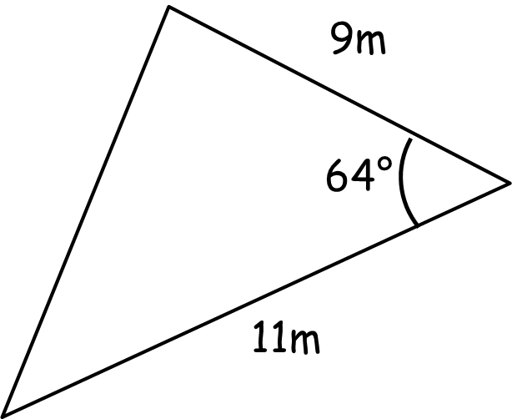

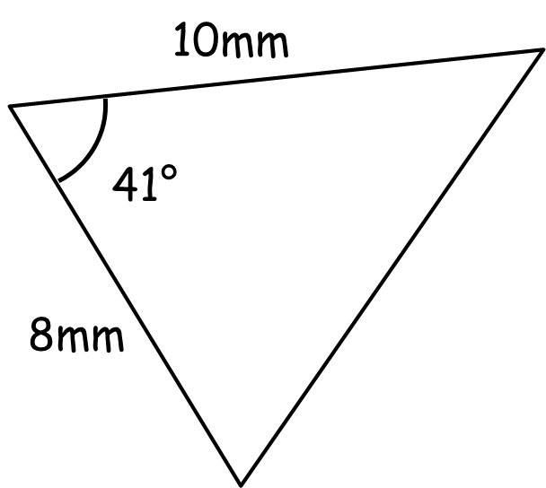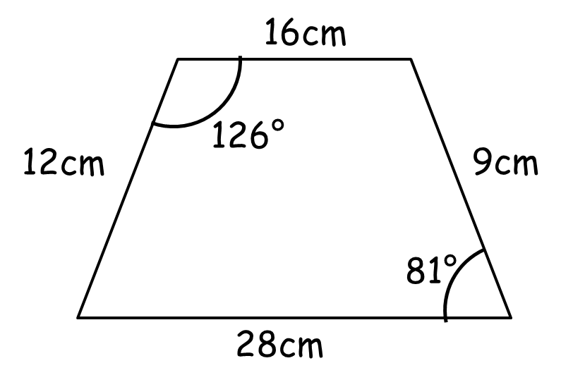

Calculate the length of $a$ and the size of angle $B$.

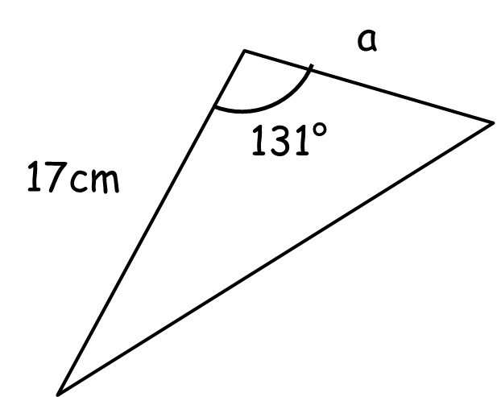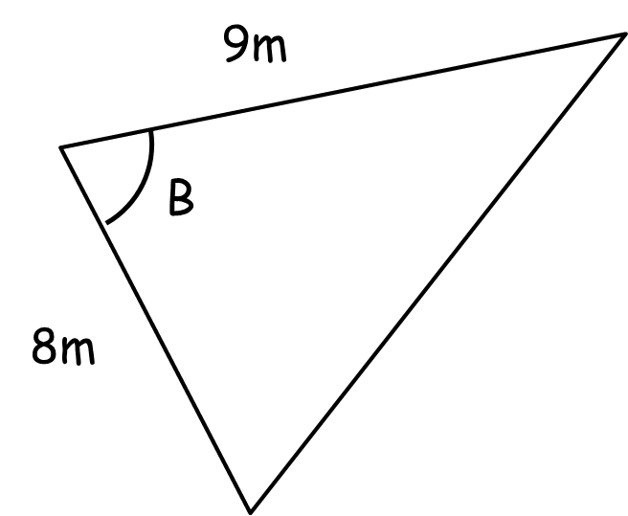

Area = 25cm² Area = 30m²

Area of non-right-angled triangles - AMBER

Calculate the area of these shapes.

$$½ ab\sin{C}$$

Calculate the length of $a$ and the size of angle $B$.

Hint: Set up an equation…

Area = 25cm² Area = 30m²

Area of non-right-angled triangles - RED

Calculate the area of these shapes.

$$½ ab\sin{C}$$

Area $=½×4×6×\sin{53}$

$=12\sin{63}=$

Calculate the length of $a$ and the size of angle $B$.

Hint: Set up an equation…

Area = 25 cm² Area = 30m²

$½×17×a×\sin{131}=25$ $½×8×9×\sin{B}=30$

