Area and Circumference of Circles GREEN

Calculate the areas and circumferences of the circles with the following dimensions. Show all your working and give your answers correct to 2 decimal places.

1) Radius of $4$ cm 6) Diameter of $5$ cm

2) Diameter of $3$ cm 7) Radius of $6$ cm

3) Diameter of $10$ cm 8) Diameter of $9$ cm

4) Radius of $2$ cm 9) Diameter of $14$ cm

5) Radius of $3.5$ cm 10) Radius of $3$ cm

Area and Circumference of Circles AMBER

Cut out and match the questions with their corresponding areas and circumferences.
You will need to show your working in your exercise book.

Question | Area | Circumference
1) Radius of $4$ cm | $12.57$ cm² | $31.42$ cm
2) Diameter of $3$ cm | $19.63$ cm² | $18.85$ cm
3) Diameter of $10$ cm | $7.07$ cm² | $15.71$ cm
4) Radius of $2$ cm | $153.94$ cm² | $28.27$ cm
5) Radius of $3.5$ cm | $78.54$ cm² | $25.13$ cm
6) Diameter of $5$ cm | $28.27$ cm² | $43.98$ cm
7) Radius of $6$ cm | $113.10$ cm² | $37.70$ cm
8) Diameter of $9$ cm | $50.27$ cm² | $12.57$ cm
9) Diameter of $14$ cm | $63.62$ cm² | $21.99$ cm
10) Radius of $3$ cm | $38.48$ cm² | $9.42$ cm

Area and Circumference of Circles RED

Calculate the areas and circumferences of the circles with the following dimensions. Show all your working and give your answers correct to 2 decimal places.

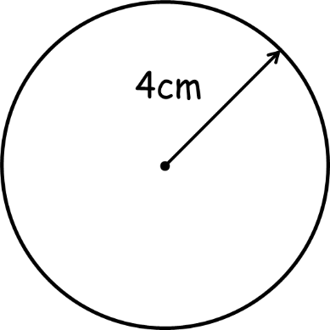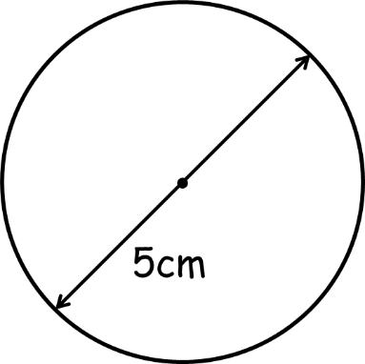
$A=πr²$
$=π×2.5²$
$=$ _____cm²

$C=πd$
$=π×5$
$=$ _____cm

$A=πr²$
$=π×4²$
$=$ _____cm²

$C=πd$
$=π×8$
$=$ _____cm
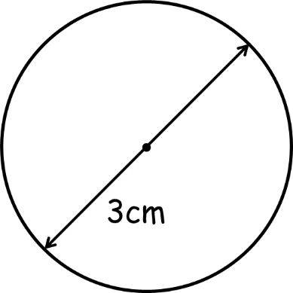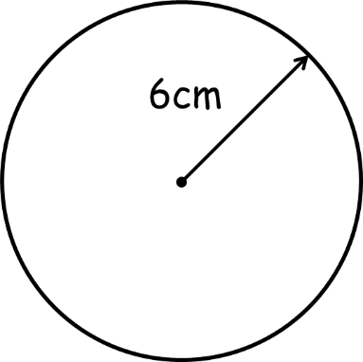
$A=πr²$
$=π×____²$
$=$ _____cm²

$C=πd$
$=π×____$
$=$ _____cm

$A=πr²$
$=π×____²$
$=$ _____cm²

$C=πd$
$=π×____$
$=$ _____cm

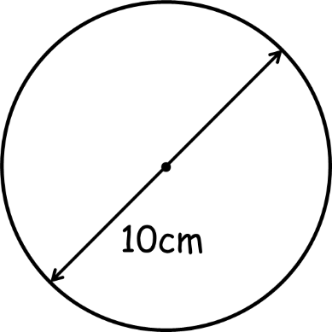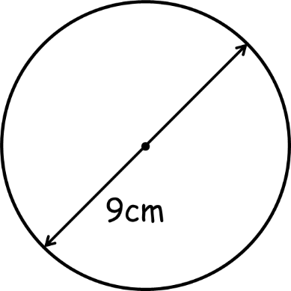
$A=πr²$
$=π×____²$
$=$ _____cm²

$C=πd$
$=π×____$
$=$ _____cm

$A=πr²$
$=π×____²$
$=$ _____cm²

$C=πd$
$=π×____$
$=$ _____cm

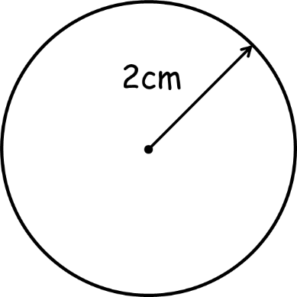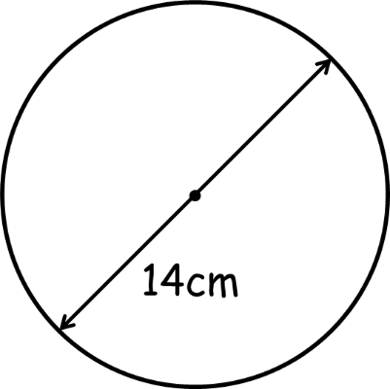
$A=πr²$
$=π×____²$
$=$ _____cm²

$C=πd$
$=π×____$
$=$ _____cm

$A=πr²$
$=π×____²$
$=$ _____cm²

$C=πd$
$=π×____$
$=$ _____cm

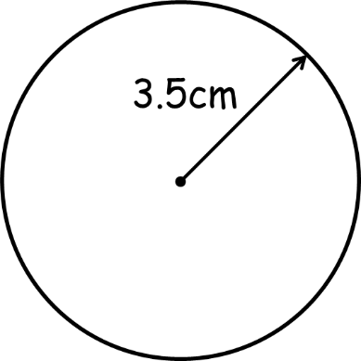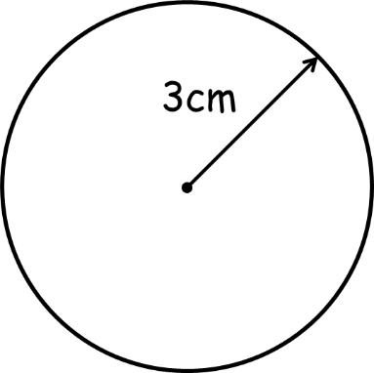
$A=πr²$
$=π×____²$
$=$ _____cm²

$C=πd$
$=π×____$
$=$ _____cm

$A=πr²$
$=π×____²$
$=$ _____cm²

$C=πd$
$=π×____$
$=$ _____cm

