Using Histograms GREEN
1. The histogram gives information about house prices in a village in 2015
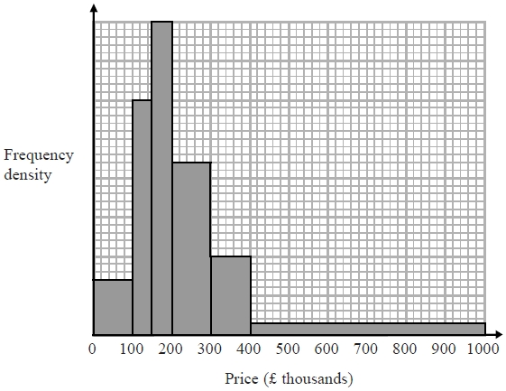
20 houses in the village have a price between £300 000 and £400 000
Work out the number of houses in the village with a price under £200 000

...........................................................

2. The histogram shows information about the times, in minutes, that some passengers had to wait at an airport.
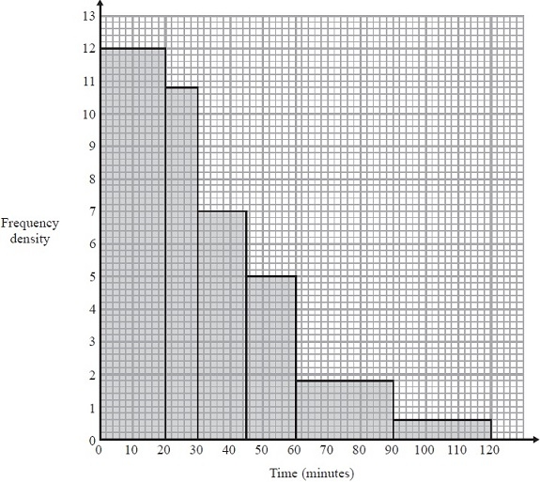
Work out the percentage of the passengers who had to wait for more than one hour.

...........................................................

3. The histogram shows information about the areas of some farms.
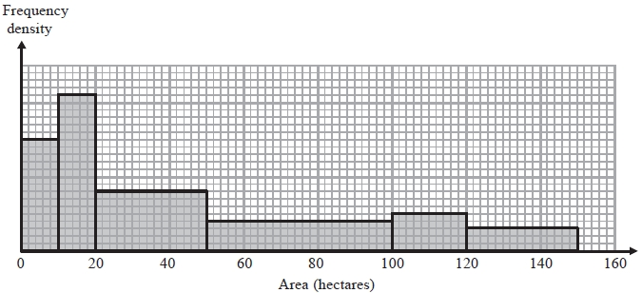

Work out an estimate for the median area of the farms.

...........................................................

4. Ulrika recorded the times some people took to run a race.
The histogram gives information about these times.
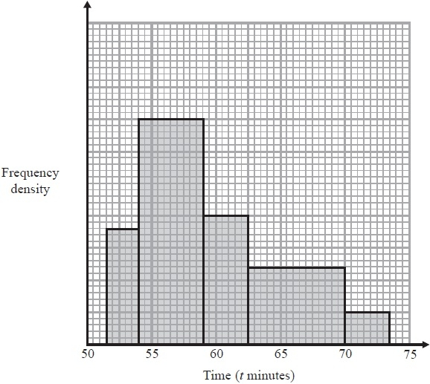
25% of the people took a time less than T minutes.
Work out an estimate for T.

...........................................................

Using Histograms AMBER
1. The histogram gives information about house prices in a village in 2015
20
20 houses in the village have a price between £300 000 and £400 000
Work out the number of houses in the village with a price under £200 000
Frequency of 20 = 50 squares, so 1 square = frequency of 0.4

...........................................................

2. The histogram shows information about the times, in minutes, that some passengers had to wait at an airport.
Work out the percentage of the passengers who had to wait for more than one hour.
Calculate the frequency of each bar by working out its area.

...........................................................

3. The histogram shows information about the areas of some farms.

Work out an estimate for the median area of the farms.
Estimate the total frequency
Estimate the frequency of each bar
Estimate one square = frequency of one

...........................................................

4. Ulrika recorded the times some people took to run a race.
The histogram gives information about these times.
25% of the people took a time less than T minutes.
Work out an estimate for T.

...........................................................

Using Histograms RED
1. The histogram gives information about house prices in a village in 2015
20
20 houses in the village have a price between £300 000 and £400 000
Work out the number of houses in the village with a price under £200 000
Price (£ thousands) | Frequency
0 – 100
100 – 150
150 - 200
Frequency of 20 = 50 squares, so 1 square = frequency of 0.4

Total frequency of first 3 bars =

...........................................................

2. The histogram shows information about the times, in minutes, that some passengers had to wait at an airport.
Work out the percentage of the passengers who had to wait for more than one hour.
% = Number of passengers who waited more than one hour x 100
Calculate the frequency of each bar by working out its area.
Total number of passengers

...........................................................

3. The histogram shows information about the areas of some farms.

Work out an estimate for the median area of the farms.
Estimate the total frequency
Estimate the frequency of each bar
Estimate one square = frequency of one

...........................................................

4. Ulrika recorded the times some people took to run a race.
The histogram gives information about these times.
25% of the people took a time less than T minutes.
Work out an estimate for T.

...........................................................

