Lines, Angles and Shapes (F)

Intervention Booklet

Name: _______________________________

Class: _______________________________

Useful websites:

www.mathswatchvle.com
(Video explanations and questions)
Centre ID: twgash
Username: firstname
Password: lastname

www.methodmaths.com
(Past papers online that get instantly marked)
Centre ID: wga
Username: firstname
Password: lastname

www.hegartymaths.com
(Online tutorials and quizzes)
Login: first name and last name are backwards and case sensitive

www.bbc.co.uk/schools/gcsebitesize/maths

Angles in triangles, on a line and around a point

Things to remember:
- Angles in a triangle sum to 180°.
- Angles on a line sum to 180°.
- Angles around a point sum to 360°.

Questions:
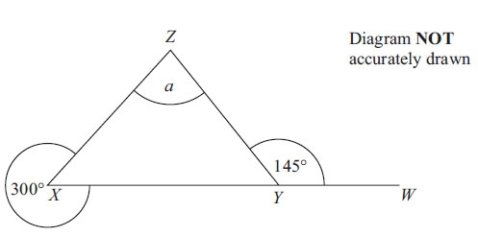
1. XYW is a straight line.
Work out the size of the angle marked a.
You must give reasons for your answer.

(Total for Question is 4 marks)
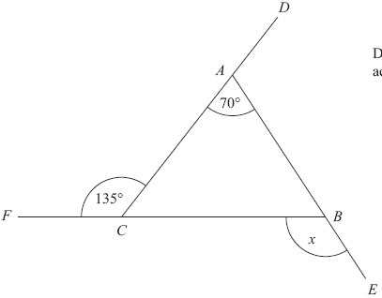
2. DAC, FCB and ABE are straight lines.
Work out the size of the angle marked x.
You must give reasons for your answer.

(Total for Question is 5 marks)
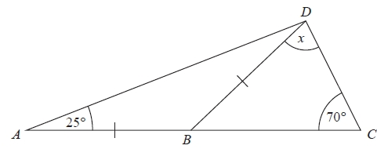
3. ABC is a straight line.
AB = BD
Angle BAD = 25°
Angle BCD = 70°
Work out the size of the angle marked x.
Give reasons for your answer.

(Total for Question is 4 marks)
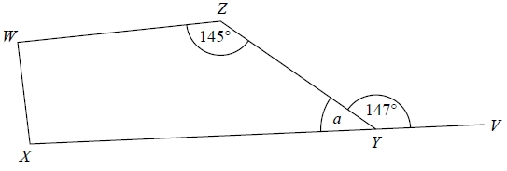
4. WXYZ is a quadrilateral.
XYV is a straight line.
(a) (i) Find the
size of the angle marked a.

...........................................................°

(ii) Give a reason for your answer.

.......................................................................................................................................
(2)
Angle ZWX = angle WXY
(b) Work out the size of angle ZWX.

...........................................................°
(2)
(Total for question = 4 marks)
Angles in parallel lines

Things to remember:
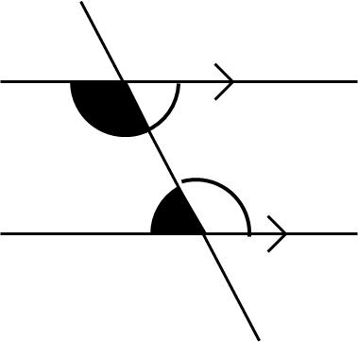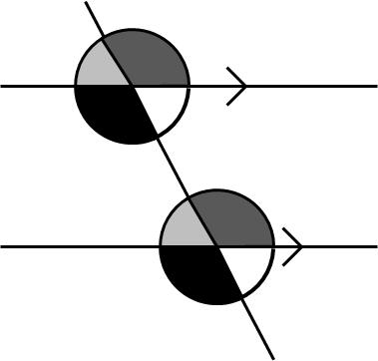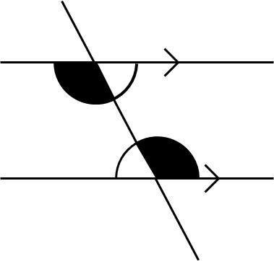
C-shape co-interior F-shaped corresponding Z-shaped alternate
angles add up to 180° angles are equal angles are equal

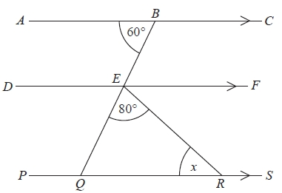
Questions:
1. Diagram not drawn accurately.
ABC, DEF and PQRS are parallel lines.
BEQ is a straight line.
Angle ABE = 60°
Angle QER = 80°
Work out the size of the angle marked x.
Give reasons for each stage of your working.

(Total for question = 4 marks)
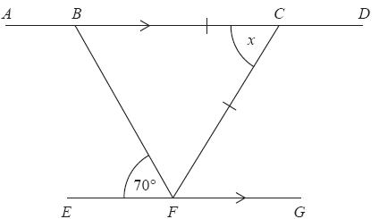
2. Diagram not drawn accurately.
ABCD and EFG are parallel lines.
BC = CF
Angle BFE = 70°
Work out the size of the angle marked x.
Give reasons for each stage of your working.

(Total for question = 4 marks)

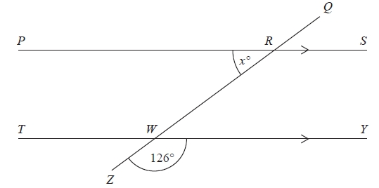
3. Diagram NOT accurately drawn
PRS and TWY are parallel straight lines.
QRWZ is a straight line.
Work out the value of x.
Give reasons for your answer.

(Total for question = 3 marks)

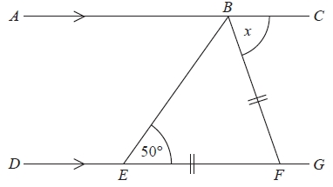
4. ABC is a straight line.
DEFG is a straight line.
AC is parallel to DG.
EF = BF.
Angle BEF = 50°.
Work out the size of the angle marked x.
Give reasons for your answer.

...........................................................°
(Total for Question is 4 marks)

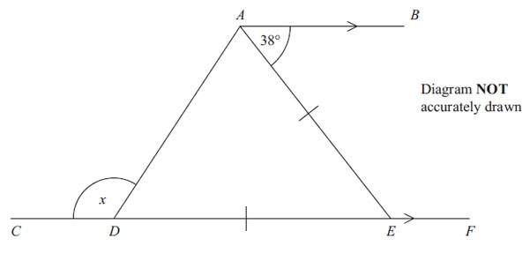
5. CDEF is a straight line.
AB is parallel to CF.
DE = AE.
Work out the size of the angle marked x.
You must give reasons for your answer.

(Total for Question is 4 marks)
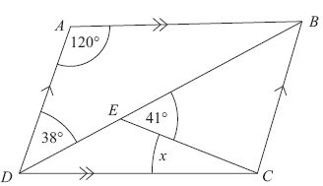
6. ABCD is a parallelogram.
Angle ADB = 38°.
Angle BEC = 41°.
Angle DAB = 120°.
Calculate the size of angle x.
You must give reasons for your answer.

(Total for Question is 4 marks)

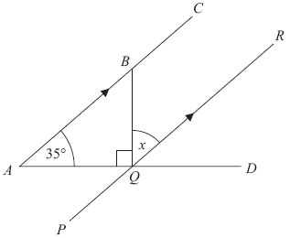
7. ABC, PQR and AQD are straight lines.
ABC is parallel to PQR.
Angle BAQ = 35°
Angle BQA = 90°
Work out the size of the angle marked x.
Give reasons for each stage of your working.

...........................................................°
(Total for Question is 4 marks)
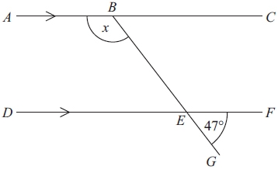
8. Diagram NOT accurately drawn
ABC and DEF are parallel lines.
BEG is a straight line.
Angle GEF = 47°.
Work out the size of the angle marked x.
Give reasons for your answer.

...........................................................°
(Total for Question is 3 marks)

Interior and exterior angles

Things to remember:
- Interior Angles:
  - For n sides, the sum of interior angles = (n – 2) x 180
  - Each interior angle = (n – 2) x 180
n
- Exterior Angles:
  - The sum of exterior angles in any shape (or polygon) is 360°

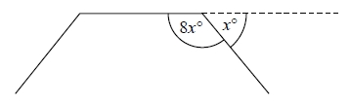
Questions:
1. The diagram shows three sides of a regular polygon.
The size of each exterior angle of the regular polygon is x°.
The size of each interior angle of the regular polygon is 8x°.
Work out the number of sides the regular polygon has.

………………………………………
(Total for question = 3 marks)

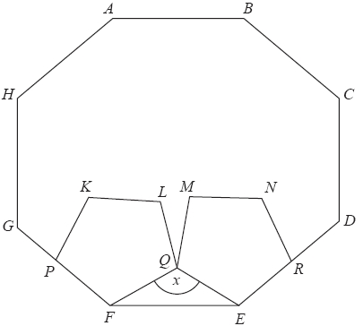
2. ABCDEFGH is a regular octagon.
KLQFP and MNREQ are two identical regular pentagons.

Work out the size of the angle marked x.
You must show all your working.

………………………………………°
(Total for question = 4 marks)
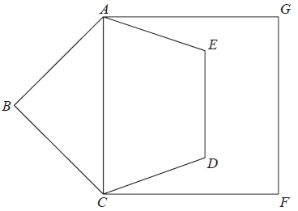
3. Diagram not drawn accurately.
ABCDE is a regular pentagon.
ACFG is a square.
Work out the size of angle DCF.
You must show all your working.

………………………………………°
(Total for question = 4 marks)
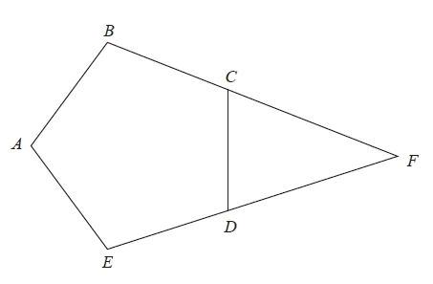
4. ABCDE is a regular pentagon.
BCF and EDF are straight lines.
Work out the size of angle CFD.
You must show how you got your answer.

………………………………………°
(Total for question = 3 marks)

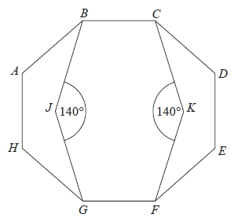
5. Diagram not drawn accurately.
ABCDEFGH is a regular octagon.
BCKFGJ is a hexagon.
JK is a line of symmetry of the hexagon.
Angle BJG = angle CKF = 140°
Work out the size of angle KFE.
You must show all your working.

........................................................... °
(Total for Question is 4 marks)
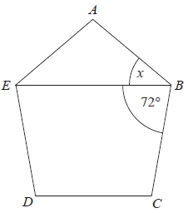
6. Diagram not drawn accurately .
ABCDE is a regular polygon.
EB is a straight line.
Angle EBC = 72°.
Work out the size of the angle marked x.

........................................................... °
(Total for question = 3 marks)

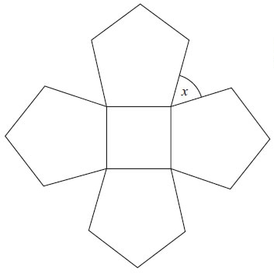
7. The diagram shows a square and 4 regular pentagons.
Work out the size of the angle marked x.

........................................................... °
(Total for question = 3 marks)

8. The diagram shows two regular shapes.
Work out the size of the angle marked x.

........................................................... °
(Total for Question is 3 marks)

Proofs of congruence and similarity

Things to remember:
- To prove congruence, look for:
  - Side, angle, side
  - Angle, side, angle
  - Side, side, side, or
  - Right-angle, hypotenuse, (other) side

Questions:
1. These shapes have been drawn on a grid of centimetre squares.

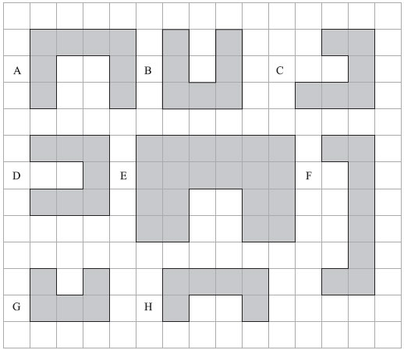

(a) (i) Write down the letters of a pair of shapes that are congruent.

.......................................................................................................................................
(ii) Write down the letters of a different pair of shapes that are similar.

.......................................................................................................................................
(2)
(b) Find the perimeter of shape D.

.......................................................................................................................................
(1)
(Total for Question is 3 marks)

2. Here are some triangles drawn on a grid.

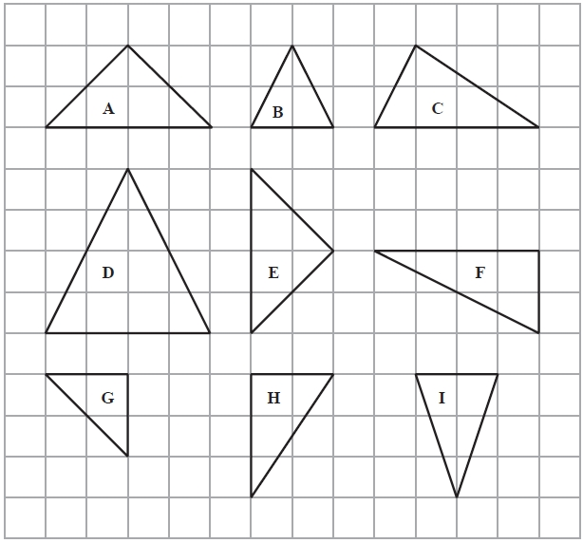

Two of these triangles are congruent.
(a) Write down the letters of these triangles.
.............................. and ..............................
(1)
One of the triangles is similar to triangle B.
(b) Write down the letter of this triangle.
..............................
(1)
(Total for Question is 2 marks)

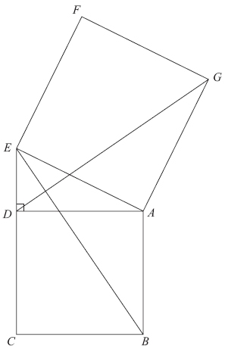
3. Diagram not drawn accurately.
In the diagram,
ADE is a right-angled triangle,
ABCD and AEFG are squares.
Prove that triangle ABE is congruent to triangle ADG.

(Total for Question is 3 marks)

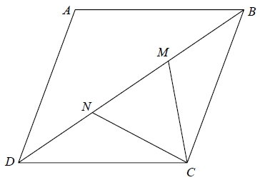
4. ABCD is a rhombus.
M and N are points on BD such that DN = MB.
Prove that triangle DNC is congruent to triangle BMC.

(Total for question = 3 marks)

5. ABCD is a parallelogram.
E is the point where the diagonals AC and BD meet.
Prove that triangle ABE is congruent to triangle CDE.

(Total for question = 3 marks)
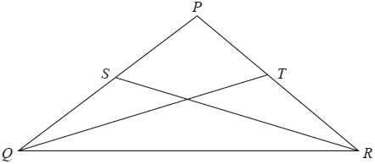
6. PQ = PR.
S is the midpoint of PQ.
T is the midpoint of PR.
Prove triangle QTR is congruent to triangle RSQ.

(Total for question is 3 marks)

