Baseline Answers

1. | - 9 - 12 | 1 mark for each correct answer | 2
2. | 32 x 17  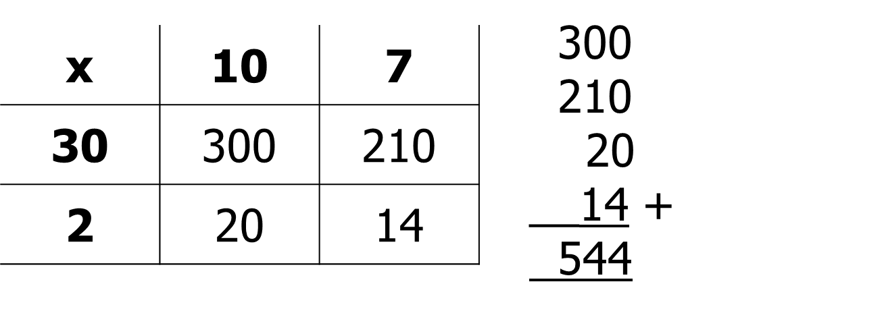  32 x 17 = 544  3.2 x 1.7 = 5.44 | 1 mark for multiplying correct integers  1 mark for correct multiplication  1 mark for correct location of dp | 3
3. | 5 thousand | Correct answer | 1
4. | A factor of 12 = 4  A multiple of 3 = 9  A prime number = 7 or 11 | 1 mark for each correct answer | 3
5. | 4² = 16 √81 = 9 | 1 mark for each correct answer | 2
6. | 2 × 3 + 4 = 10  10 – 2 × 5 = 0  16 ÷ (2 × 4) = 2 | 1 mark for each correct answer | 3
7. | 4.6 | Correct answer | 1
8. | __12___ ___18___  1 and 12 1 and 18  2 and 6 2 and 9  3 and 4 3 and 6  HCF = 6 | 1 mark for each list of factors  1 mark for 6 | 3
9. | 2.57 x 34 = 87.38 873.8 ÷ 2.57 = 340 | 1 mark for each correct answer | 2
10. | $\frac{10}{300}$ $\frac{2}{8}$ $\frac{4}{12}$ $\frac{1}{40}$ $\frac{4}{16}$ | 1 mark for each correct answer | 2
11. | 0.08 0.208 0.28 0.802 0.82 | 1 mark lost for each incorrect answer | 2
12. | 2 : 5 | Correct answer | 1
13. | $\frac{3}{5}$ $\frac{5}{8}$ $\frac{2}{3}$ $\frac{3}{4}$ | 1 mark lost for each incorrect place | 2
14. | £28 11.2g | 1 mark for 1/10 = 8g seen  1 mark for 10% or 1% seen  1 mark for each correct answer | 4
15. | Fraction Decimal Percentage  $\frac{2}{5}$ 0.4 40%  $\frac{1}{2}$ 0.5 50%  $\frac{13}{20}$ 0.65 65% | 1 mark for each correct answer | 3

16. | $\frac{1}{5}$ + $\frac{2}{3}$ = $\frac{3}{15}$ + $\frac{10}{15}$ = $\frac{13}{15}$  1 $\frac{1}{3}$ x 2 $\frac{3}{8}$ = $\frac{4}{3}$ x $\frac{19}{8}$ = $\frac{76}{24}$ = 3 $\frac{4}{24}$ = 3 $\frac{1}{6}$ | 1 mark for a correct common denominator  1 mark for correct answer  1 mark for correct improper fractions  1 mark for a correct multiplication of fractions  1 mark for correct answer | 5
17. | 10% = £12.00  10% = £12.00  10% = £12.00  10% = £12.00  _5% = £ 6.00  45% = £54.00  £120 - £54 = £66 | 1 mark for calculating 45%  1 mark for subtracting 45% from £120  1 mark for correct answer | 3
18. | 26% $\frac{1}{4}$ 0.3 $\frac{1}{3}$ $\frac{2}{5}$  0.26 0.25 0.3 0.33 0.4  $\frac{1}{4}$ 26% 0.3 $\frac{1}{3}$ $\frac{2}{5}$ | 1 mark for 3 correct equivalent FDPs  1 mark for correct order | 2
19. | 1 + 3 = 4 parts in total  60 ÷ 15 litres  15 x 3 = 45 litres | 1 mark for calculating total number of parts  1 mark for calculating value of 1 part  1 mark for correct answer | 3

