**Trigonometric Graphs**

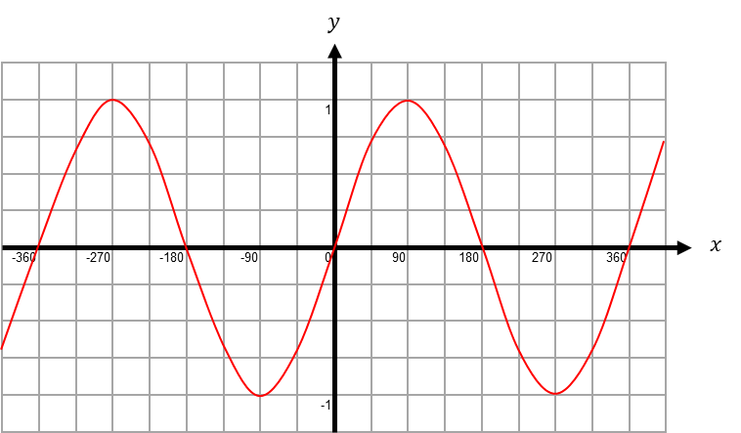

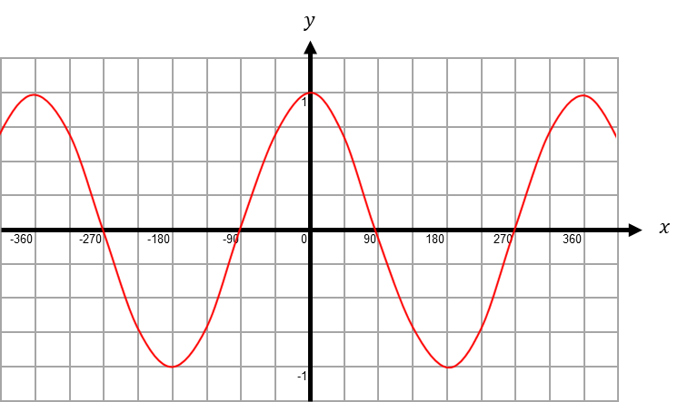

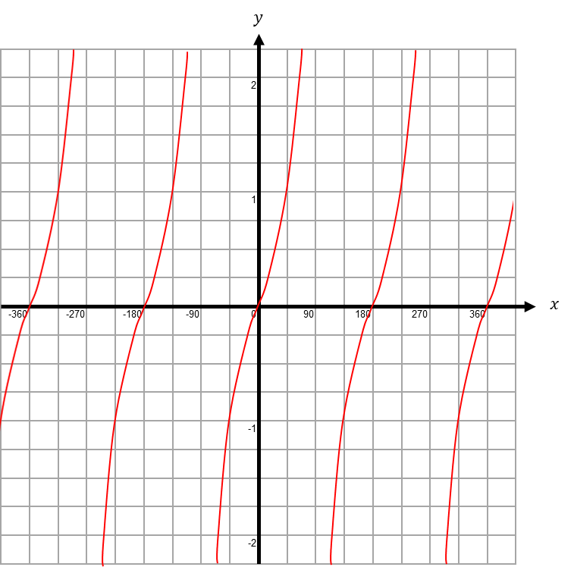

**Trigonometric Graphs**





