End of Unit Test Name: ____________________________
Area and Perimeter - FOUNDATION

1. The shape below is drawn on a centimetre grid. Estimate the area of the
shape.

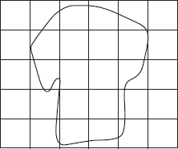
Answer ............................................................... cm²
(Total 1 mark)
2. Field A is a rectangle with sides of 30 m and 70 m.
Field B is a square with the same perimeter as Field A.
Not drawn accurately

How much bigger in area is Field B than Field A? You must show your working.

…………………………………………………………………………………………………………

…………………………………………………………………………………………………………

…………………………………………………………………………………………………………

…………………………………………………………………………………………………………

…………………………………………………………………………………………………………

…………………………………………………………………………………………………………

…………………………………………………………………………………………………………

…………………………………………………………………………………………………………

…………………………………………………………………………………………………………

…………………………………………………………………………………………………………

Answer ............................................................................. m²
(Total 4 marks)

3. This diagram shows Adam’s garden. It is in the shape of two rectangles joined together. Not drawn accurately.

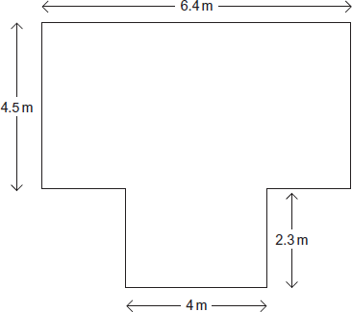
Work out the area of the garden.

…………………………………………………………………………………………………………

…………………………………………………………………………………………………………

…………………………………………………………………………………………………………

…………………………………………………………………………………………………………

…………………………………………………………………………………………………………

…………………………………………………………………………………………………………

Answer ................................................................. m²
(Total 4 marks)
4. Calculate the area of the triangle. Not drawn accurately.

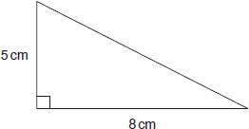

…………………………………………………………………………………………………………

…………………………………………………………………………………………………………

Answer ............................................................... cm²
(Total 2 marks)

5. ABCD is a trapezium. Not drawn accurately.

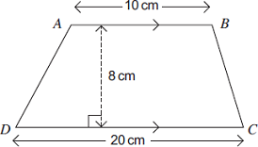
Calculate the area of ABCD. State the units of your answer.

…………………………………………………………………………………………………………

…………………………………………………………………………………………………………

…………………………………………………………………………………………………………

…………………………………………………………………………………………………………

…………………………………………………………………………………………………………

Answer ......................................................................
(Total 3 marks)
6. (a) The radius of this circle is 4 cm. Not drawn accurately

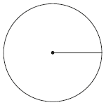

Work out the area. Use $π$ = 3.1.

…………………………………………………………………………………………………

…………………………………………………………………………………………………

…………………………………………………………………………………………………

Answer ............................................................................ cm²
(3)

(b) The diameter of this semicircle is 16 cm. Not drawn accurately

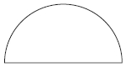

Work out the perimeter of the semicircle. Use $π$ = 3.1.

…………………………………………………………………………………………………

…………………………………………………………………………………………………

…………………………………………………………………………………………………

…………………………………………………………………………………………………

…………………………………………………………………………………………………

…………………………………………………………………………………………………

…………………………………………………………………………………………………

…………………………………………………………………………………………………

Answer .................................................................................... cm
(3)
(Total 6 marks)

(Total for test = 20 marks)

