Coordinates in the first quadrant

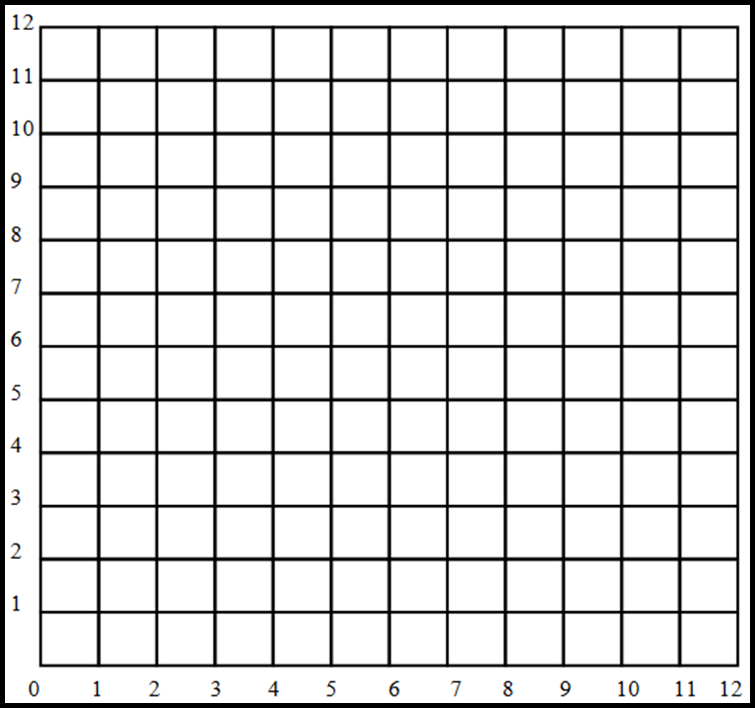

Plot each pair of coordinates and join them to the next pair to make shapes. Name each shape as accurately as possible.

- (1, 1) (4, 1) (4, 5)
Shape name = __________________________

- (7, 1) (10, 2) (5, 3)
Shape name = __________________________

- (7, 4) (11, 4) (9, 8)
Shape name = __________________________

- (9, 9) (12, 9) (12, 12) (9, 12)
Shape name = __________________________

- (3, 5) (5, 5) (7, 7) (7, 9) (5, 11) (3, 11) (1, 9) (1, 7)
Shape name = __________________________

