Area, Perimeter and Angles with Algebra

None of the diagrams are drawn accurately or to scale!
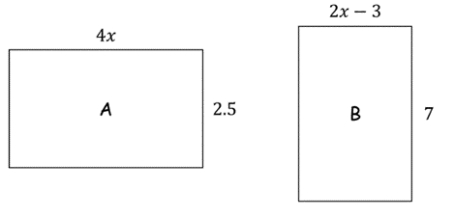
1. Here are two rectangles. All measurements are in centimetres. The area of rectangle A is equal to the area of rectangle B. Work out the perimeter of rectangle B.

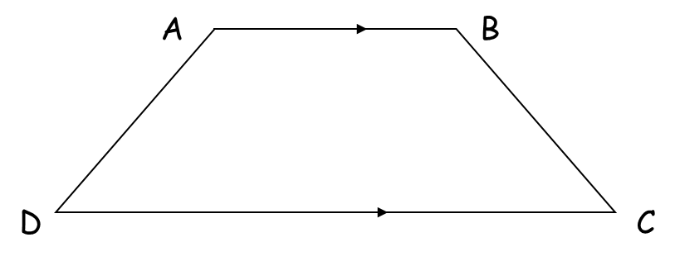
2. The diagram shows a trapezium.
AD = $x$ cm.
BC is the same length as AD.
AB is twice the length of AD.
DC is 4 cm longer than AB.
The perimeter of the trapezium is 40 cm.
Work out the length of AD.

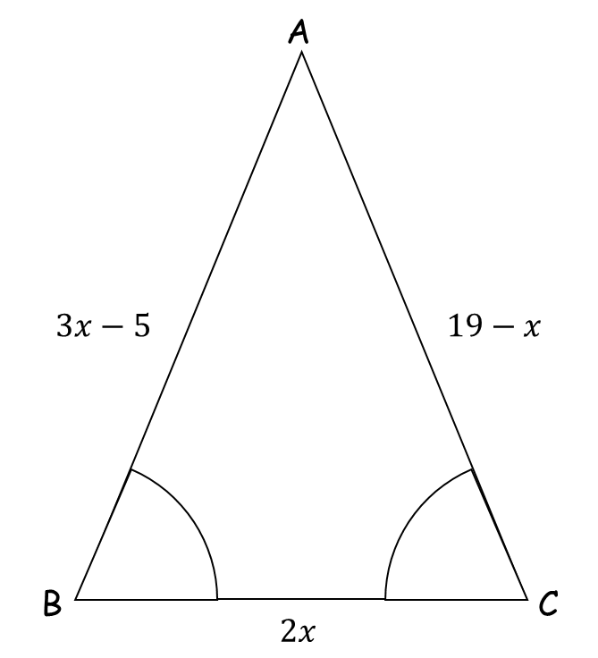
3. ABC is a triangle.
Angle ABC = angle BCA.
The length of side AB is $(3x-5)$ cm.
The length of side AC is $(19-x)$ cm.
The length of side BC is $2x$ cm.
Work out the perimeter of the triangle.
Give your answer as a number of centimetres.

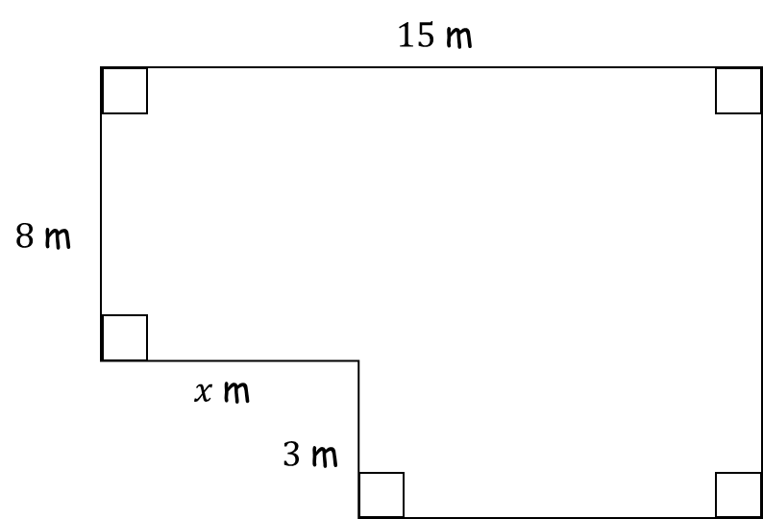
4. The diagram shows the plan of a floor.
The area of the floor is 138 m².
Work out the value of $x$.

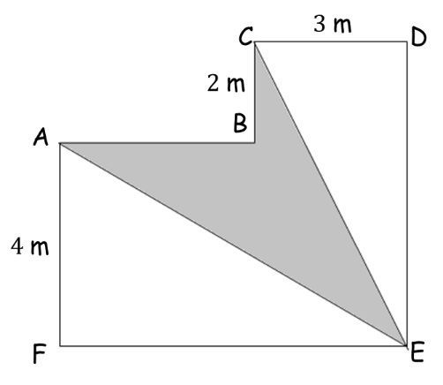

5. The diagram shows a shape ABCDEF.
All the corners of the shape are right angles.
The perimeter of the shape is 28 m.
Work out the area of ABCE shown shaded on the diagram.

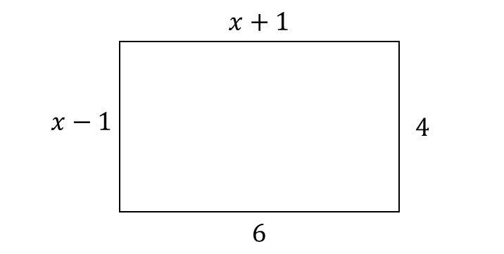
6. Here is a rectangle.
All measurements on the diagram are in centimetres.
(a) Find the value of $x$.

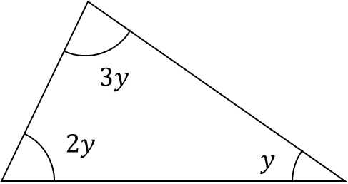
Here is a triangle.
(b) Find the size of the angle marked y.

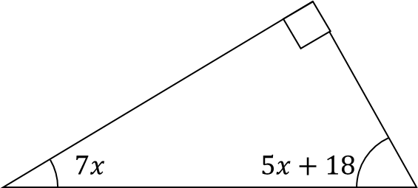
7. The diagram shows a right-angled triangle.
All the angles are in degrees.
Work out the size of the smallest angle of the triangle.

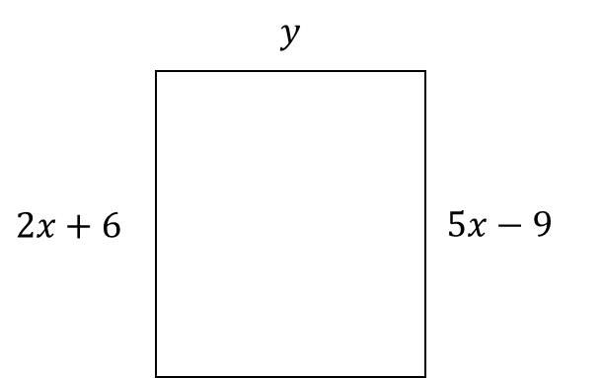
8. Here is a rectangle.
All measurements are in centimetres.
The area of the rectangle is 48 cm².
Show that $y=3$

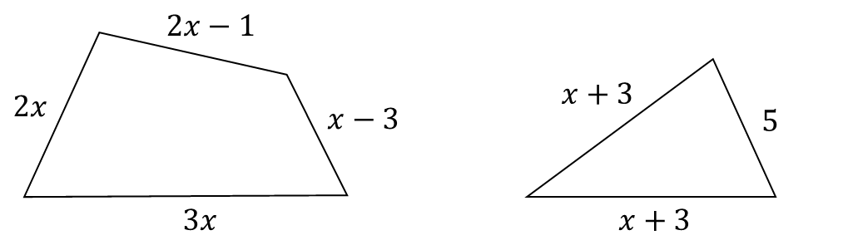
9. In the diagram all measurements are in centimetres.
The perimeter of the quadrilateral is twice the perimeter of the triangle.
Work out the perimeter of the quadrilateral.

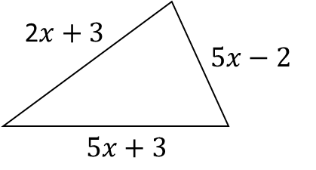
10. The perimeter of a square has the same length as the perimeter of this triangle.
All measurements are in centimetres.
Find an expression, in terms of $x$, for the length of a side of the square.
Give your answer in its simplest form.

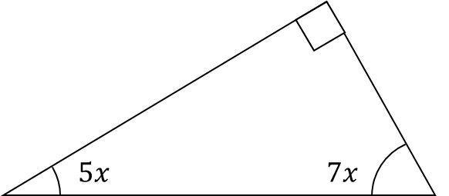
11. The diagram shows a right-angled triangle.
All the angles are in degrees.
Work out the size of the smallest angle.

