End of Unit Test Name: ____________________________
Calculations and Accuracy - FOUNDATION

Q1. Here is a list of numbers.

−9 −5 −3 −1 0 3 4 6

(a) Write down two numbers from the list that add up to 5

................................ and ................................
(1)
(b) Write down two numbers from the list that have a difference of 13

................................ and ................................
(1)
(c) Write down two numbers from the list that multiply to give −15

................................ and ................................
(1)
(d) Use three different numbers from the list to make the following calculation correct.

20 ÷ ..................... = ..................... ÷ .....................
(1)
(Total 4 marks)

Q2. (a) Write in figures the number: thirty thousand and sixteen

......................................................................
(1)
(b) Write in words the number 0.43

……………………………………........................................................................
(1)
(c) Write down the value of the digit 9 in the number 41 982

......................................................................
(1)
(Total 3 marks)

Q3. This is a bill for coffee and buns. The bill has coffee spilt on it.

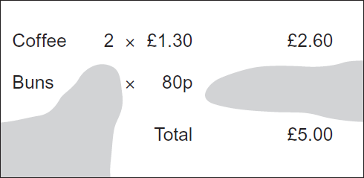

How many buns were bought? You must show your working.

………………………………………………………………………………………………………

………………………………………………………………………………………………………

………………………………………………………………………………………………………

………………………………………………………………………………………………………

......................................................................
(Total 3 marks)
Q4. Put signs in the boxes to make these calculations correct.
You may use the signs +, −, × and ÷

(a) 1 2 3 = 0
(1)

(b) 1 2 3 = 5
(1)

(c) 1 2 3 = − 4
(1)
(Total 3 marks)

Q5. These cars are for sale.

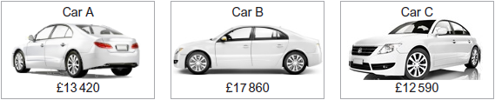
(a) Which car is the cheapest?

Answer ......................................................................
(1)
(b) The price of each car is rounded to the nearest £100. Which price changes by the greatest amount? You must show your working.

…………………………………………………………………………………………………..

…………………………………………………………………………………………………..

…………………………………………………………………………………………………..

…………………………………………………………………………………………………..

Answer ......................................................................
(3)
(Total 4 marks)
Q6. Use approximations to estimate the value of
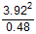

………………………………………………………………………………………………………

………………………………………………………………………………………………………

………………………………………………………………………………………………………

………………………………………………………………………………………………………

Answer ......................................................................
(Total 2 marks)
Q7. x = 2500 to the nearest 100. Circle the smallest possible value of x.

2449 2450 2495 2499

(Total 1 mark)
(Total for test = 20 marks)

