Mathematics Assessment

Bands 4-6 Problem Solving – Test 1
Calculators allowed on questions with this symbol:

Name: ______________________________

Class: ______________________________

Teacher: ______________________________

Remember:
- The test is 1 hour long.
- You will need: pen, pencil, rubber and a ruler.
- Try to answer all questions.
- Write all your answers and working in the spaces provided in this test paper – do not use any rough paper. Marks may be awarded for working.
- Check your work carefully.
- Don’t spend too long on one question. Leave it and try the next one.

Formulae Sheet
Perimeter, area, surface area and volume formulae
Sphere | Cone
Volume = $\frac{4}{3}$ πr³  Surface Area = 4πr² | Volume = $\frac{1}{3}$ πr²h  Curved Surface Area = πrl

1. | Fill in the gaps:  - (x + 2)(x + ) = x² + x + 6  - (x - )(x + 8) = x² + 5x - | / 8
2. | Enzo makes a table of values and plots the graph of y = x² + 2. Which points on the graph are incorrect?  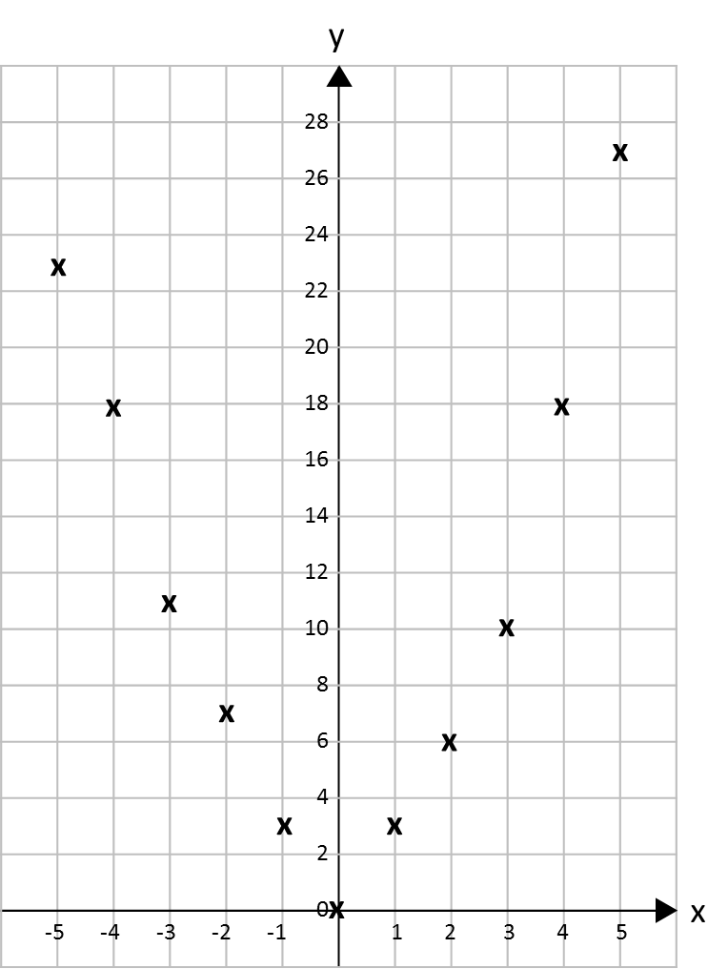 | / 6
3. | A population of ants increases at a rate of 30% per day. At the end of one week there are 3500 insects. How many insects were there at the beginning of the week?  ___________ | / 5
4. | Work out the area of this isosceles triangle. Give your answer correct to 3 significant figures.  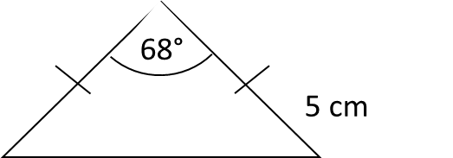  _______________ cm² | / 3
5. | Find the angle of this sector. Give your answer correct to 1 decimal place.  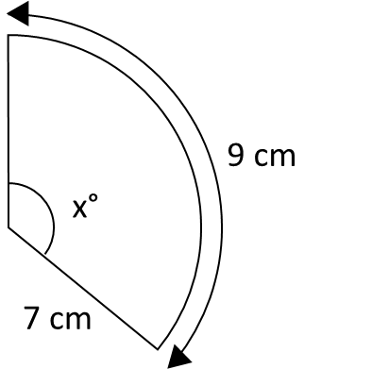  _______________ ° | / 5
6. | The pressure, P, of water on an object (in bars) is directly proportional to its depth, d (in metres). When the object is at a depth of 8 metres, the pressure on the object is 0.8 bars. A diver’s watch has been guaranteed to work at pressures up to 8.5 bars. The diver takes the watch down to 75 m. Will the watch still work? | / 6
7. | Find the coordinates of the point where these two lines meet if they are extended.  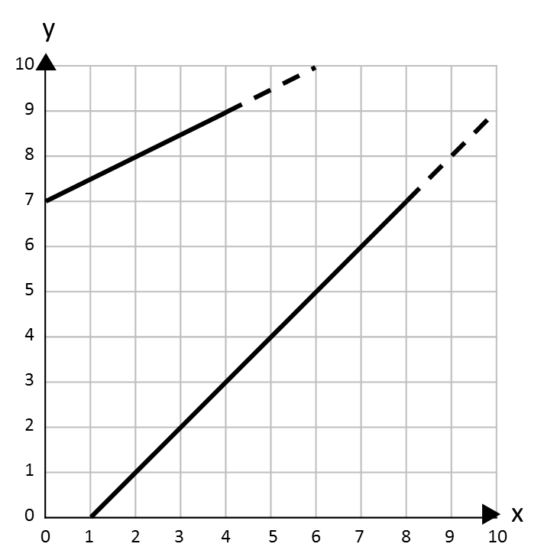  ( ____ , ____ ) | / 7
8. | The rule for a sequence of number pairs is:  (first number, last number)  (first number + last number, first number – last number)  Here is part of a sequence that follows this rule. Write in the missing number pairs.  (____ , ____) (____ , ____) (1, 2) (3, -1) (2, 4) (____ , ____) | / 7

