End of Unit Test Name: ____________________________
Pythagoras’ Theorem and Trigonometry - FOUNDATION

Calculator allowed

1) Calculate the length BC. You must show your working. Not drawn accurately

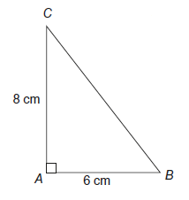

…………………………………………………………………………………………………………

…………………………………………………………………………………………………………

…………………………………………………………………………………………………………

…………………………………………………………………………………………………………

Answer ................................................................ cm
(Total 3 marks)

2) Calculate the length x in the triangle. Not drawn accurately

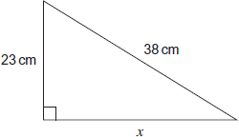

…………………………………………………………………………………………………………

…………………………………………………………………………………………………………

…………………………………………………………………………………………………………

…………………………………………………………………………………………………………

Answer ................................................................ cm
(Total 3 marks)

3) In the diagram the area of triangle ABD is 56 cm²

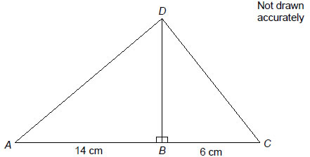
Work out the length of CD.

…………………………………………………………………………………………………………

…………………………………………………………………………………………………………

…………………………………………………………………………………………………………

…………………………………………………………………………………………………………

…………………………………………………………………………………………………………

…………………………………………………………………………………………………………

Answer ..............................................................................cm
(Total 4 marks)

4) Here are sketches of four triangles. Not drawn accurately
In each triangle.
- the longest side is exactly 1 cm
- the other length is given to 2 decimal places.

(a) Circle the value of cos 50° to 2 decimal places.

0.77 0.53 0.64 0.86
(1)

(b) Work out the value of x. Give your answer to 1 decimal place. Not drawn accurately

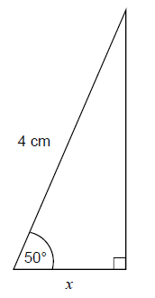
…………………………………………………………………………………………………

…………………………………………………………………………………………………

…………………………………………………………………………………………………

…………………………………………………………………………………………………

Answer ............................................cm
(2)
(Total 3 marks)

5) (a) Work out the size of angle x.

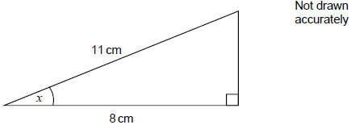

…………………………………………………………………………………………………

…………………………………………………………………………………………………

…………………………………………………………………………………………………

…………………………………………………………………………………………………

Answer ......................................................................degrees
(2)
(b) Work out length y.

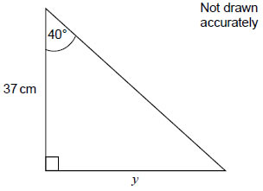

…………………………………………………………………………………………………

…………………………………………………………………………………………………

…………………………………………………………………………………………………

…………………………………………………………………………………………………

Answer ..............................................................................cm
(2)
(Total 4 marks)

6) A church tower leans at an angle. Not drawn accurately

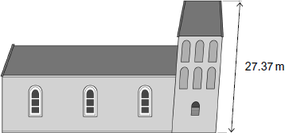
The diagram below shows the angle, y, at which the tower leans. Not drawn accurately

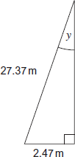

Work out angle y.

…………………………………………………………………………………………………………

…………………………………………………………………………………………………………

…………………………………………………………………………………………………………

…………………………………………………………………………………………………………

…………………………………………………………………………………………………………

Answer ............................................................ degrees
(Total 3 marks)

(Total for test = 20 marks)

