Sequences, functions and graphs (H)

Pre-Intervention Assessment

Name: _______________________________

Class: _______________________________

Date: _______________________________

Question | Objective | RAG
1 | Recognise parallel graphs using their gradients
2 | Sketch quadratic, cubic and reciprocal graphs
3 | Recognise and interpret the equation of a circle
4 | Recognise transformations of graphs
5 | Calculate the nth term of a quadratic sequence

1. Which of the following graphs are parallel? Circle the 2 you have chosen.

y = 2x + 1 y = ¼x +1 y = 2x + 4 y = 4x - 1

Explain your reasoning.

…………………………………………………………………………………………

…………………………………………………………………………………………

2. (a) Complete the table of values for y = x² − 5x + 3

x | -1 | 0 | 1 | 2 | 3 | 4 | 5
y |  | 3 | -1 |  | -3 |  | 3

(b) On the grid below, draw the graph of y = x² − 5x + 3
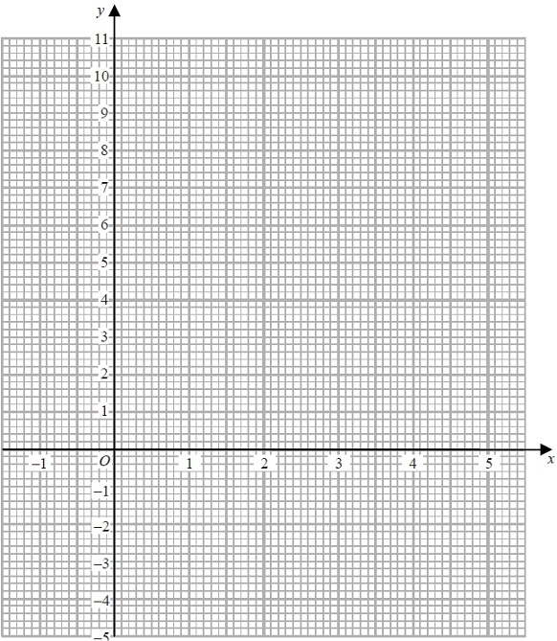

3. On the grid, construct the graph of x² + y² = 16
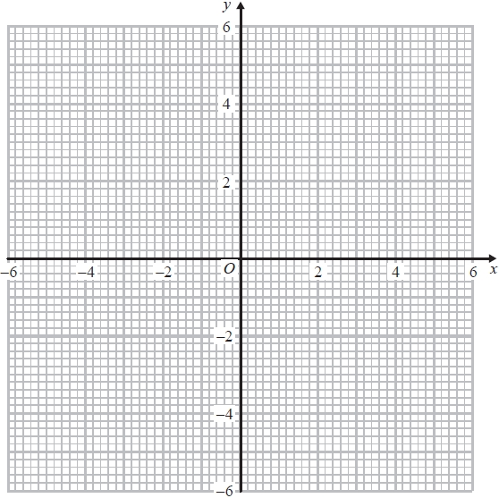

4. Here are the first 5 terms of a quadratic sequence.

1 3 7 13 21

Find an expression, in terms of n, for the nth term of this quadratic sequence.
...........................................................

[Glue here]

