Band 3 – Test 2 Answers

1. | $\frac{2}{3}$ + $\frac{1}{7}$ = $\frac{14}{21}$ + $\frac{3}{21}$ = $\frac{17}{21}$  2 $\frac{1}{4}$ ÷ 1 $\frac{5}{6}$ = $\frac{9}{4}$ x $\frac{6}{11}$ = $\frac{54}{44}$ = 1 $\frac{10}{44}$ = 1 $\frac{5}{22}$ | 1 mark for a correct common denominator  1 mark for correct answer  1 mark for correct improper fractions  1 mark for correct multiplication of fractions  1 mark for correct answer | 5
2. | 34 x 17  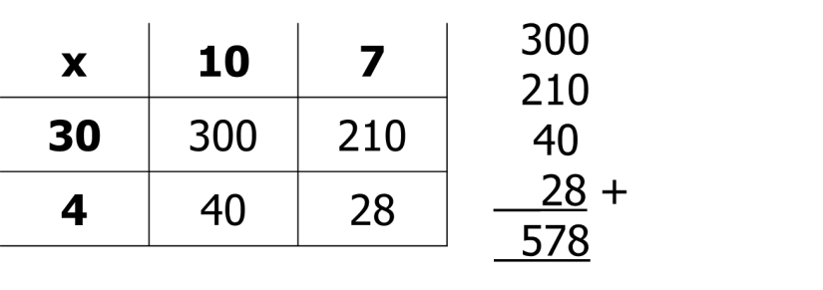  34 x 17 = 578  3.4 x 1.7 = 5.87 | 1 mark for multiplying correct integers  1 mark for correct multiplication  1 mark for correct location of dp | 3
3. | 10% = £42.00  5% = £21.00  2½% = £10.50  17½% = £73.50  £420 + £73.50 = £493.50 | 1 mark for calculating 17½%  1 mark for adding 17½% to £420  1 mark for correct answer | 3

4. | 35% $\frac{1}{4}$ 0.4 $\frac{1}{3}$ $\frac{2}{5}$  0.35 0.25 0.4 0.33 0.4  $\frac{1}{4}$ $\frac{1}{3}$ 35% $\frac{2}{5}$ or 0.4 $\frac{2}{5}$ or 0.4 | 1 mark for 3 correct equivalent FDPs  1 mark for correct order | 2
5. | 7 + 3 + 2 = 12  £36 ÷ 12 = £3  7 x £3 = £21 | 1 mark for calculating total number of parts  1 mark for calculating value of 1 part  1 mark for correct answer | 3
6. | 1.3 x 1.7 = 2.21 22.1 ÷ 1700 = 0.013 | 1 mark for each correct answer | 2
7. | 1.962631579 1.96 | 2 marks for correct calculation  1 mark for correct rounding | 3
8. | t⁸ m⁵ | 1 mark for each correct answer | 2
9. | 1/3 | Correct answer | 1
10. | x² + 3x | Correct answer | 1
11. | 7r + 2 = 5r – 20  2r + 2 = -20  2r = -22  r = -11 | 1 mark for 2r = -22  1 mark for correct answer | 2
12. | T = 35h + 50 | 1 mark for 35h  1 marks for + 50 | 2
13. | 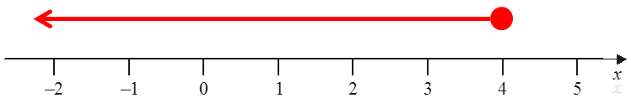 | Correct answer | 1
14. | x -2 -1 0 1 2 3  y -5 -2 1 4 7 10  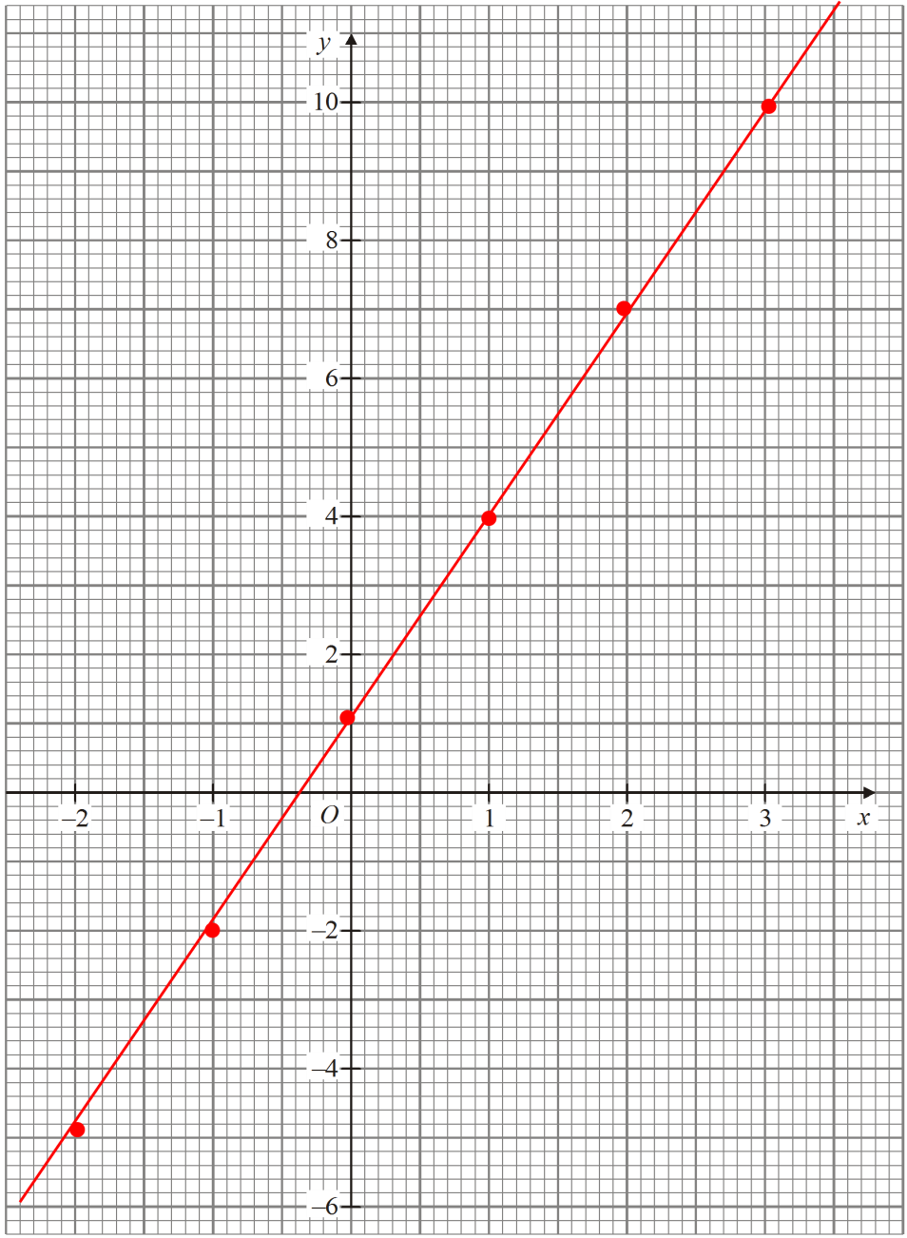 | 1 mark for at least 2 y values correct  Or 2 marks for all 3 values correct  1 mark for coordinates plotted correctly  1 mark for straight line segment through coordinates | 4

15. | 110º  Corresponding angles are equal  35º  Angles on a straight line sum to 180º OR vertically opposite angles are equal OR angles in a triangle sum to 180º | 1 mark for each correct answer  1 mark for each correct reason | 4
16. | 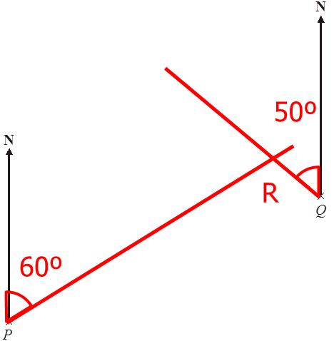 | 1 mark for each correct angle  1 mark for R correctly located | 3
17. | (2 x 12) + (½ x 6 x 5) = 24 + 15 = 39 cm² | 1 mark for correct area of triangle  1 mark for correct area of rectangle  1 mark for correct total area | 3
18. | 200 ÷ (10 x 5) = 200 ÷ 50 = 4 cm | 1 mark for volume ÷ 50  1 mark for correct answer | 2
19. | 1200 ÷ 4 = 300 km/h | 1 mark for distance ÷ time  1 mark for correct answer | 2

20. | Region Frequency Angle  Midlands 22 88º  London 36 144º  Southern England 8 32º  Northern England 24 96º  Total 90 360º  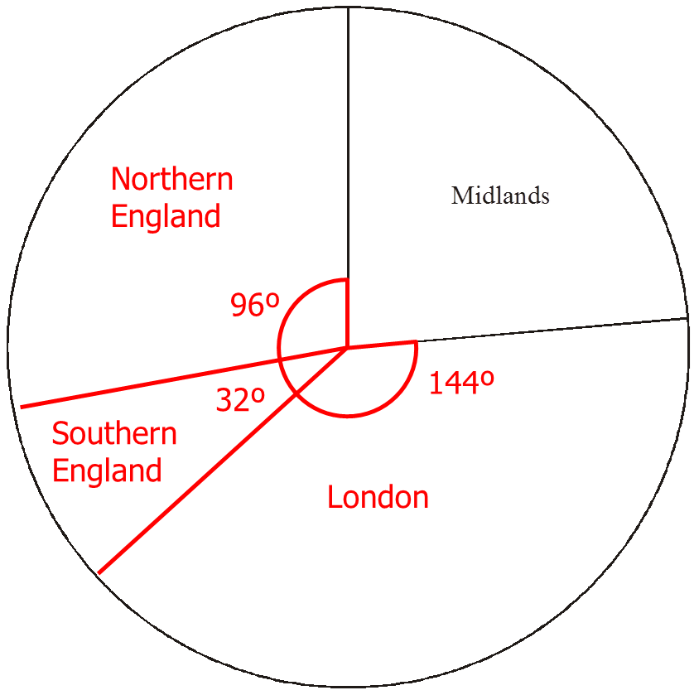 | 1 mark for x 4 seen  1 mark for correctly calculating angles  1 mark for correctly drawn pie chart with labels | 3
21. | Coin Dice  1 2 3 4 5 6  1 2 3 4 5 6 7  2 3 4 5 6 7 8  3 4 5 6 7 8 9  4 5 6 7 8 9 10  5 6 7 8 9 10 11  6 7 8 9 10 11 12  P(7) = 6/36 | 1 mark for correctly completing sample space diagram  1 mark for identifying 36 possible outcomes  1 mark for 6 7s. | 3

