**Rotational Symmetry GREEN**

Complete these so that they have rotational symmetry about the centre.



**Rotational Symmetry AMBER**

Find the order of rotation of these shapes:

_____ _____ _____ _____

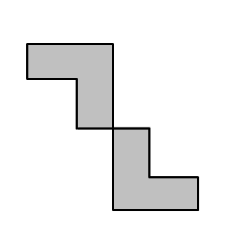 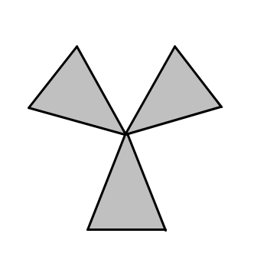 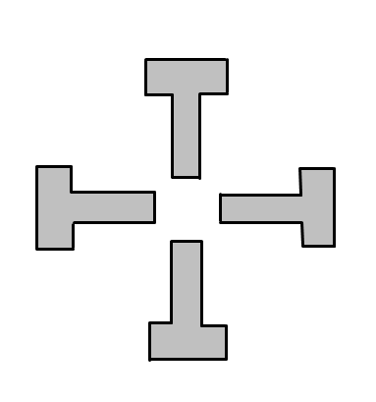

_____ _____ _____ _____

**Extension**: Find the centre of rotation on each of these shapes