**3D SOH CAH TOA GREEN**



The diagram represents a prism.  
*AEFD* is a rectangle.  
*ABCD* is a square.

*EB* and *FC* are perpendicular to plane *ABCD.*

*AB* *=* 60 cm. *AD* *=* 60 cm. Angle *ABE* *=* 90°. Angle *BAE* *=* 30°.

Calculate the size of the angle that the line *DE* makes with the plane *ABCD.*  
Give your answer correct to 1 decimal place.

..........................°

(Total 4 marks)

**2.**



The diagram represents a cuboid *ABCDEFGH*.

*AB* = 5 cm. *BC* = 7 cm. *AE* = 3 cm.

(a) Calculate the length of *AG*.  
Give your answer correct to 3 significant figures.

.................................... cm

(2)

(b) Calculate the size of the angle between *AG* and the face *ABCD*.  
Give your answer correct to 1 decimal place.

........................................°

(2)

(Total 4 marks)

**3D SOH CAH TOA AMBER**

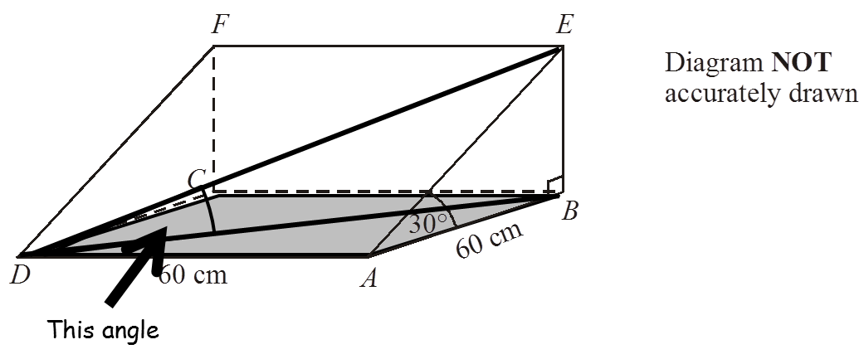

The diagram represents a prism.  
*AEFD* is a rectangle.  
*ABCD* is a square.

*EB* and *FC* are perpendicular to plane *ABCD.*

*AB* *=* 60 cm. *AD* *=* 60 cm. Angle *ABE* *=* 90°. Angle *BAE* *=* 30°.

Calculate the size of the angle that the line *DE* makes with the plane *ABCD.*  
Give your answer correct to 1 decimal place.

..........................°

(Total 4 marks)

**2.**

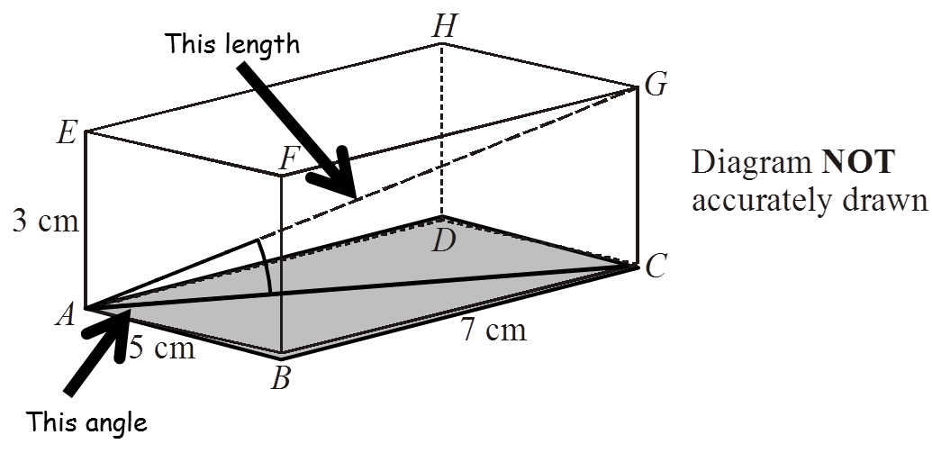

The diagram represents a cuboid *ABCDEFGH*.

*AB* = 5 cm. *BC* = 7 cm. *AE* = 3 cm.

(a) Calculate the length of *AG*.  
Give your answer correct to 3 significant figures.

.................................... cm

(2)

(b) Calculate the size of the angle between *AG* and the face *ABCD*.  
Give your answer correct to 1 decimal place.

........................................°

(2)

(Total 4 marks)

**3D SOH CAH TOA RED**



Start by using Pythagoras’ Theorem with triangle ABD to calculate length BD.

Then use SOHCAHTOA with triangle ABE to calculate the height of the prism.

THEN use SOHCAHTOA with triangle BDE to calculate the angle shown on the diagram.

The diagram represents a prism.  
*AEFD* is a rectangle.  
*ABCD* is a square.

*EB* and *FC* are perpendicular to plane *ABCD.*

*AB* *=* 60 cm. *AD* *=* 60 cm. Angle *ABE* *=* 90°. Angle *BAE* *=* 30°.

Calculate the size of the angle that the line *DE* makes with the plane *ABCD.*  
Give your answer correct to 1 decimal place.

..........................°

(Total 4 marks)

**2.**



Start by using Pythagoras’ Theorem with triangle ABC to calculate length AC.

Then use Pythagoras’ Theorem with triangle ACG to calculate length AG.

The diagram represents a cuboid *ABCDEFGH*.

*AB* = 5 cm. *BC* = 7 cm. *AE* = 3 cm.

(a) Calculate the length of *AG*.  
Give your answer correct to 3 significant figures.

.................................... cm

(2)

(b) Calculate the size of the angle between *AG* and the face *ABCD*.  
Give your answer correct to 1 decimal place.

Use SOHCAHTOA with triangle ACG to calculate the angle shown on the diagram (you have lengths AG and CG already).

........................................°

(2)

(Total 4 marks)