Mathematics Assessment

Bands 5-7 Problem Solving – Test 3
Calculators allowed on questions with this symbol:

Name: ______________________________

Class: ______________________________

Teacher: ______________________________

Remember:
- The test is 1 hour long.
- You will need: pen, pencil, rubber and a ruler.
- Try to answer all questions.
- Write all your answers and working in the spaces provided in this test paper – do not use any rough paper. Marks may be awarded for working.
- Check your work carefully.
- Don’t spend too long on one question. Leave it and try the next one.

Formulae Sheet
Perimeter, area, surface area and volume formulae
Sphere | Cone
Volume = $\frac{4}{3}$ πr³  Surface Area = 4πr² | Volume = $\frac{1}{3}$ πr²h  Curved Surface Area = πrl

1. | A can of paint is 18 cm tall and holds 2.5 L of paint. A similar can is 1.5 times as tall. How much paint does it hold?  _____________ L | / 2
2. | A spherical ball is made from 20 mm of molten steel. Work out its radius. Give your answer correct to the nearest ml.  _______________ ml | / 4
3. | Manjit bought a house. The value of her house went up by 5% in the first year. In the second year the value went up by 2%. At the end of the two years, her house was worth £171 360. Work out how much Manjit paid for her house originally.  £ _______________________ | / 4
4. | A car, initially travelling at a speed of u m/s, accelerates at a constant rate of a m/s². The distance s travelled in t seconds is given by the formula:  s = ut + ½at²  A car joins a motorway travelling at 10 m/s and has a constant accelaration of 0.6 m/s². Work out the distance travelled by the car in 20 seconds.  ______________________ m | / 4
5. | The time taken, t (in seconds), to boil a kettle is inversely proportional to the power, p (in watts), of the kettle. A full kettle of power 1500 W boils the water in 400 seconds. A similar kettle has a power of 2500 W. Can this kettle boil the same amount of water in less than 3 minutes? | / 6
6. | Which 2 of the following lines pass through (0, 3)?  - y = 3x – 3  - 4y – 8x = 12  - 5y = 3x – 15  - 2x – y = 3  - 3x + y = 3 | / 5
7. | 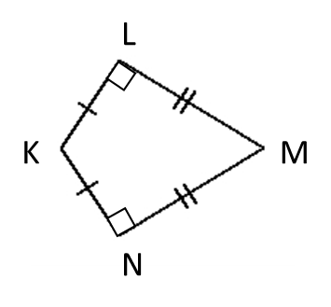  Explain why triangles KLN and MLN are not congruent. | / 3
8. | 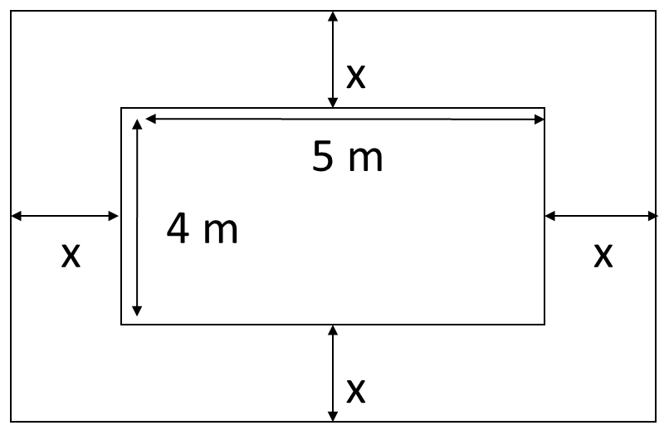  Gerri has a patio that is 4 m by 5 m. She has 10 m² of turf and wants to use it to create a border around the patio that is the same width all the way around. Gerri uses all her turf. Write an equation and solve it to find x.  x = __________________ m | / 7

9. | The diagram shows a square of side length x, and a triangle with a vertex at a perpendicular distance y from one side of the square.  - Find an expression for the shaded area in terms of x and y.  ________________________  - If y = ½x calculate the percentage of the square that is shaded.  ___________ %  - What is the minimum percentage area of the square that can be shaded?  ___________ %  - Explain your answer | / 10

