End of Unit Test Name: ____________________________
Calculations and Accuracy - HIGHER

Q1. Use approximations to estimate the value of

..................................................................................................................................

..................................................................................................................................

..................................................................................................................................

..................................................................................................................................

Answer ......................................................................
(Total 3 marks)
Q2. Use approximations to estimate the value of 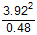

...................................................................................................................................

...................................................................................................................................

...................................................................................................................................

...................................................................................................................................

Answer ......................................................................
(Total 2 marks)
Q3. x = 400 to 1 significant figure.
y = 25 to 2 significant figures.
Work out the maximum integer value of

...................................................................................................................................

...................................................................................................................................

...................................................................................................................................

...................................................................................................................................

...................................................................................................................................

...................................................................................................................................

Answer ......................................................................
(Total 3 marks)

Q4. Luke has a rectangular garden. The length is 40 m. The width is 25 m. Both measurements are given to the nearest metre.
Mira also has a garden. The area is 970 m² to the nearest 10 m². Mira thinks her garden has a bigger area.
Is she correct? Tick a box. You must show your working.

 | Correct |  | Incorrect |  | Cannot tell

...................................................................................................................................

...................................................................................................................................

...................................................................................................................................

...................................................................................................................................

...................................................................................................................................
(Total 3 marks)
Q5. A box is a cuboid with dimensions 27 cm by 15 cm by 20 cm. These dimensions are to the
nearest centimetre. DVD cases are cuboids with dimensions 1.5 cm by 14.3 cm by 19.2 cm. These dimensions are to the nearest millimetre.

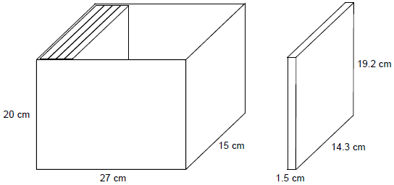

Show that 17 DVD cases, stacked as shown, will definitely fit in the box.

..................................................................................................................................

..................................................................................................................................

..................................................................................................................................

..................................................................................................................................

..................................................................................................................................

..................................................................................................................................

..................................................................................................................................
(Total 4 marks)
Q6. The maximum safe load of a bridge is 1500 kg to the nearest 10 kg. An average soldier is 75 kg to the nearest kilogram. Work out an estimate for the maximum number of soldiers that can safely cross the bridge at the same time.

..................................................................................................................................

..................................................................................................................................

..................................................................................................................................

..................................................................................................................................

..................................................................................................................................

..................................................................................................................................

..................................................................................................................................

..................................................................................................................................

Answer ......................................................................
(Total 5 marks)
(Total for test = 20 marks)

