Linear Graphs from a Table of Values Starter

For each question:
- Complete the table of values using substitution.
- Write the coordinates underneath.
- Plot the coordinates on the given axes with a PENCIL.
- Join the coordinates with a RULER.

1. | $$x$$ | $$0$$ | $$1$$ | $$2$$ | $$3$$ | $$4$$ | $$5$$
 | $$y=x+1$$
 |  | ( ) | ( ) | ( ) | ( ) | ( ) | ( )

2. | $$x$$ | $$0$$ | $$1$$ | $$2$$ | $$3$$ | $$4$$ | $$5$$
 | $$y=2x$$
 |  | ( ) | ( ) | ( ) | ( ) | ( ) | ( )
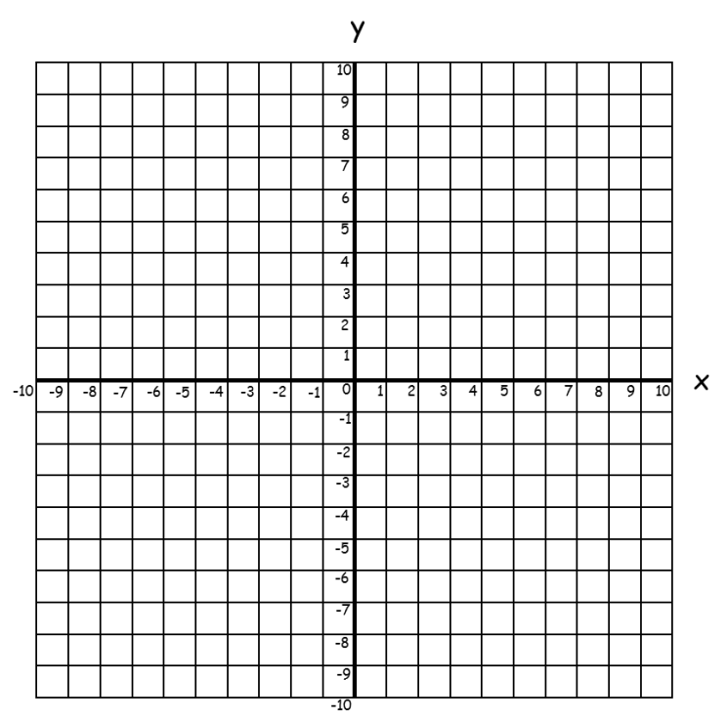
Linear Graphs from a Table of Values Starter

For each question:
- Complete the table of values using substitution.
- Write the coordinates underneath.
- Plot the coordinates on the given axes with a PENCIL.
- Join the coordinates with a RULER.

1. | $$x$$ | $$0$$ | $$1$$ | $$2$$ | $$3$$ | $$4$$ | $$5$$
 | $$y=x+1$$
 |  | ( ) | ( ) | ( ) | ( ) | ( ) | ( )

2. | $$x$$ | $$0$$ | $$1$$ | $$2$$ | $$3$$ | $$4$$ | $$5$$
 | $$y=2x$$
 |  | ( ) | ( ) | ( ) | ( ) | ( ) | ( )

