Calculate the area and perimeter of this rectangle:  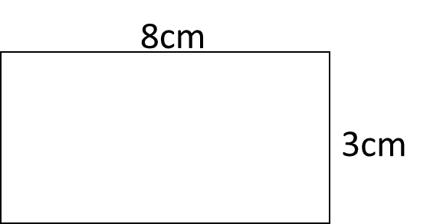 | Calculate the area and perimeter of this rectangle:
Calculate the area and perimeter of this rectangle: | Calculate the area and perimeter of this rectangle:
Calculate the area and perimeter of this rectangle: | Calculate the area and perimeter of this rectangle:
Calculate the area and perimeter of this rectangle: | Calculate the area and perimeter of this rectangle:
Calculate the area and perimeter of this rectangle: | Calculate the area and perimeter of this rectangle:
Calculate the area and perimeter of this rectangle: | Calculate the area and perimeter of this rectangle:
Calculate the area and perimeter of this rectangle: | Calculate the area and perimeter of this rectangle:
Calculate the area and perimeter of this triangle:  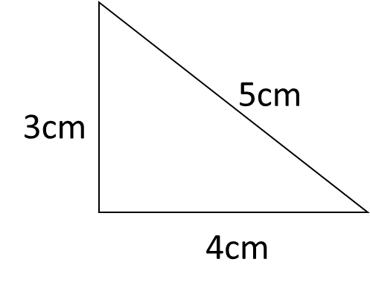 | Calculate the area and perimeter of this triangle:
Calculate the area and perimeter of this triangle: | Calculate the area and perimeter of this triangle:
Calculate the area and perimeter of this triangle: | Calculate the area and perimeter of this triangle:
Calculate the area and perimeter of this triangle: | Calculate the area and perimeter of this triangle:
Calculate the area and perimeter of this triangle: | Calculate the area and perimeter of this triangle:
Calculate the area and perimeter of this triangle: | Calculate the area and perimeter of this triangle:
Calculate the area and perimeter of this triangle: | Calculate the area and perimeter of this triangle:
Calculate the area and perimeter of this compound shape:  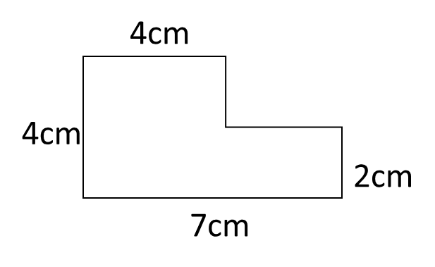 | Calculate the area and perimeter of this compound shape:
Calculate the area and perimeter of this compound shape: | Calculate the area and perimeter of this compound shape:
Calculate the area and perimeter of this compound shape: | Calculate the area and perimeter of this compound shape:
Calculate the area and perimeter of this compound shape: | Calculate the area and perimeter of this compound shape:
Calculate the area and perimeter of this compound shape: | Calculate the area and perimeter of this compound shape:
Calculate the area and perimeter of this compound shape: | Calculate the area and perimeter of this compound shape:
Calculate the area and perimeter of this compound shape: | Calculate the area and perimeter of this compound shape:
Calculate the area of this trapezium:  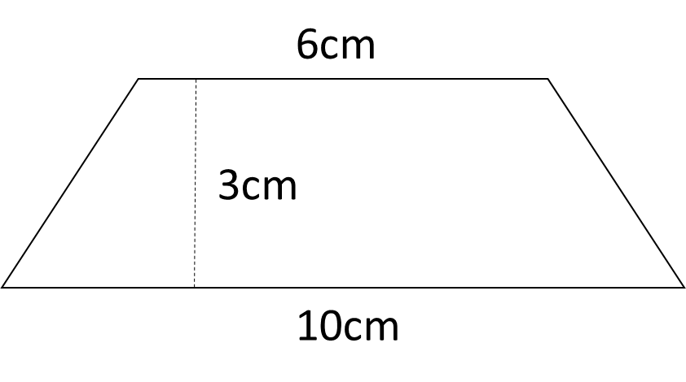 | Calculate the area of this trapezium:
Calculate the area of this trapezium: | Calculate the area of this trapezium:
Calculate the area of this trapezium: | Calculate the area of this trapezium:
Calculate the area of this trapezium: | Calculate the area of this trapezium:
Calculate the area of this trapezium: | Calculate the area of this trapezium:
Calculate the area of this trapezium: | Calculate the area of this trapezium:
Calculate the area of this trapezium: | Calculate the area of this trapezium:
Calculate the area and circumference of a circle with radius 5.5 cm. | Calculate the area and circumference of a circle with radius 5.5 cm.
Calculate the area and circumference of a circle with radius 5.5 cm. | Calculate the area and circumference of a circle with radius 5.5 cm.
Calculate the area and circumference of a circle with radius 5.5 cm. | Calculate the area and circumference of a circle with radius 5.5 cm.
Calculate the area and circumference of a circle with radius 5.5 cm. | Calculate the area and circumference of a circle with radius 5.5 cm.
Calculate the area and circumference of a circle with radius 5.5 cm. | Calculate the area and circumference of a circle with radius 5.5 cm.
Calculate the area and circumference of a circle with radius 5.5 cm. | Calculate the area and circumference of a circle with radius 5.5 cm.
Calculate the area and circumference of a circle with radius 5.5 cm. | Calculate the area and circumference of a circle with radius 5.5 cm.
Calculate the area and perimeter of this shape:  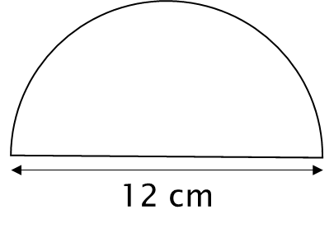 | Calculate the area and perimeter of this shape:
Calculate the area and perimeter of this shape: | Calculate the area and perimeter of this shape:
Calculate the area and perimeter of this shape: | Calculate the area and perimeter of this shape:
Calculate the area and perimeter of this shape: | Calculate the area and perimeter of this shape:
Calculate the area and perimeter of this shape: | Calculate the area and perimeter of this shape:
Calculate the area and perimeter of this shape: | Calculate the area and perimeter of this shape:
Calculate the area and perimeter of this shape: | Calculate the area and perimeter of this shape:
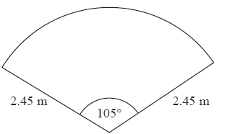  The diagram shows a pond. The pond is in the shape of a sector of a circle. Toby is going to put edging on the perimeter of the pond. Edging is sold in lengths of 1.75 metres. Each length of edging costs £3.49. Work out the total cost of edging Toby needs to buy. | The diagram shows a pond. The pond is in the shape of a sector of a circle. Toby is going to put edging on the perimeter of the pond. Edging is sold in lengths of 1.75 metres. Each length of edging costs £3.49. Work out the total cost of edging Toby needs to buy.
The diagram shows a pond. The pond is in the shape of a sector of a circle. Toby is going to put edging on the perimeter of the pond. Edging is sold in lengths of 1.75 metres. Each length of edging costs £3.49. Work out the total cost of edging Toby needs to buy. | The diagram shows a pond. The pond is in the shape of a sector of a circle. Toby is going to put edging on the perimeter of the pond. Edging is sold in lengths of 1.75 metres. Each length of edging costs £3.49. Work out the total cost of edging Toby needs to buy.
The diagram shows a pond. The pond is in the shape of a sector of a circle. Toby is going to put edging on the perimeter of the pond. Edging is sold in lengths of 1.75 metres. Each length of edging costs £3.49. Work out the total cost of edging Toby needs to buy. | The diagram shows a pond. The pond is in the shape of a sector of a circle. Toby is going to put edging on the perimeter of the pond. Edging is sold in lengths of 1.75 metres. Each length of edging costs £3.49. Work out the total cost of edging Toby needs to buy.
The diagram shows a pond. The pond is in the shape of a sector of a circle. Toby is going to put edging on the perimeter of the pond. Edging is sold in lengths of 1.75 metres. Each length of edging costs £3.49. Work out the total cost of edging Toby needs to buy. | The diagram shows a pond. The pond is in the shape of a sector of a circle. Toby is going to put edging on the perimeter of the pond. Edging is sold in lengths of 1.75 metres. Each length of edging costs £3.49. Work out the total cost of edging Toby needs to buy.
The diagram shows a pond. The pond is in the shape of a sector of a circle. Toby is going to put edging on the perimeter of the pond. Edging is sold in lengths of 1.75 metres. Each length of edging costs £3.49. Work out the total cost of edging Toby needs to buy. | The diagram shows a pond. The pond is in the shape of a sector of a circle. Toby is going to put edging on the perimeter of the pond. Edging is sold in lengths of 1.75 metres. Each length of edging costs £3.49. Work out the total cost of edging Toby needs to buy.
The diagram shows a pond. The pond is in the shape of a sector of a circle. Toby is going to put edging on the perimeter of the pond. Edging is sold in lengths of 1.75 metres. Each length of edging costs £3.49. Work out the total cost of edging Toby needs to buy. | The diagram shows a pond. The pond is in the shape of a sector of a circle. Toby is going to put edging on the perimeter of the pond. Edging is sold in lengths of 1.75 metres. Each length of edging costs £3.49. Work out the total cost of edging Toby needs to buy.
The diagram shows a pond. The pond is in the shape of a sector of a circle. Toby is going to put edging on the perimeter of the pond. Edging is sold in lengths of 1.75 metres. Each length of edging costs £3.49. Work out the total cost of edging Toby needs to buy. | The diagram shows a pond. The pond is in the shape of a sector of a circle. Toby is going to put edging on the perimeter of the pond. Edging is sold in lengths of 1.75 metres. Each length of edging costs £3.49. Work out the total cost of edging Toby needs to buy.

