Mathematics Assessment

Bands 5-7 Problem Solving – Test 2
Calculators allowed on questions with this symbol:

Name: ______________________________

Class: ______________________________

Teacher: ______________________________

Remember:
- The test is 1 hour long.
- You will need: pen, pencil, rubber and a ruler.
- Try to answer all questions.
- Write all your answers and working in the spaces provided in this test paper – do not use any rough paper. Marks may be awarded for working.
- Check your work carefully.
- Don’t spend too long on one question. Leave it and try the next one.

Formulae Sheet
Perimeter, area, surface area and volume formulae
Sphere | Cone
Volume = $\frac{4}{3}$ πr³  Surface Area = 4πr² | Volume = $\frac{1}{3}$ πr²h  Curved Surface Area = πrl

1. | You multiply three powers of 9 together.  What could the indices be when:  - All the indices are the same?  _________ _________ _________  - All the indices are different?  _________ _________ _________ | / 2
2. | A Formula 1 racing car has a top speed of 350 km/h. A peregrine falcon is the fastest bird with a speed of 108 m/s. Which is fastest? Explain your answer. | / 4

3. | The area of triangle ABC is 21 cm². Calculate the size of the obtuse angle ABC. Give your answer to a suitable degree of accuracy.  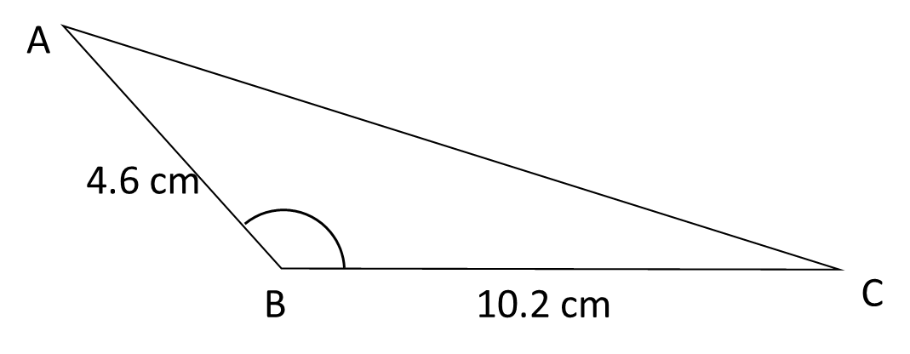  ___________________ ° | / 3
4. | A sheet of A2 paper and a sheet of A4 paper are similar. The area ofa sheet pf A2 paper is 2500 cm² and the area of a sheet of A4 paper is 625 cm². The width of a sheet of A4 paper is 21 cm. What is the width of a sheet of A4 paper?  _________________ cm | / 4
5. | 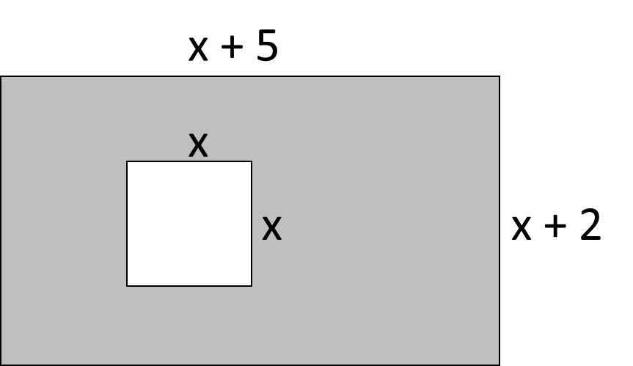  A rectangular piece of paper has length (x + 5) cm and width (x + 2) cm. A square with sides x cm is removed. Find x if the shaded area is 31 cm².  x = ____________ cm | / 4
6. | Rugs come in several shapes and sizes. A small rug has dimensions a x a. A large rug has dimensions 2a x (a + 1). The area of the large rug is 12 m². What are the dimensions of the small rug?  _____________________ | / 7
7. | Some students did a French test and a German test. Here are their results.  French test results:  44 28 39 50 14 20 32 34 20 45 31  German test results:  50 25 38 36 31 22 54 45 51 48 42  On the grid, draw diagrams that could be used to compare the French test results with the German test results.  Make one comparison between the French test results and the German test results. | / 4

8. | The cost of fuel per hour, C (in £), to propel a boat through the water is directly proportional to the cube of its speed, s (in mph). A boat travelling at 10 mph uses £50 of fuel per hour. What is the cost of fuel per hour when the boat is travelling at 5 mph?  £ _____________________ | / 5
9. | 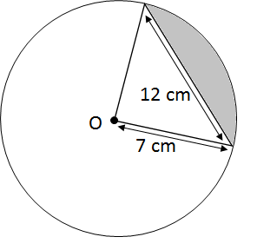  Calculate the area of the shaded segment. Give you answer correct to 3 decimal places.  ____________________ cm² | / 6
10 | A rectangle is placed symmetrically inside a square.  The rectangle has sides of length m and n. Find the area of the square in terms of m and n.  ___________________________________ | / 4

11. | Here is part of the graph of a quadratic function. Find the equation of the graph.  ___________________________ | / 4

