**Calculations and Accuracy (F)**

Intervention Booklet

Name: _______________________________

Class: _______________________________

**Useful websites:**

**www.mathswatchvle.com**

*(Video explanations and questions)*

Username: STH…@twgash

Password: sthmaths

**www.methodmaths.com**

*(Past papers online that get instantly marked)*

Centre ID: wga

Username: firstname

Password: lastname

**www.hegartymaths.com**

*(Online tutorials and quizzes)*

Login: first name and last name are case sensitive

**www.bbc.co.uk/schools/gcsebitesize/maths**

**Directed Numbers**

**Things to remember:**

* Mixed means minus!
* Use a number line – if you’re adding you need to move in a positive direction (right), if you’re subtracting you need to move in a negative direction (left).

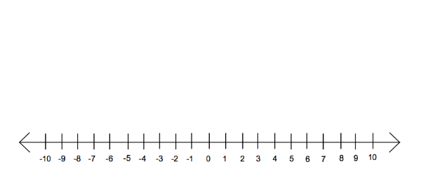

**Questions:**

1. Here is a map of the British Isles.

The temperatures in some places, one night last winter are shown on the map.

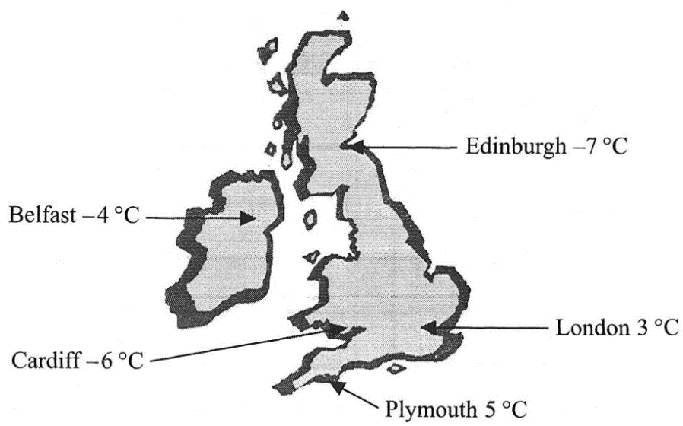

(a) (i) Write down the names of the two places that had the biggest difference in

temperature.

…........................................................

…........................................................

(ii) Work out the difference in temperature between these two places.

….........................°C

**(3)**

(b) Two pairs of places have a difference in temperature of 2 °C.  
Write down the names of these places.

(i) …......................................... and ….............................................

(ii) …......................................... and ….............................................

**(2)**

**(Total 5 marks)**

**2.** Sally wrote down the temperature at different times on 1st January 2003.

|  |  |
| --- | --- |
| **Time** | **Temperature** |
| midnight | – 6 °C |
| 4 am | –10 °C |
| 8 am | – 4 °C |
| noon | 7 °C |
| 3 pm | 6 °C |
| 7 pm | –2 °C |

(a) Write down

(i) the **highest** temperature,

….........................°C

(ii) the **lowest** temperature.

….........................°C

**(2)**

(b) Work out the difference in the temperature between

(i) 4 am and 8 am,

….........................°C

(ii) 3 pm and 7 pm.

….........................°C

**(2)**

At 11 pm that day the temperature had fallen by 5 °C from its value at 7 pm.

(c) Work out the temperature at 11 pm.

….........................°C

**(1)**

**(Total 5 marks)**

**3.** The table shows the temperature on the surface of each of five planets.

|  |  |
| --- | --- |
| **Planet** | **Temperature** |
| Venus | 480 °C |
| Mars | – 60 °C |
| Jupiter | – 150 °C |
| Saturn | – 180 °C |
| Uranus | – 210 °C |

1. Work out the difference in temperature between Mars and Jupiter.

….........................°C

**(1)**

(b) Work out the difference in temperature between Venus and Mars.

….........................°C

**(1)**

(c) Which planet has a temperature 30 °C higher than the temperature on Saturn?

…........................................................

**(1)**

The temperature on Pluto is 20 °C lower than the temperature on Uranus.

(d) Work out the temperature on Pluto.

….........................°C

**(1)**

**(Total 4 marks)**

**4.** (a) Write down the temperature shown on the thermometer.

….........................°C

**(1)**

The temperature falls by 8°C.

(b) Work out the new temperature.

….........................°C

**(1)**

**(Total 2 marks)**

**5.** The table shows the highest and lowest temperatures one day in London and Moscow.

|  |  |
| --- | --- |
| **Highest** | **Lowest** |
| London | 8°C | –6°C |
| Moscow | –3°C | –8°C |

1. Work out the difference between the **lowest** temperature in London and the **lowest**temperature in Moscow.

….........................°C

**(1)**

(b) Work out the difference between the **highest** and **lowest** temperature in London.

….........................°C

**(1)**

**(Total 2 marks)**

**6.** The table shows the midday temperatures in 4 different cities on Monday.

|  |  |
| --- | --- |
| **City** | **Midday temperature (°C)** |
| Belfast | 5 |
| Cardiff | –1 |
| Glasgow | –6 |
| London | –4 |

1. Which city had the lowest temperature?

…........................................................

**(1)**

(b) Work out the difference between the temperature in Cardiff and the temperature in Belfast.

….........................°C

**(1)**

By Tuesday, the midday temperature in London had risen by 7 °C.

(c) Work out the midday temperature in London on Tuesday.

….........................°C

**(1)**

**(Total 3 marks)**

**Place Value**

**Things to remember:**

Label columns as below

|  |  |  |  |  |  |  |
| --- | --- | --- | --- | --- | --- | --- |
| Thousands | Hundreds | Tens | Units |  |  |  |

**Questions:**

**1.** (a) Write the number **seven thousand and twenty five** in figures.

…........................................................

**(1)**

(b) Write the number 9450 in words.

…………………………………………………………………………………………………..

**(1)**

(c) Write the number 28.75 to the nearest whole number.

…........................................................

**(1)**

(d) Write the number 7380 to the nearest thousand.

…........................................................

**(1)**

**(Total for Question is 4 marks)**

**2.** Write down the value of the 3 in the number 4376

…........................................................

**(Total for question = 1 mark)**

**3.** Write down the value of the 3 in 16.35

…........................................................

**(Total for question is 1 mark)**

**4.** (a) Work out 90 ÷ 10

…........................................................

**(1)**

(b) Write these numbers in order of size. Start with the smallest number.

2.8 4.71 0.6 13.4

…………………………………………………………………………………………………..

**(1)**

(c) Write 7⁄10 as a decimal.

…........................................................

**(1)**

**(Total for Question is 3 marks)**

**5.** (a)   Write these numbers in order of size. Start with the smallest number.

3007           4435           399           4011           3333

…………………………………………………………………………………………………..

**(1)**

(b)   Write these numbers in order of size. Start with the smallest number.

3.7           5.62           0.7           14.3

…………………………………………………………………………………………………..

**(1)**

(c)   Write as a decimal.

…........................................................

**(1)**

**(Total for question = 3 marks)**

**6.** Write the following numbers in order of size. Start with the smallest number.

0.61           0.1           0.16           0.106

…………………………………………………………………………………………………..

**(Total for question = 1 mark)**

**BIDMAS**

**Things to remember:**

* BIDMAS is the order in which operations need to be carried out.
* Brackets, indices, division, multiplication, addition, subtraction.

**Questions:**

**1.** Work out

(i) 2 × 3 + 4

...........................................................

(ii) 10 – 2 × 5

...........................................................

(iii) 16 ÷ (2 × 4)

...........................................................

**(Total 3 marks)**

**2.** Beth says 20 − 5 × 3 is 45

Pat says 20 − 5 × 3 is 5

(a) Who is right?  
Give a reason for your answer.

....................................... is right because

…………………………………………………………………………………………………..

…………………………………………………………………………………………………..

**(1)**

(b) Work out (12 + 9) ÷ 3

...........................................................

**(1)**

**(Total 2 marks)**

**3.** Work out

(i) 3 × 3 – 5

...........................................................

(ii) 20 ÷ (12 – 2)

...........................................................

(iii) 7 + 8 ÷ 4

...........................................................

**(Total 3 marks)**

**4.** (a) Work out 2 × (11 + 9)

...........................................................

**(1)**

(b) Work out 3 × 5 + 4

...........................................................

**(1)**

(c) Work out 20 – 5 × 3

...........................................................

**(1)**

**(Total 3 marks)**

**Rounding**

**Things to remember:**

* If the next number is less than 5, round down.
* If the next number is 5 or more, round up.

**Questions:**

**1.** Write the number 2.738 correct to 2 decimal places.

 ...........................................................

**(Total for Question is 1 mark)**

**2.** Write the number **7378** to the nearest hundred.

 ...........................................................

**(Total for Question is 1 mark)**

**3.** 28569 people watch a football match. Write 28569 to the nearest hundred.

 ...........................................................

**(Total for Question is 1 mark)**

**4.** (a) Write 5643 to the nearest hundred.

 ...........................................................

**(1)**

(b) Write 197 768 to the nearest thousand.

 ...........................................................

**(1)**

**(Total for Question is 2 marks)**

**5.** (a) Write the number 28.75 to the nearest whole number.

  ...........................................................

**(1)**

(b) Write the number 7380 to the nearest thousand.

  ...........................................................

**(1)**

**(Total for Question is 4 marks)**

**6.** Write down 157 correct to the nearest 10

...........................................................

**(Total for Question is 1 mark)**

**Estimating Calculations**

**Things to remember:**

* Round each number to one significant figure first (e.g. nearest whole number, nearest ten, nearest one decimal place) – this earns you one mark.
* Don’t forget to use BIDMAS.

**Questions:**

**1.** Work out an estimate for

……………………………………

**(Total for Question is 3 marks)**

**2.** Margaret has some goats.  
 The goats produce an average total of 21.7 litres of milk per day for 280 days.  
 Margaret sells the milk in ½ litre bottles.

Work out an estimate for the total number of bottles that Margaret will be able to fill with the milk.

You must show clearly how you got your estimate.

……………………………………

**(Total for Question is 3 marks)**

**3.** Work out an estimate for the value of

……………………………………

**(Total for Question is 2 marks)**

**4.** Work out an estimate for

……………………………………

**(Total for question = 3 marks)**