Bands 3 – 5 Problem Solving – Test 2 Answers

1. | 3.5 m ÷ 50 cm = 7 slabs  2 m ÷ 50 cm = 4 slabs  7 x 4 = 28 slabs  Matt does have enough  or  3.5 x 2 = 7 m² = 70 000 cm²  50 x 50 = 2500 cm²  70 000 ÷ 2500 = 28 slabs  Matt does have enough | 1 mark for slabs needed for width  1 mark for slabs needed for length  1 mark for 28 seen  1 mark for correct conclusion  or  1 mark for area of patio  1 mark for area of slab  1 mark for 28 seen  1 mark for correct conclusion | 4
2. | 0.7 x $287.50 = $208.25 (30% = $86.25)  £250 = $208.25  £1 = $0.83 | 1 mark for 30% or 70% of New York price calculated  1 mark for London price in dollars  1 mark for correct answer | 3

3. | Scale factor = 2  Area scale factor = 2² = 4  4 x 100 = 400 cm²  or  $πr^{2}$= 100  Radius of A = $\sqrt{\frac{100}{π}}$  Radius of B = $2\sqrt{\frac{100}{π}}$  Area of B = $π$ x ${\left(2\sqrt{\frac{100}{π}}\right)}^{2}$  = $π$ x $4\left(\frac{100}{π}\right)$  = 400 cm² | 1 mark for linear scale factor  1 mark for area scale factor  1 mark for correct answer  or  1 mark for radius of A in terms of $π$  1 mark for expression for area of B  1 mark for correct answer | 3
4. | 5x = x + 24  4x = 24  x = 6 | 1 mark for an equation  1 mark for 4x seen oe  1 mark for correct answer | 3
5. | 17.5 ÷ 5 = 3.5 mph  3.5 x 8 = 28 km  Sunita is correct | 1 mark for distance ÷ time  1 mark for correct answer  1 mark for 28 km seen  1 mark for correct conclusion | 4

6. | Volume of pot = $π$ x 6² x 15 = 1696.46… cm³  1 L = 1000 cm³  15 000 ÷ 1696.46… = 8.84…  8 flowerpots can be filled completely | 1 mark for volume of flowerpot  1 mark for litre/cm³ conversion  1 mark for dividing total compost by volume of flowerpot  1 mark for correct answer | 4
7. | 5 : 1  5 – 1 = 4 parts difference  6 ÷ 4 = 1.5 kg  1.5 x 5 = 7.5 kg | 1 mark for ratio  1 mark for calculating parts difference  1 mark for calculating value of 1 part  1 mark for correct answer | 4
8. | 3h + 3r = 126  - 3h + 2r = 114  r = 12 cm  3h + 36 = 126  h = 30 cm  2r + h = 24 + 30 54 cm  or  Difference is 1 rectangle and 12 cm  3 x 12 = 36  (126 – 36) ÷ 3 = 30 cm  2 x 12 + 30 = 54 cm | 1 mark for 2 equations for r and h  1 mark for r calculated  1 mark for substituting r into either equation  1 mark for h calculated  1 mark for correct answer  or  1 mark for 12 cm calculated  1 mark for 3 x 12  1 mark for subtracting 36 and dividing by 3  1 mark for 30 cm calculated  1 mark for correct answer | 5

9. | Bank A Bank B  £4000 x 1.03² = £4243.60 or £4000 x 0.03² = £243.60 (£4000 x 0.32 x 2) + 4000 = £4256 or (£4000 x 0.32 x 2) = £256  Henry should choose Bank B for more interest | 1 mark for Bank A calculation  1 mark for Bank A answer  1 mark for Bank B calculation  1 mark for Bank B answer  1 mark for correct conclusion (dependent on previous working) | 5
10. | 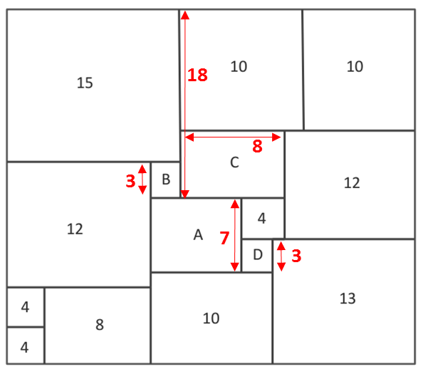  A = 7, B = 3, C = 8, D = 3 | 1 mark for D calculated  1 mark for A calculated  1 mark for C calculated  1 mark for 18 seen  1 mark for B calculated | 5

11. | 30 x £3 = £90 spent  40% of £3 = £1.20  Selling price = £3 + £1.20 = £4.20  $\frac{3}{5}$ of 30 = 18 books sold at £4.20  18 x £4.20 = £75.60  80% of £4.20 = £3.36 (20% = 84p)  12 x £3.36 = £40.32  £75.60 + £40.32 = £115.92  £115.92 - £90 = £25.92 profit  25.92 x 100 = 28.8% profit  90 | 1 mark for total spent  1 mark for new selling price  1 mark for income for this selling price  1 mark for 20% or 80% calculated  1 mark for income at this selling price  1 mark for total profit  1 mark for correct answer (accept percentage only, accept 29%) | 8

