Transformation of graphs investigation

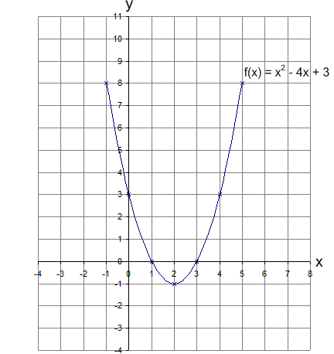
This is the graph of $f(x)=x^{2}-4x+3$

For each question (a) to (f):
- write out the new function;
- fill in the table of values;
- draw and label the graph on the grid above; and
- write down any observations or comparisons to the original graph.

a) $f(x)+2=$
$$x$$ | $$-1$$ | $$0$$ | $$1$$ | $$2$$ | $$3$$ | $$4$$ | $$5$$
$$y$$

b) $f(x+2)=$
$$x$$ | $$-3$$ | $$-2$$ | $$-1$$ | $$0$$ | $$1$$ | $$2$$ | $$3$$
$$y$$

c) $2f(x)=$
$$x$$ | $$-1$$ | $$0$$ | $$1$$ | $$2$$ | $$3$$ | $$4$$ | $$5$$
$$y$$

d) $f(2x)=$
$$x$$ | $$-1$$ | $$0$$ | $$1$$ | $$2$$ | $$3$$
$$y$$

e) $-f(x)=$
$$x$$ | $$-1$$ | $$0$$ | $$1$$ | $$2$$ | $$3$$ | $$4$$ | $$5$$
$$y$$

f) f(-x) =
$$x$$ | $$-5$$ | $$-4$$ | $$-3$$ | $$-2$$ | $$-1$$ | $$0$$ | $$1$$
$$y$$

