Coordinates RED

The picture shows a map of an island. Write down the co-ordinates of all the places.

Remember to start at the origin and go along the corridor and up or down the stairs.
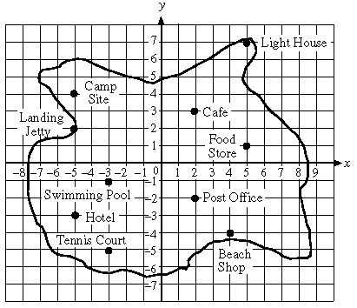

Landing jetty ( ____ , ____ ) Café ( ____ , ____ )

Swimming pool ( ____ , ____ ) Beach shop ( ____ , ____ )

Camp site ( ____ , ____ ) Post office ( ____ , ____ )

Food store ( ____ , ____ ) Light house ( ____ , ____ )

Tennis court ( ____ , ____ ) Hotel ( ____ , ____ )

Coordinates AMBER

The picture shows a map of an island. Write down the co-ordinates of all the places.

Landing jetty ____________ Café ____________

Swimming pool ____________ Beach shop ____________

Camp site ____________ Post office ____________

Food store ____________ Light house ____________

Tennis court ____________ Hotel ____________

Coordinates GREEN
