Bands 1 – 3 Problem Solving – Test 1 Answers

1. | 40 – 35 = 5 hours remaining  50 mins + 2 hrs + 40 mins + 1 hr + 35 mins = 5 hrs 5 mins  Sumire cannot record all 3 programmes | 1 mark for calculating hours remaining  1 mark for adding lengths of 3 shows  1 mark for total time  1 mark for correct conclusion | 4
2. | Flavour Tally Total/frequency  Salt and vinegar |||| 4  Chicken ||| 3  Plain |||| ||| 8  Bovril |||| 5  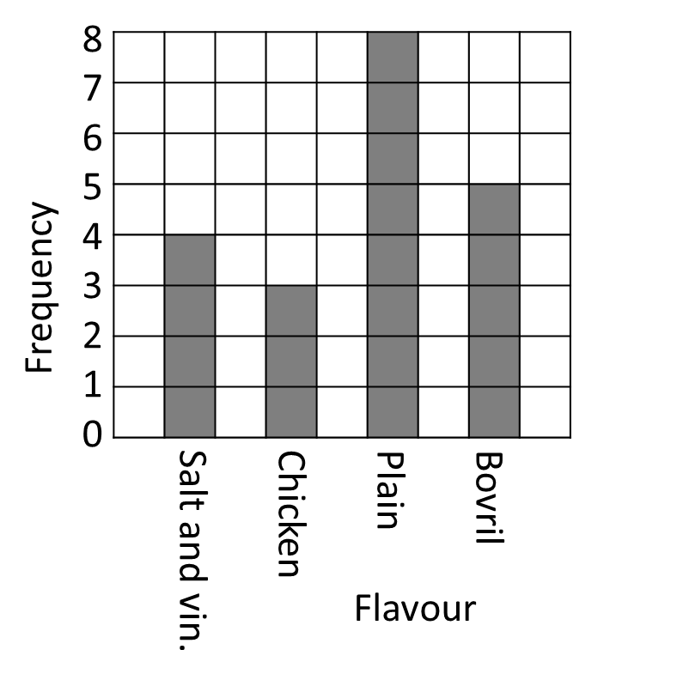 | 3 marks for a tally chart or bar graph  (1 mark for different options)  (1 mark for tally column or correct axes)  (1 mark for total/frequency column or bars of all correct height)  1 mark for “4”  1 mark for “plain” | 5
3. | 40 ÷ 15 = 2 r 10 = 3 minibuses  3 x £30 = £90  £90 + £150 = £240  £240 ÷ 40 = £6 per person | 1 mark for 40 ÷ 15  1 mark for rounding to 3 minibuses  1 mark for cost of 3 minibuses  1 mark for 90 + 150  1 mark for 240 ÷ 40  1 mark for correct answer | 6
4. | ¼ + 20% + 0.15 = 0.25 + 0.2 + 0.15 = 0.6  1 – 0.6 = 0.4 = $\frac{4}{10}$ = $\frac{2}{5}$ | 1 mark for converting all to percentages or decimals  1 mark for subtracting from 1  1 mark for correct answer oe (accept fractions only) | 3
5. | 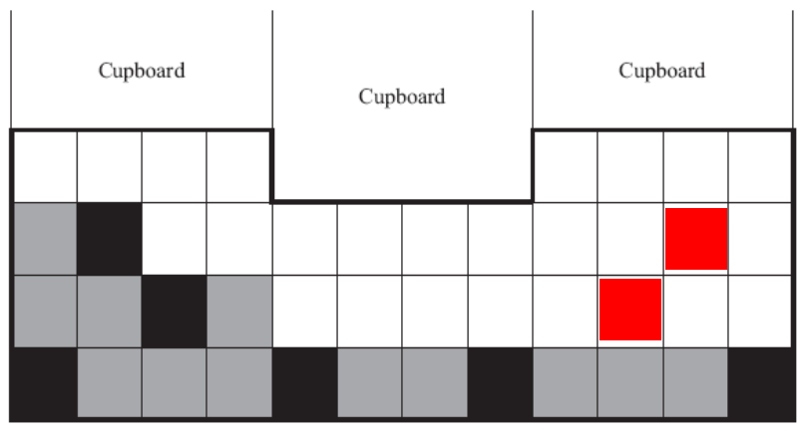  44 grey tiles  £6.20 x 5 = £31.00 | 1 mark for adding 2 tiles to make wall symmetrical  1 mark for adding 2 tiles of their own and maintaining symmetry  1 mark for calculating grey tiles needed  1 mark for £6.20 x 5  1 mark for correct answer | 5

6. | 14 cubes  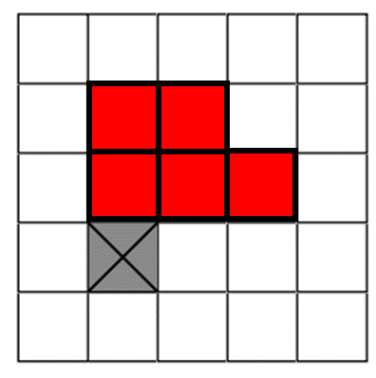 | 1 mark for correct answer  1 mark for correct plan | 2
7. | £80 000 - £60 000 = £20 000  2% of £60 000 = £1200  1% of £20 000 = £200  £1200 + £200 = £1400 | 1 mark for calculating amount to be charged at each rate  1 mark for calculating 2% of £60 000  1 mark for calculating 1% of £20 000  1 mark for correct answer | 4

8. | Multiples of:  12 8 9  24 16 18  36 24 27  48 32 36  60 40 45  72 48 54  84 56 63  96 64 72  108 72 81  120 80 90  72 – 70 = 2 bags | 1 mark for listing multiples of at least 2 of the 3 numbers  1 mark for identifying 72 as the LCM  1 mark for 72 – 70  1 mark for correct answer | 4
9. | First offer: Of 6 pots you pay for 4 pots  Second offer: Of 6 pots you pay for 4.5 pots  First offer is better as pay for fewer pots | 1 mark for calculating with first offer  1 mark for calculating with second offer  1 mark for correct answer  1 mark for reasoning | 4
10. | There are many possibilities, all 5 units (the length of AB) from  either A or B. For example,  (1,6), (2,3), (6,1), (9,2), (10,3), (11,6) and so on  (Note that the perpendicular bisector of AB does not pass  through any point that has whole number coordinates) | 1 mark for each coordinate | 3
11. | $\frac{3}{10}$ = $\frac{90}{300}$  300 – 90 = 210 | 1 mark for calculating 300 counters in total  1 mark for correct answer | 2

12. | Median of 11 so place 11 on middle line  Mode of 12 so place two 12s after 11  Mean of 10 so any two other numbers less than 11 which have a sum of 15 (a + b = 15)  a b 11 12 12 | 1 mark for median calculation  1 mark for mode calculation  1 mark for mean calculation | 3
13. | 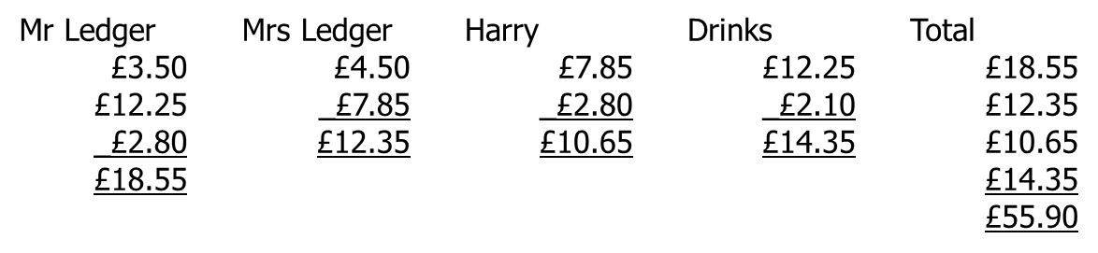  10% of £55.90 = £5.59  £55.90 + £5.59 = £61.49  6% of £7.85  5% = £0.39  1% = £0.08  = £0.47  £7.85 + 47p = £8.32 | 2 marks for calculating total of bill  1 mark for calculating 10% of total  1 mark for correct answer  1 mark for calculating 5% or 1%  1 mark for calculating 6%  1 mark for correct answer | 7

