Bands 4 – 6 Problem Solving – Test 1 Answers

1. | 2 x 3 = 6  2 + 3 = 5  (x + 2)(x + 3) = x² + 5x + 6  8 – 3 = 5  3 x 8 = 24  (x - 3)(x + 8) = x² + 5x - 24 | 1 mark for 2 x 3 oe  1 mark for 2 + 3 oe  1 mark for each correct gap  1 mark for 8 – 3 oe  1 mark for 3 x 8 oe  1 mark for each correct gap | 8

2. | 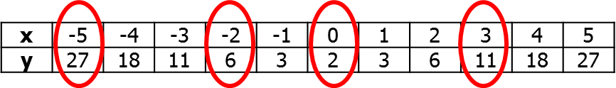  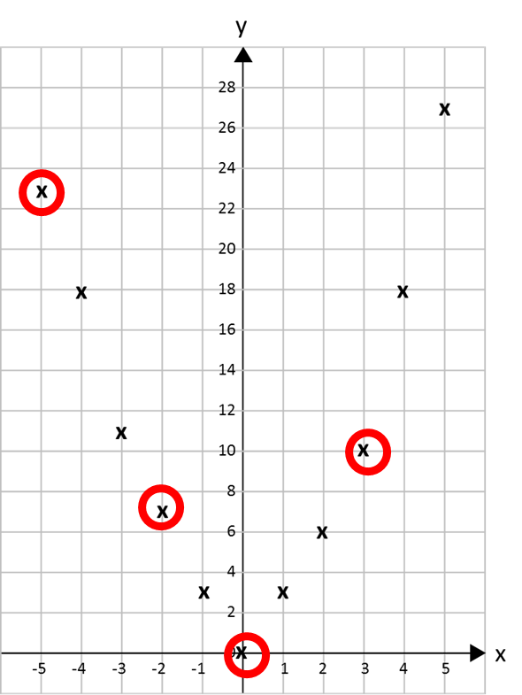 | 4 marks for all correct coordinates in table of values (3 marks for at least 9, 2 marks for at least 6, 1 mark for at least 3 correct)  2 marks for 4 coordinates identified as incorrect (1 mark for at least 2) | 6

3. | a x ${1.3}^{7}$ = 3500  a = 3500 ÷ ${1.3}^{7}$ = 557.782… = 558 insects | 1 mark for ${1.3}^{7}$ seen  1 mark for identifying 3500 as the outcome  1 mark for dividing  1 mark for 557 seen  1 mark for correct answer | 5
4. | ½ x 5 x 5 x sin68 = 11.5897… = 11.6 cm² | 1 mark for correct substitution into  ½ ab sinC  1 mark for 11 seen  1 mark for correct answer | 3
5. | 2 x 7 = 14 cm diameter  9 = $\frac{x}{360}$ x 14 x $π$  x = 9 x 360 ÷ 14 ÷ $π$ = 73.6660022… = 73.7° | 1 mark for calculating diameter  1 mark for substituting into formula  1 mark for x 360, ÷ 14 or ÷ $π$  1 mark for 73 seen  1 mark for correct answer | 5
6. | P α d  0.8 = k x 8  k = 0.1  P = 0.1d  P = 0.1 x 75 = 7.5 bars  Yes, the watch will still work | 1 mark for proportion sentence  1 mark for substitution to find k  1 mark for formula written  1 mark for substitution into formula  1 mark for 7.5 bars seen  1 mark for correct conclusion | 6
7. | y = x – 1 and y = ½x + 7  x – 1 = ½x + 7  2x – 2 = x + 14  x = 16  y = x – 1 = 16 – 1 = 15  (16, 15) | 1 mark for each equation written  1 mark for equation set up for both graphs  1 mark for x calculated  1 mark for x substituted  1 mark for y calculated  1 mark for correct answer | 7
8. | To calculate 2nd pair:  a + b = 1  a – b = 2 +  2a = 3_  So a = 1.5 and b = -0.5 (1.5, -0.5)  To calculate 1st pair:  a + b = 1.5  a – b = -0.5 +  2a = 1____  So a = 0.5 and b = 1 (0.5, 1)  To calculate 6th pair:  2 + 4 = 6 and 2 – 4 = -2 (6, -2) | 1 mark for 2 equations for 2nd coordinate  1 mark for x  1 mark for y  1 mark for 2 equations for 1st coordinate  1 mark for x  1 mark for y  1 mark for 6th coordinate | 7

