Inequalities (H)

Post-Intervention Assessment

Name: _______________________________

Class: _______________________________

Date: _______________________________

Question | Objective | RAG
1 | Represent linear inequalities graphically
2 | Solve quadratic inequalities

1. On the grid below, show by shading, the region defined by the inequalities
x + y < 6 x > − 1 y > 2
Mark this region with the letter R.
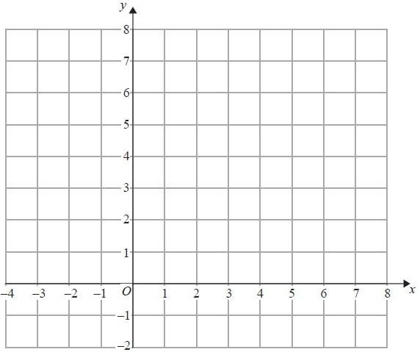

2. Solve the inequality x² - x ≥ 12

...........................................................

[Glue here]

