[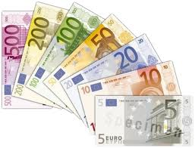](http://www.google.co.uk/imgres?q=euro&safe=vss&biw=1366&bih=651&tbm=isch&tbnid=j5Wtt9zkYGqfrM:&imgrefurl=http://commons.wikimedia.org/wiki/File:Euro_banknotes.png&docid=TuBo_z_e3F3EnM&imgurl=http://upload.wikimedia.org/wikipedia/commons/b/be/Euro_banknotes.png&w=479&h=366&ei=Idd3Uc37LOie0QXo64HICw&zoom=1&ved=1t:3588,r:5,s:0,i:101&iact=rc&dur=1795&page=1&tbnh=184&tbnw=241&start=0&ndsp=16&tx=130&ty=82)I came home with some money in my pocket! Hooray! [](http://en.wikipedia.org/wiki/File:Flag_of_Europe.svg)

[Australia](http://www.theodora.com/flags/australia_flag.html)Work out how much of each currency I have left.

[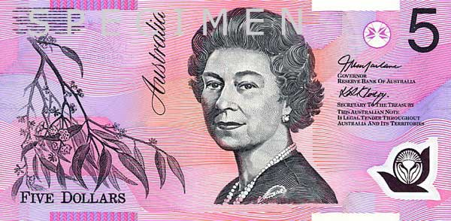](http://www.google.co.uk/url?sa=i&rct=j&q=australian+dollar&source=images&cd=&cad=rja&docid=9_aIO6UypZ5-YM&tbnid=5I5n5HJluTFJPM:&ved=0CAUQjRw&url=http://www.reference4kids.com/currencies/australian_dollar.html&ei=stV3UcX1LaGn0QXc9oCwAg&psig=AFQjCNH_2Ityh0a8-7--9PYnez3eS38S2w&ust=1366894253378327)[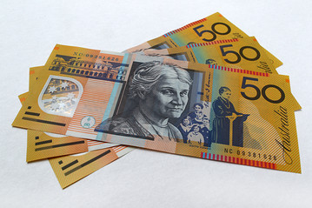](http://www.google.co.uk/url?sa=i&rct=j&q=australian+dollar&source=images&cd=&cad=rja&docid=jzJ59j2JiY5DwM&tbnid=P2MNgTUxv0-5nM:&ved=0CAUQjRw&url=http://blogs.wsj.com/dealjournalaustralia/2012/10/24/aussie-dollar-en-route-to-new-highs-says-citi/&ei=S9V3Ua7dFseO0AXEgIH4DQ&psig=AFQjCNH_2Ityh0a8-7--9PYnez3eS38S2w&ust=1366894253378327)

[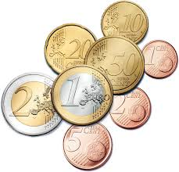](http://www.google.co.uk/imgres?q=euro&safe=vss&biw=1366&bih=651&tbm=isch&tbnid=e7Osqc6tvlKm5M:&imgrefurl=http://globetribune.info/2011/06/21/euro-grek-financial-crisis-german-reunification-european-union/euro-coins-version-ii/&docid=7DNk1Cmk3NR8lM&imgurl=http://globetribune.info/wp-content/uploads/2011/06/euro-coins-version-ii.png&w=1389&h=1331&ei=Idd3Uc37LOie0QXo64HICw&zoom=1&ved=1t:3588,r:10,s:0,i:116&iact=rc&dur=1554&page=1&tbnh=180&tbnw=187&start=0&ndsp=16&tx=93&ty=97)

[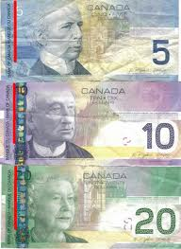](http://www.google.co.uk/imgres?q=canada+dollar&safe=vss&biw=1366&bih=651&tbm=isch&tbnid=YGNkrKFK28B_RM:&imgrefurl=http://richinwriters.com/canadian-dollar-backed-gold/&docid=kGbe_HPo17nryM&imgurl=http://richinwriters.com/Canada%20Money.jpg&w=590&h=808&ei=p9Z3UY_yAaWG0AWexYHYCg&zoom=1&ved=1t:3588,r:37,s:0,i:207&iact=rc&dur=2579&page=3&tbnh=166&tbnw=121&start=37&ndsp=20&tx=29&ty=85)[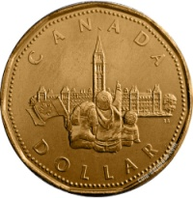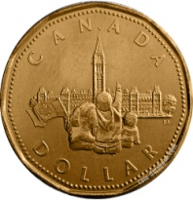](http://www.google.co.uk/url?sa=i&rct=j&q=canada+dollar&source=images&cd=&cad=rja&docid=Z-mVwlYBBHehXM&tbnid=9v-jZh5Rv4v1QM:&ved=0CAUQjRw&url=http://www.coin-database.com/series/canada-commemorative-loonies-1-dollar.html&ei=59Z3UbkPyKXTBbvNgZgC&psig=AFQjCNFRz6ZO8je2v1laRYf_6fQpB7eFJg&ust=1366894631362489)Canada

[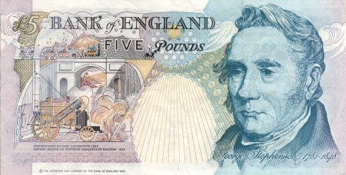](http://www.google.co.uk/url?sa=i&rct=j&q=british+currency&source=images&cd=&cad=rja&docid=S53MJBk8-eNmZM&tbnid=XtN2QC6m9G7zWM:&ved=0CAUQjRw&url=http://abstract.desktopnexus.com/wallpaper/1371613/&ei=u9t3UfvVN-SA0AXP94GgDg&psig=AFQjCNGiL1cNyjX0Aw1pwLlb-4XyIjOhUA&ust=1366895206531484)[United Kingdom](http://www.theodora.com/flags)

[](http://www.google.co.uk/url?sa=i&rct=j&q=canada+dollar&source=images&cd=&cad=rja&docid=Z-mVwlYBBHehXM&tbnid=9v-jZh5Rv4v1QM:&ved=0CAUQjRw&url=http://www.coin-database.com/series/canada-commemorative-loonies-1-dollar.html&ei=59Z3UbkPyKXTBbvNgZgC&psig=AFQjCNFRz6ZO8je2v1laRYf_6fQpB7eFJg&ust=1366894631362489)

[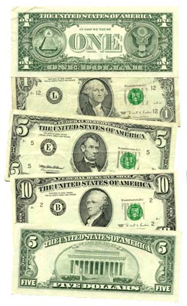](http://www.google.co.uk/url?sa=i&rct=j&q=american+dollar&source=images&cd=&cad=rja&docid=2H1isyXoHUWDYM&tbnid=TDIApHI5MCEPjM:&ved=0CAUQjRw&url=http://en.wikipedia.org/wiki/History_of_the_United_States_dollar&ei=L9h3UYHZNYjJ0AX8zoCQBQ&psig=AFQjCNGTeuqm2OBpZlzR2-JtA-ZkQ_WDCA&ust=1366895015279946)

[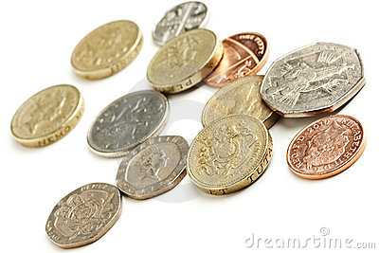](http://www.google.co.uk/url?sa=i&rct=j&q=british+currency&source=images&cd=&cad=rja&docid=iWN6_AhtvPlGCM&tbnid=JBukQ454SC5HDM:&ved=0CAUQjRw&url=http://www.dreamstime.com/royalty-free-stock-photography-british-currency-coins-image20549547&ei=5Np3UaznOYjL0QWp-4DoBg&psig=AFQjCNGiL1cNyjX0Aw1pwLlb-4XyIjOhUA&ust=1366895206531484)

Now change all the currency to British pounds to see how much money I have now!

[United States](http://www.theodora.com/flags/united_states_flag.html)