Inequalities (F)

Post-Intervention Assessment

Name: _______________________________

Class: _______________________________

Date: _______________________________

Question | Objective | RAG
1 | Represent a set of solutions on a number line
2 | Solve linear inequalities
3 | Represent linear inequalities graphically

1. –4 < n ≤ 1
n is an integer.
(a) Write down all the possible values of n.

…........................................................

(b) Write down the inequalities represented on the number line.
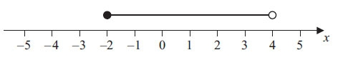

…........................................................

2. Solve 5x + 3 > 19

...........................................................

3. On the grid below, show by shading, the region defined by the inequalities
x + y < 6 x > − 1 y > 2
Mark this region with the letter R.
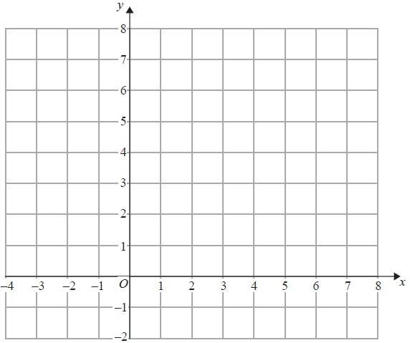

[Glue here]

