Mathematics Assessment

Baseline Assessment
Calculators not allowed

Name: ______________________________

Class: ______________________________

Teacher: ______________________________

Remember:
- The test is 1 hour long.
- You must not use a calculator for any question in this test.
- You will need: pen, pencil, rubber and a ruler.
- Try to answer all questions.
- Write all your answers and working in the spaces provided in this test paper – do not use any rough paper. Marks may be awarded for working.
- Check your work carefully.
- Don’t spend too long on one question. Leave it and try the next one.

1. | -3 - 6 = ____ 4 x -3 = ____ | / 2
2. | Work out 3.2 x 1.7  _____ | / 3
3. | Write the value of the 5 in the number 65 498.  __________________________ | / 1
4. | 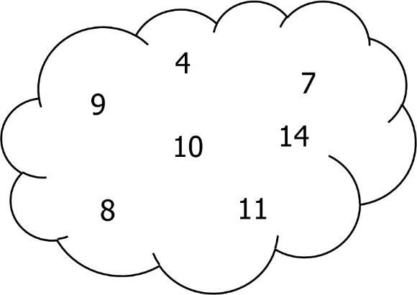  From the bubble above, write down:  A factor of 12 ___ A multiple of 3 ___ A prime number ___ | / 3
5. | 4² = ____ √81 = ____ | / 2
6. | Work out:  2 × 3 + 4 = ____  10 – 2 × 5 = ____  16 ÷ (2 × 4) = _____ | / 3
7. | Round 4.561 to 1 decimal place.  ______ | / 1
8. | Find the highest common factor of 12 and 18.  ______ | / 3
9. | Use the information that 257 × 34 = 8738 to find the value of  2.57 × 34 = _______  873.8 ÷ 2.57 = _______ | / 2
10. | Circle the two fractions below that are equivalent to $\frac{1}{4}$.  $\frac{10}{300}$ $\frac{2}{8}$ $\frac{4}{12}$ $\frac{1}{40}$ $\frac{4}{16}$ | / 2
11. | Put these decimals in order from smallest to largest.  0.28 0.82 0.208 0.08 0.802  ____ ____ ____ ____ ____ | / 2
12. | Write the ratio 6 : 15 in its simplest form.  ____:____ | / 1
13. | Write these fractions in order of size, starting with the smallest.  $\frac{5}{8}$ $\frac{2}{3}$ $\frac{3}{4}$ $\frac{3}{5}$  ____ ____ ____ ____ | / 2
14. | Calculate:  $\frac{7}{10}$ of £40 £______  16% of 70g ______g | / 4

15. | Complete the table below:  Fraction Decimal Percentage  $\frac{2}{5}$ 0.4  $\frac{1}{2}$ 50%  0.65 65% | / 3
16. | Work out and write in their simplest form:  $\frac{1}{5}$ + $\frac{2}{3}$  1 $\frac{1}{3}$ x 2 $\frac{3}{8}$ | / 5
17. | The normal cost of a pair of boots is £120.  In a sale the cost of the boots is reduced by 45%.  Work out the sale price of the boots.  £________ | / 3
18. | Write these numbers in order of size. Start with the smallest number.  26% $\frac{1}{4}$ 0.3 $\frac{1}{3}$ $\frac{2}{5}$  ____ ____ ____ ____ ____ | / 2
19. | Paul is making grey paint. He mixes black and white paint in the ratio 1: 3. He makes 60 litres of grey paint. How much white paint does he use?  ____ litres | / 3

