Band 5 – Test 3 Answers

1. | 0.91² = 83%  0.91³ = 75%  0.91⁴ = 69%  0.91⁵ = 62%  0.91⁶ = 57%  0.91⁷ = 52%  0.91⁸ = 47%  8 years | 1 mark for 2 trials correct  1 mark for trials up to 8 years  1 mark for correct answer | 3
2. | q α 1  t²  q = k  t²  8.5 = k  4²  k = 136  q = 136  t²  q = 136 = 5.44  5² | 1 mark for calculating k  1 mark for correct formula  1 mark for substituting t  1 mark for correct answer | 4
3. | $${\frac{9}{4}}^{3/2}= {\sqrt{\frac{9}{4}}}^{3}= {\frac{3}{2}}^{3}= \frac{27}{8}$$ | 1 mark for √  1 mark for cubing answer | 2
4. | (4 x 10³) ÷ (8 x 10⁵)  = 4 ÷ 8 x 10⁻²  = 0.5 x 10⁻²  = 5 x 10⁻³ | 1 mark for 0.5 or 5 seen  1 mark for correct answer | 2
5. | x -2 -1 0 1 2  y -14 -4 0 4 14  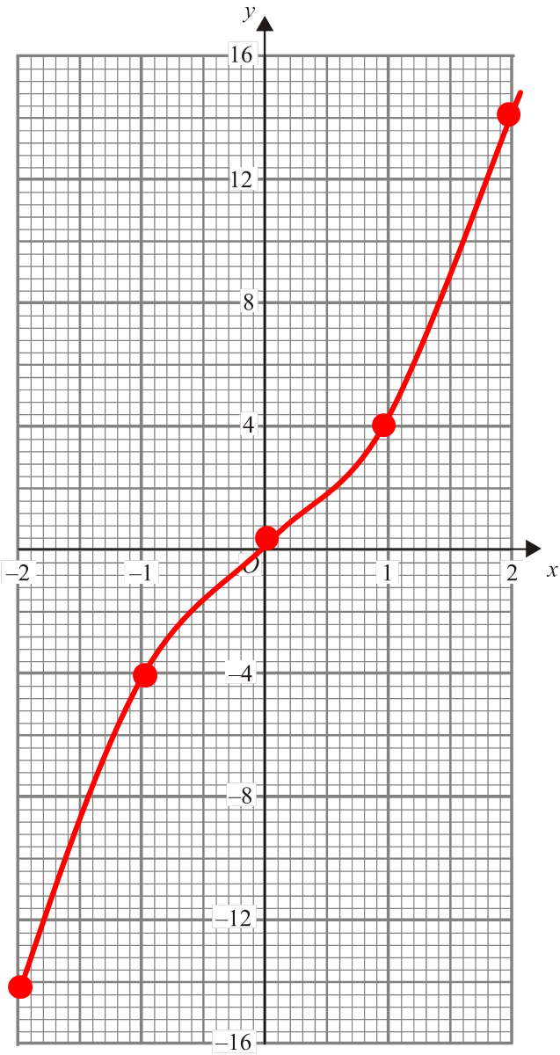 | 1 mark for 2 y values correct  Or 2 marks for all y values correct  1 mark for correct coordinates plotted  1 mark for correct graph drawn | 4

6. | L₂: y = 2x + c  4 = 2(3) + c  c = -2  y = 2x - 2 |  | 1 mark for calculating gradient  1 mark for substituting to find c  1 mark for correct answer | 3
7. | (x – 8)(x + 5)  x = 8 or -5 |  | 1 mark for 5 or 8 seen  1 mark for correct factorisation  1 mark for correct answer | 3
8. | 3x + y = 1 x1  x – 2y = 19 x3  3x + y = 1  3x – 6y = 57 -  7y = -56  y = -8___  3x + y = 1  3x – 8 = 1  3x = 9  x = 3 | 3x + y = 1 x2  x – 2y = 19 x1  6x + 2y = 2  x – 2y = 19 +  7x = 21  x = 3_____  3x + y = 1  9 + y = 1  y = -8 | 1 mark for scaling up correctly  1 mark for calculating 1 variable  1 mark for correct substitution  1 mark for calculating other variable  0 marks if non-algebraic method used | 4
9. | __x__ = p  x + c q  xq = p(x + c)  xq = px + pc  xq – px = pc  x(q – p) = pc  x = _pc_  q + p |  | 1 mark for multiplying by denominators  1 mark for expanding brackets  1 mark for factorising  1 mark for correct answer | 4
10. | 3t + 1 < t + 12  2t + 1 < 12  2t < 11  t < 5.5 |  | 1 mark for 5.5 oe  1 mark for correct inequality symbol used | 2
11. | AB = BC = CD = AD as per diagram with equal lengths  BD shared by both triangles  SSS proves congruence |  | 1 mark for AB = BC = CD = AD  1 mark for BD  1 mark for SSS oe in words | 3
12. | 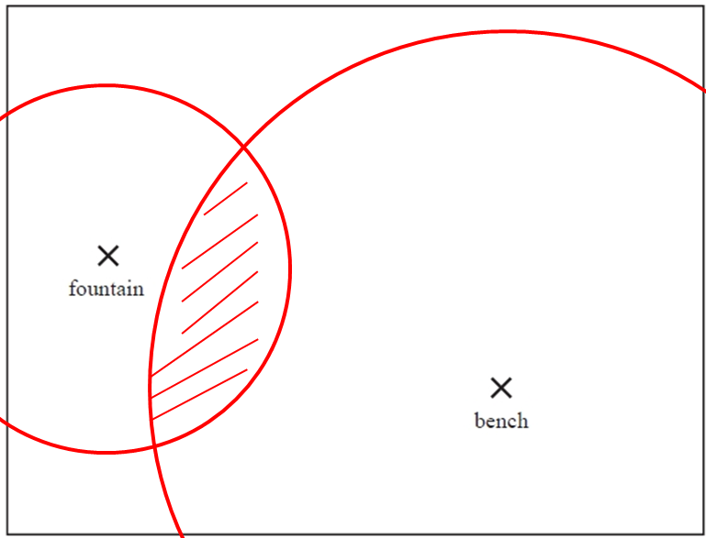 |  | 1 mark for line 1.5 cm from patio  1 mark for circle radius 3 from pond  1 mark for correct region shaded | 3
13. | x = cos⁻¹(3.9 ÷ 4.7) = 33.923112… = 33.9º |  | 1 mark for use of cos  1 mark for correct working  1 mark for correctly rounded answer | 3

14. | 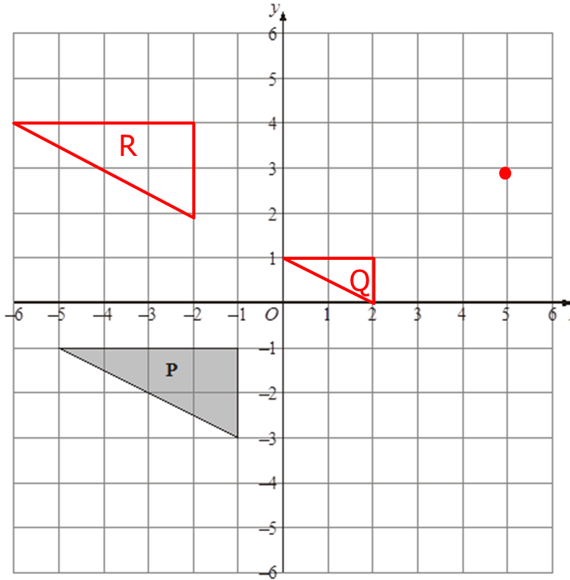 | 1 mark for identifying C of E  1 mark for correct enlargement of ½  1 mark for enlargement in correct place  1 mark for correct x movement  1 mark for correct y movement | 5
15. | 15 = _Θ_ x 20 x π  360  Θ = 15 ÷ 20 ÷ π x 360 = 85.943669… = 85.9º | 1 mark for equal to 15  1 mark for correct working  1 mark for correct answer | 3
16. | l = $\sqrt{{12}^{2}+ 5^{2}}$ = 13  π x 5 x 13 = 204.20352… = 204.20 cm² | 1 mark for Pythagoras to calculate l  1 mark for correct working  1 mark for correct answer | 3

17. | 8 x 2.5 = 20 cm  15 ÷ 2.5 = 6 cm | 1 marks for each correct working  1 mark for each correct answer | 4
18. | Number of cups of coffee Frequency M x f  29 2 58  30 5 150  31 2 62  32 1 32  Mean = 302 = 30.2 pins  10 | 1 mark for correct third column  1 mark for Σmf  Σf  1 mark for correct answer rounded correctly | 3
19. | _399_ x 70 = 19.24879… = 19 students  1451 | 1 mark for correct working  1 mark for correct answer | 2
20. | 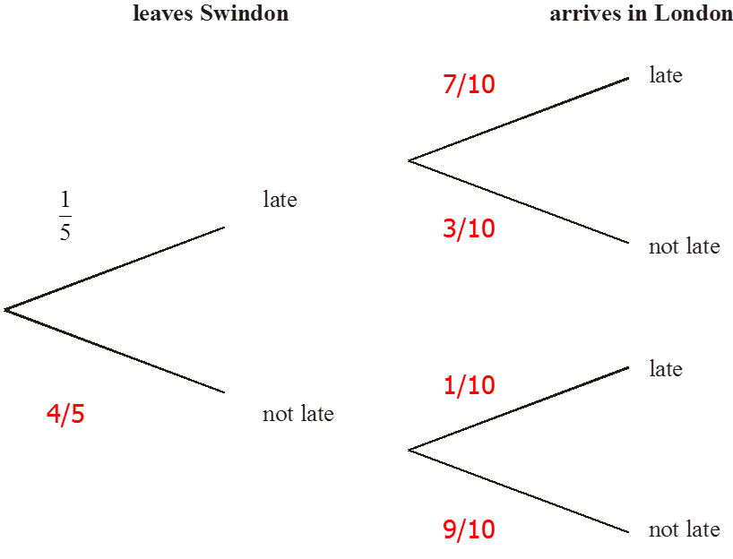  P(L and L or nL and L or L and nL)  = 1 x 7 + 4 x 1 + 1 x 3 = 7 + 4 + 3 = 14  5 10 5 10 5 10 50 50 50 50 | 1 mark for 1st train correct  1 mark for 2nd train correct  1 mark for correct working  1 mark for correct answer | 4

