Histograms Plenary

What are the differences between bar chart and histograms?

Category | Bar Chart | Histogram
 | 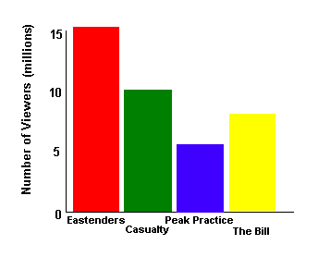 | 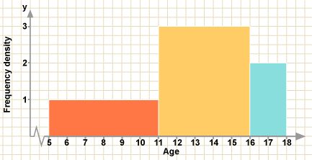
Bars
$x$-Axis
$y$-Axis

Histograms Plenary

What are the differences between bar chart and histograms?

Category | Bar Chart | Histogram
Bars
$x$-Axis
$y$-Axis

