Mathematics Assessment

Bands 4-6 Problem Solving – Test 3
Calculators allowed on questions with this symbol:

Name: ______________________________

Class: ______________________________

Teacher: ______________________________

Remember:
- The test is 1 hour long.
- You will need: pen, pencil, rubber and a ruler.
- Try to answer all questions.
- Write all your answers and working in the spaces provided in this test paper – do not use any rough paper. Marks may be awarded for working.
- Check your work carefully.
- Don’t spend too long on one question. Leave it and try the next one.

Formulae Sheet
Perimeter, area, surface area and volume formulae
Sphere | Cone
Volume = $\frac{4}{3}$ πr³  Surface Area = 4πr² | Volume = $\frac{1}{3}$ πr²h  Curved Surface Area = πrl

1. | An aerial photograph shows a campsite with a swimming pool. In the photograph, the pool measures 5 cm x 2 cm. The real pool in 25 m long. How wide is it?  ________ m | / 3
2. | 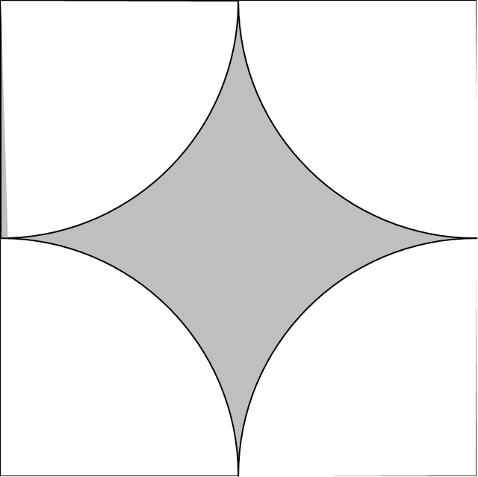  Four quarter circles are cut from a 10 cm square. Work out the shaded area and give your answer correct to 2 decimal places.  __________ cm² | / 5
3. | Will says that ${25}^{{-1}/2}$ x ${64}^{2/3}$ = 80. Show that Will is wrong. | / 5
4. | A roof truss is made of wood. The vertical support bisects the horizontal span. Work out the total length of wood needed to make the truss. Give your answer correct to 1 decimal place.  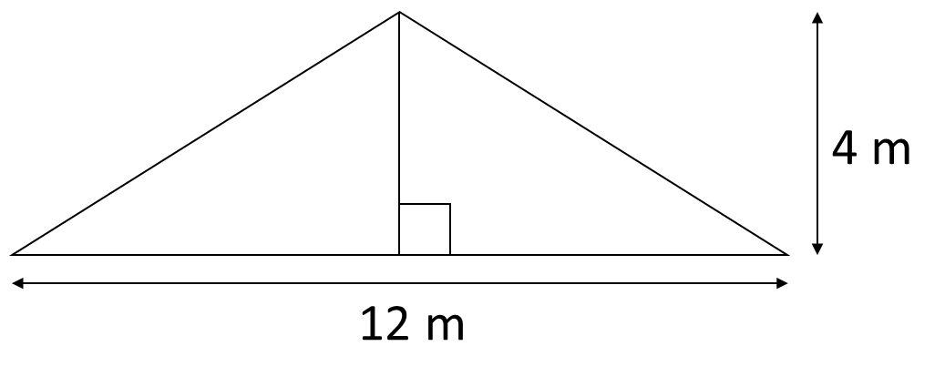  ____________ m | / 4
5. | Two meals and a bottle of wine cost £36. The bottle of wine costs £3 more than a meal. How much do each cost?  Wine: £ __________  Meal: £ __________ | / 6
6. | The lines A and B are parallel. What is the equation of line B?  ________________________ | / 5
7. | 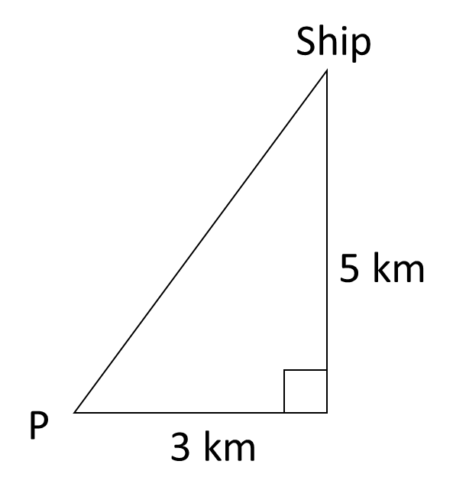  From P, a ship sails 3 km East and 5 km North to its destination. A helicopter flies from P directly to the ship. On what bearing from P should the helicopter fly? Give your answer correct to the nearest degree.  __________° | / 5
8. | In a circuit, the resistance, R ohms, is inversely proportional to the current, I amps. When the resistance is 12 ohms, the current in the circuit is 8 amps. Find the current when the resistance in the circuit is 6.4 ohms.  _______________ amps | / 5
9. | The diagram shows a rectangle EFGH. Length EF is 24 cm. width FG is 3cm. The length of the rectangle decreases by 40% and the width increases by 30%. What is the overall percentage change to the area of the rectangle?  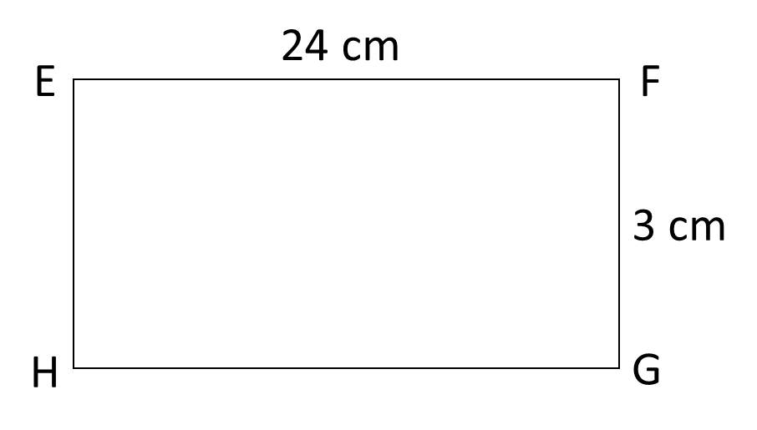  _________ % _______________________ | / 8

