Problem Solving with Probability

Name: _____________________________________
Class: _____________________________________

Time: 1 hour 20 mins
Total marks available: 70 | Total marks achieved: _____

Q1.
* There are only black balls and white balls in bag A and in bag B, as shown in the diagram.
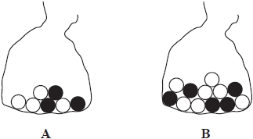
Heidi is going to take at random a ball from bag A and a ball from bag B.
Which bag gives Heidi the greater probability of taking a black ball, bag A or bag B?
You must show how you get your answer.

(Total for question = 3 marks)
Q2.
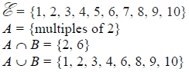
Draw a Venn diagram for this information.

(Total for question is 4 marks)
Q3.
Here are the heights, in centimetres, of 15 children.
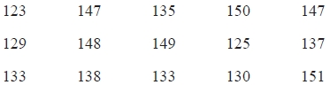
(a) Show this information in a stem and leaf diagram.
(3)
One of the children is chosen at random.
(b) What is the probability that this child has a height greater than 140 cm?
...........................................................
(2)

(Total for question is 5 marks)

Q4.
There are 3 counters in a bag. One counter is red.  One counter is green.  One counter is blue. Mike takes at random a counter from the bag.  He puts the counter back in the bag. Then Ellie takes at random a counter from the bag. (a) Is Ellie more likely to take a blue counter from the bag than Mike?  You must explain your answer. | 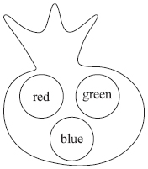
..............................................................................................................................................

..............................................................................................................................................
(1)
(b) Write a list of all the possible combinations of the two counters that Mike and Ellie can take.
..............................................................................................................................................

..............................................................................................................................................
(2)
(c) Find the probability that Mike takes a blue counter and then Ellie takes a green counter.

..............................................................................................................................................
(1)
(Total for Question is 4 marks)

Q5.
There are 9 white beads and 11 red beads in a bag.
There are no other beads in the bag.
Jim takes at random a bead from the bag.
(a) Write down the probability that the bead will be white.
...........................................................
(2)
There are 9 green beads and 11 blue beads in a box.
Jim adds 10 more beads to this box.
Jim is going to take at random a bead from the 30 beads in the box.
The probability that he will take a green bead is
(b) Work out how many green beads Jim adds to the box.
...........................................................
(3)

(Total for question = 5 marks)

Q6.
Four friends each throw a biased coin a number of times.
The table shows the number of heads and the number of tails each friend got.
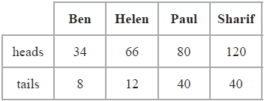
The coin is to be thrown one more time.
(a) Which of the four friends' results will give the best estimate for the probability that the coin will land heads?
Justify your answer.
.............................................................................................................................................
.............................................................................................................................................
.............................................................................................................................................
(1)
Paul says,
"With this coin you are twice as likely to get heads as to get tails."
(b) Is Paul correct?
Justify your answer.
.............................................................................................................................................
.............................................................................................................................................
.............................................................................................................................................
(2)
The coin is to be thrown twice.
(c) Use all the results in the table to work out an estimate for the probability that the coin will land heads both times.
...........................................................
(2)

(Total for question is 5 marks)
Q7.
David has designed a game.
He uses a fair 6–sided dice and a fair 5–sided spinner.
The dice is numbered 1 to 6
The spinner is numbered 1 to 5
Each player rolls the dice once and spins the spinner once.
A player can win £5 or win £2
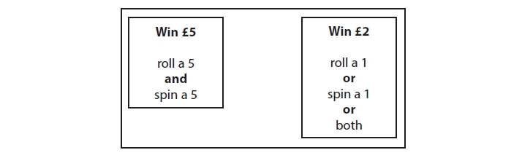
David expects 30 people will play his game.
Each person will pay David £1 to play the game.
(a) Work out how much profit David can expect to make.
£ ...........................................................
(4)
(b) Give a reason why David's actual profit may be different to the profit he expects to
make.
.............................................................................................................................................
.............................................................................................................................................
(1)

(Total for question = 5 marks)

Q8.
There are 25 boys and 32 girls in a club.
of the boys and of the girls walk to the club.
The club leader picks at random a child from the children who walk to the club.
Work out the probability that this child is a boy.
...........................................................

(Total for question = 3 marks)

Q9.
The diagram shows a security lock.
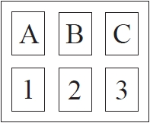
You have to enter the correct code to open the lock.
The correct code is B3
Dan does not know the code.
He enters at random one of the letters.
He then enters at random one of the numbers.
Work out the probability that Dan enters the correct code.
...........................................................

(Total for question = 3 marks)

Q10.
(a) The probability scale shows the probability that a spinner will land on red.
It also shows the probability that the spinner will land on blue.
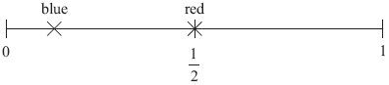
Tony says the spinner is more likely to land on blue than on red.
Is he right?
Explain your answer.
..............................................................................................................................................

..............................................................................................................................................
(1)
(b) There are 3 white counters and 4 black counters in a box.
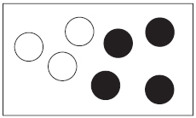
Jenny is going to take at random a counter from the box.
(i) Write down the probability that Jenny will take a black counter.

..............................................................................................................................................

(ii) Write down the probability that Jenny will take a yellow counter.

..............................................................................................................................................

(2)
(Total for Question is 3 marks)

Q11.
likely impossible certain evens unlikely
(a) Use a word from the box which best describes the probability of each of the following events.
(i) When you throw an ordinary coin you get a tail.
...........................................................
(ii) When you throw an ordinary dice you get a number less than 7
...........................................................
(2)
Bill has some counters in a bag.
3 of the counters are red.
7 of the counters are blue.
The rest of the counters are yellow.
Bill takes at random a counter from the bag.
The probability that he takes a yellow counter is
(b) How many yellow counters are in the bag before Bill takes a counter?
...........................................................
(2)
(Total for Question is 4 marks)
Q12.
Zak has a fair 8-sided spinner for a game.
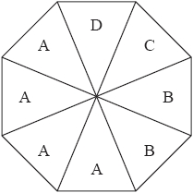
Zak is going to spin the spinner once.
The spinner will land on A or on B or on C or on D.
(a) From the list above, write down the word that best describes the likelihood
(i) that the spinner will land on C,
...........................................................
(ii) that the spinner will land on F,
...........................................................
(iii) that the spinner will land on A.
...........................................................
(3)

Jill is making a different fair 8-sided spinner.
She uses the letters J, K, L and M.
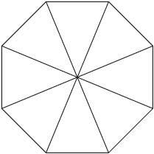
The probability that the spinner will land on J
is the same as the probability that it will land on K.
The probability that the spinner will land on L
is twice the probability that it will land on M.
(b) Write the letters on the spinner.
(2)

(Total for question = 5 marks)

Q13.
Here is a fair 6-sided spinner.
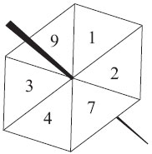
Jake is going to spin the spinner once.
(a) Write down the probability that the spinner will land
(i) on 4
. . . . . . . . . . . . . . . . . . . . . .
(ii) on a number greater than 10
. . . . . . . . . . . . . . . . . . . . . .
(2)
Liz is going to spin the spinner 120 times.
(b) Work out an estimate for the number of times the spinner will land on 7

. . . . . . . . . . . . . . . . . . . . . .
(2)
(Total for Question is 4 mark)

Q14.
Kerry has two fair 6-sided dice, A and B.
Kerry is going to roll both dice.
(a) Complete the sample space diagram to show all the possible outcomes.
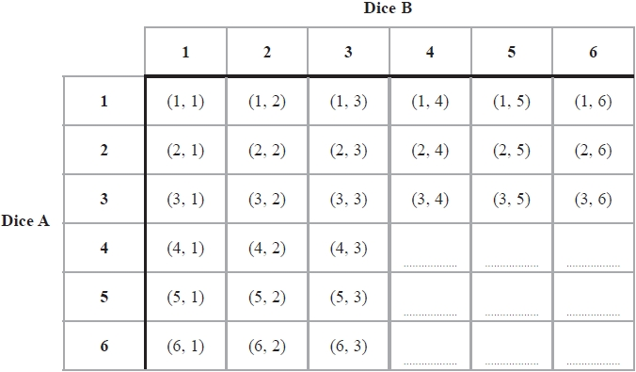
(1)
(b) Write down the probability that Kerry will get a 1 on dice A and a 1 on dice B.
...........................................................
(1)
Kerry rolls dice A and dice B.
*(c) Compare the probability that Kerry will get a total of 6 with the probability that she will get a total of 7
.............................................................................................................................................
.............................................................................................................................................
(1)

(Total for question = 3 marks)
Q15.
100 students had some homework.
42 of these students are boys.
8 of the 100 students did not do their homework.
53 of the girls did do their homework.
(a) Use this information to complete the frequency tree.
(3)
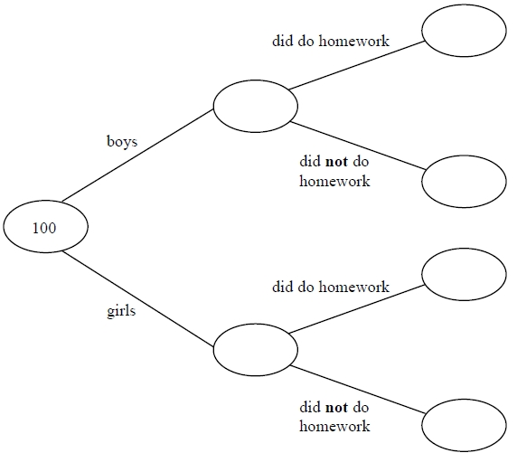
One of the girls is chosen at random.
(b) Work out the probability that this girl did not do her homework.
...........................................................
(2)
(Total for question = 5 marks)
Q16.
The stem and leaf diagram gives information about the speeds of 27 cars.
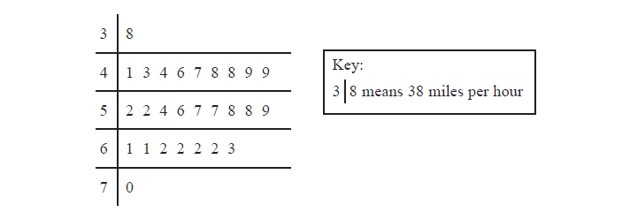
(a) Find the median speed.
........................................................... miles per hour
(1)
(b) Work out the range.
........................................................... miles per hour
(1)
One of the cars is chosen at random.
Jack says,
"The probability that the speed of this car is more than 60 miles per hour is "
(c) Jack is wrong.
Explain why.
.............................................................................................................................................
.............................................................................................................................................
(2)

(Total for question = 4 marks)

Q17.
Keira uses letter cards to spell the word MATHEMATICS.
Keira is going to take at random one of these cards.
(a) Choose the word that best describes the probability that the card will have the letter S on it.
impossible | unlikely | evens | likely | certain
. . . . . . . . . . . . . . . . . . . . . .
(1)
(b) Choose the word that best describes the probability that the card will have the letter P on it.
impossible | unlikely | evens | likely | certain
. . . . . . . . . . . . . . . . . . . . . .
(1)
(c) On the probability scale below, mark with a cross (×), the probability that the card will have the letter K on it.
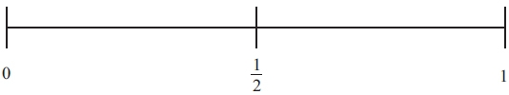
(1)
(d) Write down the probability that the card will have the letter M on it.

. . . . . . . . . . . . . . . . . . . . . .
(2)
(Total for Question is 5 marks)

