Patterns and Sequences GREEN

1) For each pattern, draw the next shape or image.

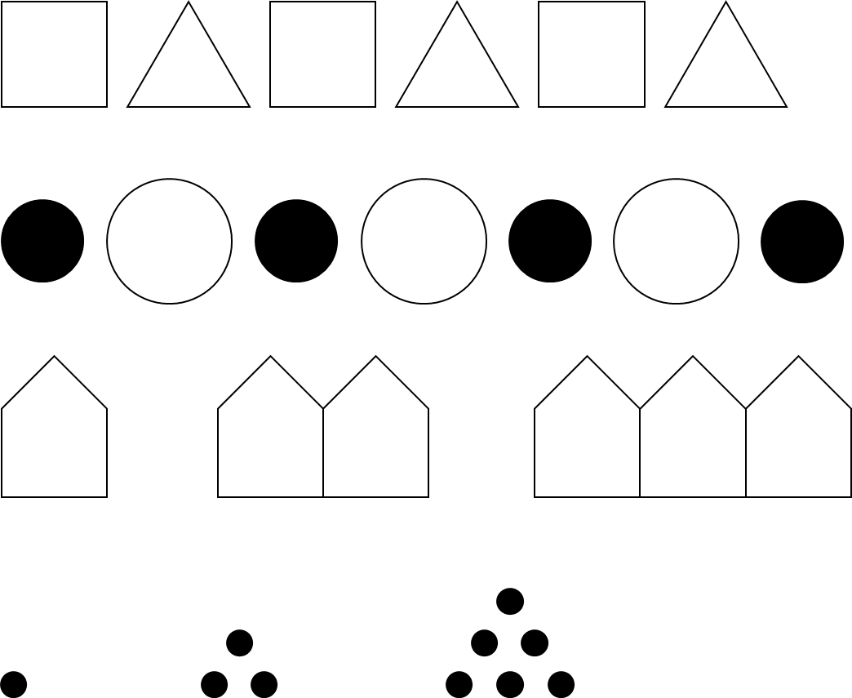
a)

b)

c)

d)

2) Identify the rule for each of the sequences below and find the missing terms.

- 12, 13, 14, ____, ____, ____ Rule: ____
- 25, 27, 29, ____, ____, ____ Rule: ____
- 13, 24, 35, ____, ____, ____ Rule: ____
- 19, 17, 15, ____, ____, ____ Rule: ____
- ____, 49, 46, ____, 40, ____ Rule: ____
- ____, 22, 34, ____, 58, ____ Rule: ____
- 27, 24, ____, 18, ____, ____ Rule: ____
- 3, 6, 12, ____, ____, ____ Rule: ____
- 5, ____, 20, 40, ____, ____ Rule: ____
- 64, 32, ____, 8, ____, ____ Rule: ____
- ____, ____, 12, 6, 3, ____ Rule: ____
- ____, 3, 9, ____, 81, ____ Rule: ____
- ____, 13, 8, ____, -2, ____ Rule: ____
- -8, ____, ____, 1, ____, 7 Rule: ____
- ____, 7, ____, 17, ____, 27 Rule: ____

Patterns and Sequences AMBER

1) For each pattern, draw the next shape or image.
Look at what repeats in each pattern!

a)

b)

c)

d)

2) Identify the rule for each of the sequences below and find the missing terms.

- 12, 13, 14, ____, ____, ____ Rule: ____
Look at two numbers next to each other and work out how to get to the second number from the first. That gives you the rule.
Then you can use the rule to find the missing terms.
- 25, 27, 29, ____, ____, ____ Rule: ____
- 13, 24, 35, ____, ____, ____ Rule: ____
- 19, 17, 15, ____, ____, ____ Rule: ____
- ____, 49, 46, ____, 40, ____ Rule: ____
- ____, 22, 34, ____, 58, ____ Rule: ____
- 27, 24, ____, 18, ____, ____ Rule: ____
- 3, 6, 12, ____, ____, ____ Rule: ____
- 5, ____, 20, 40, ____, ____ Rule: ____
- 64, 32, ____, 8, ____, ____ Rule: ____
- ____, ____, 12, 6, 3, ____ Rule: ____
- ____, 3, 9, ____, 81, ____ Rule: ____
- ____, 13, 8, ____, -2, ____ Rule: ____
- -8, ____, ____, 1, ____, 7 Rule: ____
- ____, 7, ____, 17, ____, 27 Rule: ____

Patterns and Sequences RED

1) For each pattern, draw the next shape or image.
Look at what repeats in each pattern!

a)

b)

c)

d)

2) Identify the rule for each of the sequences below and find the missing terms.

- 12, 13, 14, ____, ____, ____ Rule: +1
Look at two numbers next to each other and work out how to get to the second number from the first. That gives you the rule.
Then you can use the rule to find the missing terms.
- 25, 27, 29, ____, ____, ____ Rule: +2
- 13, 24, 35, ____, ____, ____ Rule: ____
- 19, 17, 15, ____, ____, ____ Rule: ____
- ____, 49, 46, ____, 40, ____ Rule: -3
- ____, 22, 34, ____, 58, ____ Rule: ____
- 27, 24, ____, 18, ____, ____ Rule: ____
- 3, 6, 12, ____, ____, ____ Rule: x2
- 5, ____, 20, 40, ____, ____ Rule: ____
- 64, 32, ____, 8, ____, ____ Rule: ÷2
- ____, ____, 12, 6, 3, ____ Rule: ____
- ____, 3, 9, ____, 81, ____ Rule: ____
- ____, 13, 8, ____, -2, ____ Rule: ____
- -8, ____, ____, 1, ____, 7 Rule: ____
- ____, 7, ____, 17, ____, 27 Rule: ____

