Own Question – Authors: ______________________  f(x) = _______________  Graph of f(x):  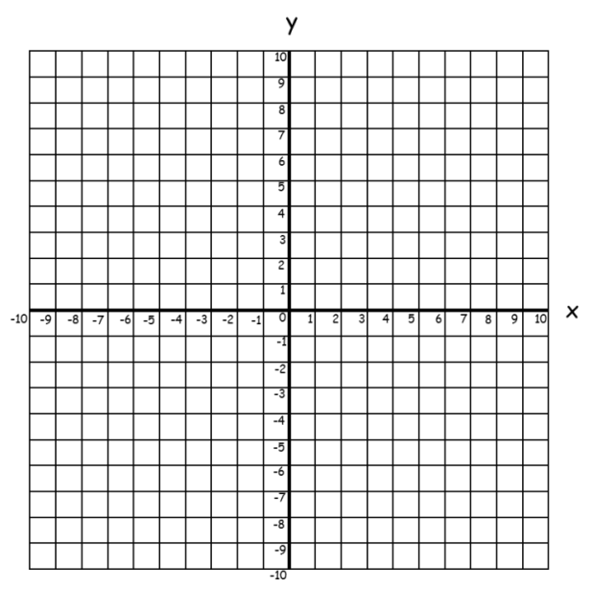  Question:  (Total ____ marks) | 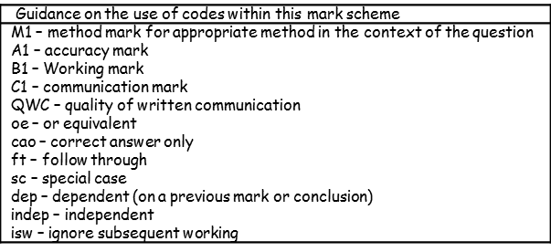  Markscheme

