**Inverse Functions GREEN**

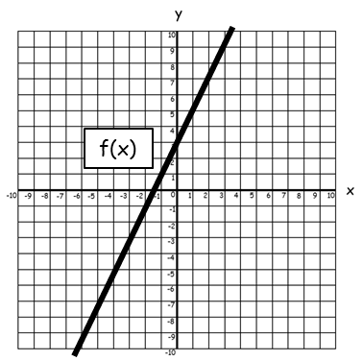

1. Given that f(x) = 2x + 3,

a) Sketch the graph of f-1(x)

b) Determine the equation of f-1(x).

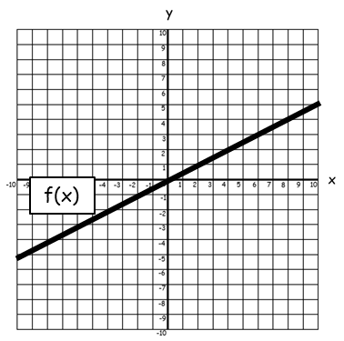

2. Given that f(x) = ,

a) Sketch the graph of f-1(x)

b) Determine the equation of f-1(x).

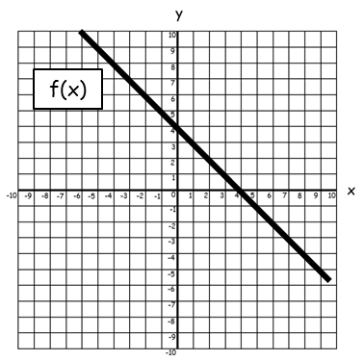3. Given that f(x) = 4 - x,

a) Sketch the graph of f-1(x)

b) Determine the equation of f-1(x).

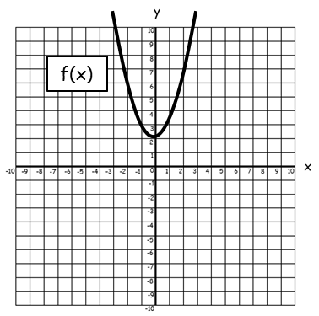

4. Given that f(x) = x² + 2,

a) Sketch the graph of f-1(x)

b) Determine the equation of f-1(x).

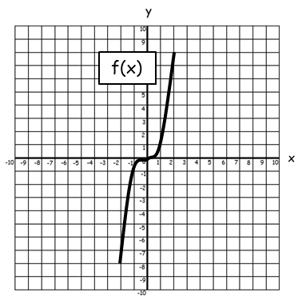

5. Given that f(x) = x³,

a) Sketch the graph of f-1(x)

b) Determine the equation of f-1(x).

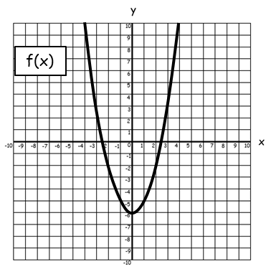

6. Given that f(x) = x² - 6,

a) Sketch the graph of f-1(x)

b) Determine the equation of f-1(x).

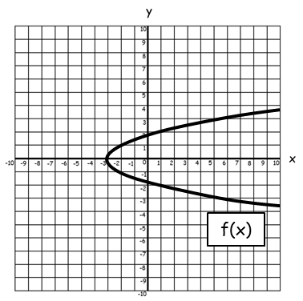

7. Given that f(x) = ,

a) Sketch the graph of f-1(x)

b) Determine the equation of f-1(x).

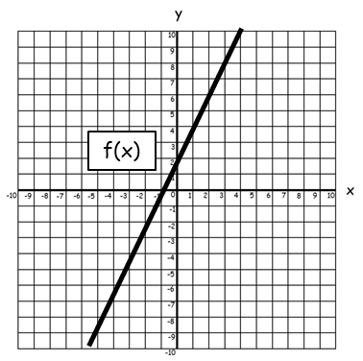

8. Given that f(x) = ****,

a) Sketch the graph of f-1(x)

b) Determine the equation of f-1(x).

**Inverse Functions AMBER**



1. Given that f(x) = 2x + 3,

a) Sketch the graph of f-1(x)

b) Determine the equation of f-1(x).

Hint: Let f(x) = y and rearrange to make x the subject.

y = 2x + 3



2. Given that f(x) = ,

a) Sketch the graph of f-1(x)

b) Determine the equation of f-1(x).

Hint: Let f(x) = y and rearrange to make x the subject.

3. Given that f(x) = 4 - x,

a) Sketch the graph of f-1(x)

b) Determine the equation of f-1(x).

Hint: Let f(x) = y and rearrange to make x the subject.



4. Given that f(x) = x² + 2,

a) Sketch the graph of f-1(x)

b) Determine the equation of f-1(x).



5. Given that f(x) = x³,

a) Sketch the graph of f-1(x)

b) Determine the equation of f-1(x).



6. Given that f(x) = x² - 6,

a) Sketch the graph of f-1(x)

b) Determine the equation of f-1(x).



7. Given that f(x) = ,

a) Sketch the graph of f-1(x)

b) Determine the equation of f-1(x).



8. Given that f(x) = ****,

a) Sketch the graph of f-1(x)

b) Determine the equation of f-1(x).

**Inverse Functions RED**

Reflect the graph in y = x



1. Given that f(x) = 2x + 3,

a) Sketch the graph of f-1(x)

b) Determine the equation of f-1(x).

Hint: Let f(x) = y and **rearrange** to make x the subject.

y = 2x + 3

y – 3 = 2x

= x

Therefore f-1(x) =



2. Given that f(x) = ,

a) Sketch the graph of f-1(x)

b) Determine the equation of f-1(x).

Hint: Let f(x) = y and **rearrange** to make x the subject.

y =

3. Given that f(x) = 4 - x,

a) Sketch the graph of f-1(x)

b) Determine the equation of f-1(x).

Hint: Let f(x) = y and **rearrange** to make x the subject.



4. Given that f(x) = x² + 2,

a) Sketch the graph of f-1(x)

b) Determine the equation of f-1(x).



5. Given that f(x) = x³,

a) Sketch the graph of f-1(x)

b) Determine the equation of f-1(x).



6. Given that f(x) = x² - 6,

a) Sketch the graph of f-1(x)

b) Determine the equation of f-1(x).



7. Given that f(x) = ,

a) Sketch the graph of f-1(x)

b) Determine the equation of f-1(x).



8. Given that f(x) = ****,

a) Sketch the graph of f-1(x)

b) Determine the equation of f-1(x).