Probability Trees GREEN

Question 1
Jayne has 12 coloured balls in a bag. 5 of the balls are yellow and the rest are blue. She removes a ball at random from the bag and notes the colour before replacing it. She then chooses a second ball.

a) Draw a tree diagram showing all possible outcomes.

b) Calculate the probability that:

i) She selects two blue balls

ii) She selects a yellow then a blue ball

iii) She selects two balls of the same colour

iv) She selects two balls of different colours
Question 2
Kelvin has 15 chocolates left in a box. 11 are strawberry creams and 4 are orange creams. Kelvin takes two chocolates (one after the other) from his box and eats them.

a) Draw a tree diagram showing all possible outcomes.

b) Calculate the probability that:

i) He eats two strawberry creams

ii) He eats an orange cream and then a strawberry cream

iii) He eats two of the same chocolate

iv) He eats two different chocolates

Probability Trees AMBER

Question 1
Jayne has 12 coloured balls in a bag. 5 of the balls are yellow and the rest are blue. She removes a ball at random from the bag and notes the colour before replacing it. She then chooses a second ball.

a) Draw a tree diagram showing all possible outcomes.

b) Calculate the probability that:

i) She selects two blue balls $=P$(blue AND blue) $=$

ii) She selects a yellow then a blue ball $=P$(yellow AND blue) $=$

iii) She selects two balls of the same colour
$=P$(yellow AND yellow OR blue AND blue) $=$

iv) She selects two balls of different colours
Question 2
Kelvin has 15 chocolates left in a box. 11 are strawberry creams and 4 are orange creams. Kelvin takes two chocolates (one after the other) from his box and eats them.

a) Draw a tree diagram showing all possible outcomes.

b) Calculate the probability that:

i) He eats two strawberry creams

ii) He eats an orange cream and then a strawberry cream

iii) He eats two of the same chocolate

iv) He eats two different chocolates

Probability Trees RED

Question 1
Jayne has 12 coloured balls in a bag. 5 of the balls are yellow and the rest are blue. She removes a ball at random from the bag and notes the colour before replacing it. She then chooses a second ball.

a) Draw a tree diagram showing all possible outcomes.

First choice Second choice

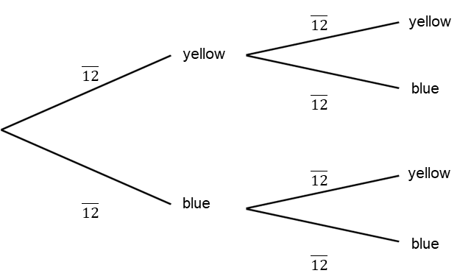

b) Calculate the probability that:

i) She selects two blue balls $=P$(blue AND blue) $=$

ii) She selects a yellow then a blue ball $=P$(yellow AND blue) $=$

iii) She selects two balls of the same colour
$=P$(yellow AND yellow OR blue AND blue) $=$

iv) She selects two balls of different colours

Question 2
Kelvin has 15 chocolates left in a box. 11 are strawberry creams and 4 are orange creams. Kelvin takes two chocolates (one after the other) from his box and eats them.

a) Draw a tree diagram showing all possible outcomes.

First choice Second choice

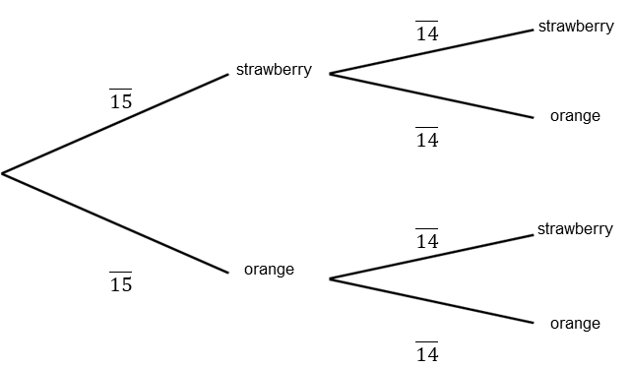

b) Calculate the probability that:

i) He eats two strawberry creams

ii) He eats an orange cream and then a strawberry cream

iii) He eats two of the same chocolate

iv) He eats two different chocolates

