Band 4 – Test 1 Answers

1. | 180 – 165 = 15  15 ÷ 180 x 100 = 8.3% | 1 mark for calculating change value  1 mark for change x 100  original  1 mark for correct answer | 3
2. | £450 x 2.1 = 945 francs | 1 mark for multiplying by exchange rate  1 mark for correct answer | 2
3. | 15.95 15.5 16.05 16.4 16.5 | Correct answer | 1
4. | 6 x 300 = 1800 = 3600  0.5 0.5 | 1 mark for rounding one value to 1 significant figure  1 mark for rounding all values to 1 significant figure  1 mark for correct answer | 3
5. | a¹² | Correct answer | 1
6. | 4 x 10⁷ 0.00003 | 1 mark for each correct answer | 2
7. | 5x(y + 2x)  x² - 3x + 4x – 12  x² + x - 12 | 1 mark for partially factorised  Or 2 marks for fully factorised  1 mark for expanding correctly  1 mark for simplifying correctly | 4

8. | 7r + 2 = 5(r – 4)  7r + 2 = 5r – 20  2r + 2 = -20  2r = -22  r = -11 | 1 mark for correctly expanding brackets  1 mark for 2r = -22  1 mark for correct answer | 3
9. | v = u + 5t  v – u = 5t  v – u = t  5 | 1 mark for –u or ÷5  1 mark for correct answer | 2
10. | 6x – 3 < 9  6x < 12  x < 2 | 1 mark for 2  1 mark for correct inequality symbol used | 2
11. | 360 – (119 + 105 + 78) = 360 – 302 = 58º  180 – 58 = 122º | 1 mark for subtracting 302º from 360º  1 mark for subtracting 58º from 180º  1 mark for correct answer | 3
12. | Correct sketch with all construction lines present | 1 mark for correct answer  1 mark for construction lines | 2
13. | 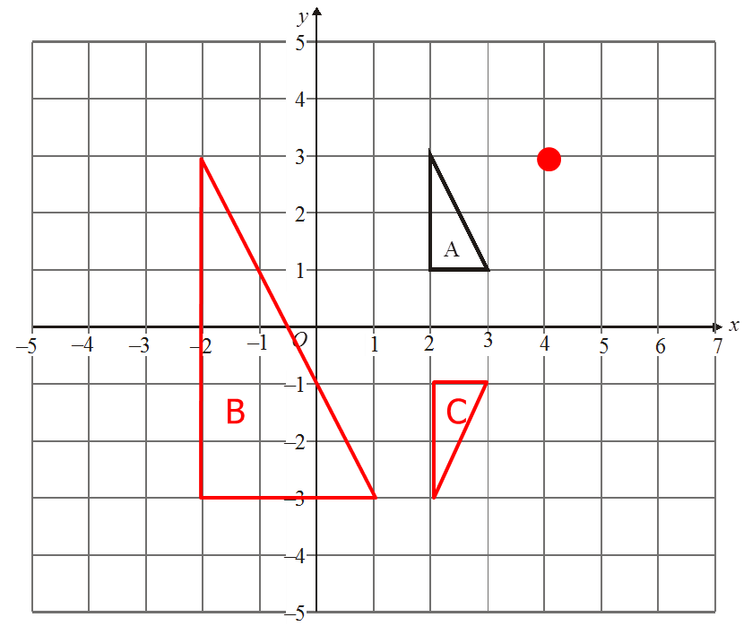 | 1 mark for identifying C of E  1 mark for an enlargement of scale factor 3  1 mark for fully correct enlargement  1 mark for identifying x axis  1 mark for fully correct reflection | 5
14. | $\sqrt{{17}^{2}-{10}^{2}}= \sqrt{289-100}= \sqrt{189}$ = 13.74772… = 13.7 cm | 1 mark for 17² and 10²  1 mark for subtracting and square rooting  1 mark for correctly rounded answer | 3
15. | 09 05  7 km  10 mins | 1 mark for each correct answer | 3
16. | ½ x 4.5 x 6 x 10 = 13.5 x 10 = 135 cm³ | 1 mark for correctly calculating area of cross section  1 mark for multiplying by depth  1 mark for correct answer | 3

17. | Every member of the population has an equal chance of selection  The sample contains the correct proportion for each group of the population | 1 mark for each correct answer | 2
18. | Positive correlation  Correct line segment that can be used as a line of best fit  Accept answers between 45 and 50 | 1 mark for each correct answer | 3
19. | Team Tally Frequency  Arsenal  Man Utd  Chelsea  Liverpool  Man City  Aston Villa  Other  None | 1 mark for at least 3 options, other and none  1 mark for tally column  1 mark for frequency column | 3
20. | 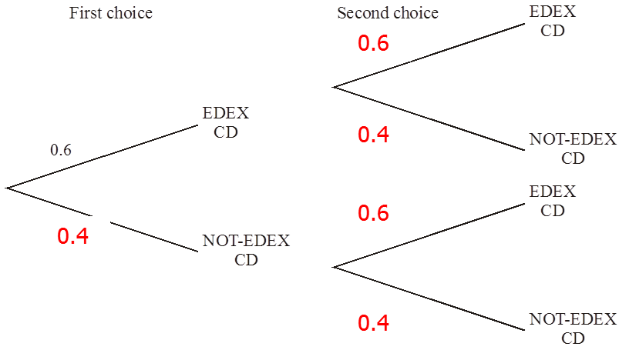 | 1 mark for correct answer for first choice  1 mark for correct answers for second choice | 2

