**Pythagoras’ Theorem and Trigonometry**

**(F)**

Post-Intervention Assessment

Name: _______________________________

Class: _______________________________

Date: _______________________________

|  |  |  |
| --- | --- | --- |
| **Question** | **Objective** | **RAG** |
| 1 | Apply Pythagoras’ Theorem |  |
| 2 | Use SOH CAH TOA to calculate missing sides |  |
| 3 | Use SOH CAH TOA to calculate missing angles |  |

**1.** Here is a right-angled triangle.

Diagram NOT accurately drawn  
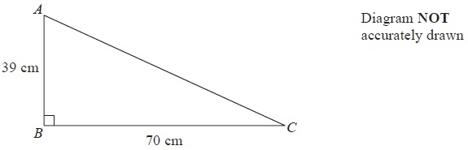

Work out the length of *AC*.

Give your answer correct to 1 decimal place.

........................................................... cm

**2**. Calculate the length of the side *x* in this right-angled triangle.  
Give your answer correct to 3 significant figures.

Diagram **NOT** accurately drawn

........................................................... cm

**3**. Calculate the size of angle *a* in this right-angled triangle.  
Give your answer correct to 3 significant figures.

Diagram **NOT** accurately drawn

........................................................... °

[Glue here]