End of Unit Test Name: ____________________________
Sequences, Functions and Graphs - FOUNDATION

1. The diagram shows patterns made with sticks.
Pattern 1 Pattern 2 Pattern 3
(a) How many sticks are in Pattern 3?
Answer ......................................................................
(1)
(b) Draw Pattern 4.

(1)
(c) How many sticks are in Pattern 6?

…………………………………………………………………………………………………..

Answer ......................................................................
(2)
(Total 4 marks)
2. Here is a linear sequence.
46 40 34 28 22 ......
Work out the nth term of the sequence.

…………………………………………………………………………………………………………..

…………………………………………………………………………………………………………..

Answer ...................................................................................
(Total 2 marks)
3. Here is the graph of y = 5 − x for values of x from 0 to 5
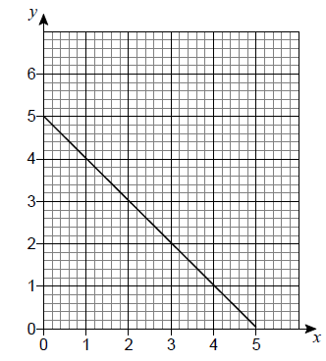
(a) On the same grid, draw the graph of y = x + 1 for values of x from 0 to 5

(2)
(b) Use the graphs to solve the simultaneous equations
y = 5 − x and y = x + 1

x = ............................................
y = ............................................
(1)
(Total 3 marks)
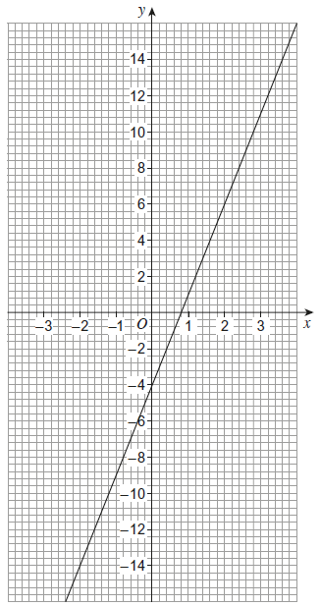
4. Here is a straight-line graph.
(a) Use the graph to work out the value of x when y = 8

Answer ...................................................
(1)
(b) Work out the gradient of the line.

……………………………………………………

……………………………………………………

……………………………………………………

……………………………………………………

……………………………………………………

Answer ...................................................
(3)
(Total 4 marks)

5. Circle the equation of a line that is parallel to y = 5x – 2
y = 2x – 5 y = 5x + 2 y = 3x – 2 y = – x – 2

(Total 1 mark)
6. (a) Complete the table of values for y = 2 + x − x²
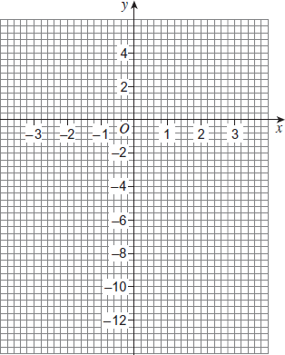
x | -3 | -2 | -1 | 0 | 1 | 2 | 3
y | -10 |  | 0 | 2 |  | 0 | -4
(2)
(b) Draw the graph of y = 2 + x − x² for values of x from −3 to 3
(2)
(c) Draw the line y = −3 on the same grid.
(1)
(d) Write down the solutions to the equation 2 + x − x² = −3
Answer ………………………………………
(1)
(Total 6 marks)
(Total for test = 20 marks)

