Band 7 – Test 3 Answers

1. | F: 2 x 7 = 14  O: 2 x -√3 = -2√3  I: √3 x 7 = 7√3  L: √3 x -√3 = -3  14 - 2√3 + 7√3 - 3 = 11 + 5√3 | 1 mark for at least 3 correct terms from expansion  1 mark for attempt to simplify  1 mark for correct answer | 3
2. | $\frac{4}{\sqrt{20}} x \frac{\sqrt{20}}{\sqrt{20}}= \frac{4\sqrt{20}}{20}= \frac{8\sqrt{5}}{20}= \frac{2\sqrt{5}}{5}$ | 1 mark for multiplying numerator and denominator by √20  1 mark for correct answer | 2
3. | $\frac{x+1}{3}$ + $\frac{x+3}{2}$ = 10  $\frac{2\left(x+1\right)+3(x+3)}{6}$ = 10  2x + 2 + 3x + 9 = 60  5x = 49  x = 9.8 | 1 mark for calculating a common denominator  1 mark for 5x seen  1 mark for correct answer oe (fraction accepted) | 3
4. | $\frac{3}{x-1}$ + $\frac{2}{2x+3}$ = 5  $\frac{3\left(2x+3\right)+2(x-1)}{(x-1)(2x+3)}$ = 5  6x + 9 + 2x – 2 = 5(2x² + x – 3)  0 = 10x² - 3x – 22  $x=\frac{-(-3)±\sqrt{{(-3)}^{2}-4(10)(-22)}}{2(10)}$ = 1.64 or -1.34 | 1 mark for calculating a common denominator  1 mark for = 0 seen  1 mark for substitution into quadratic formula  1 mark for correct answer oe | 4

5. | 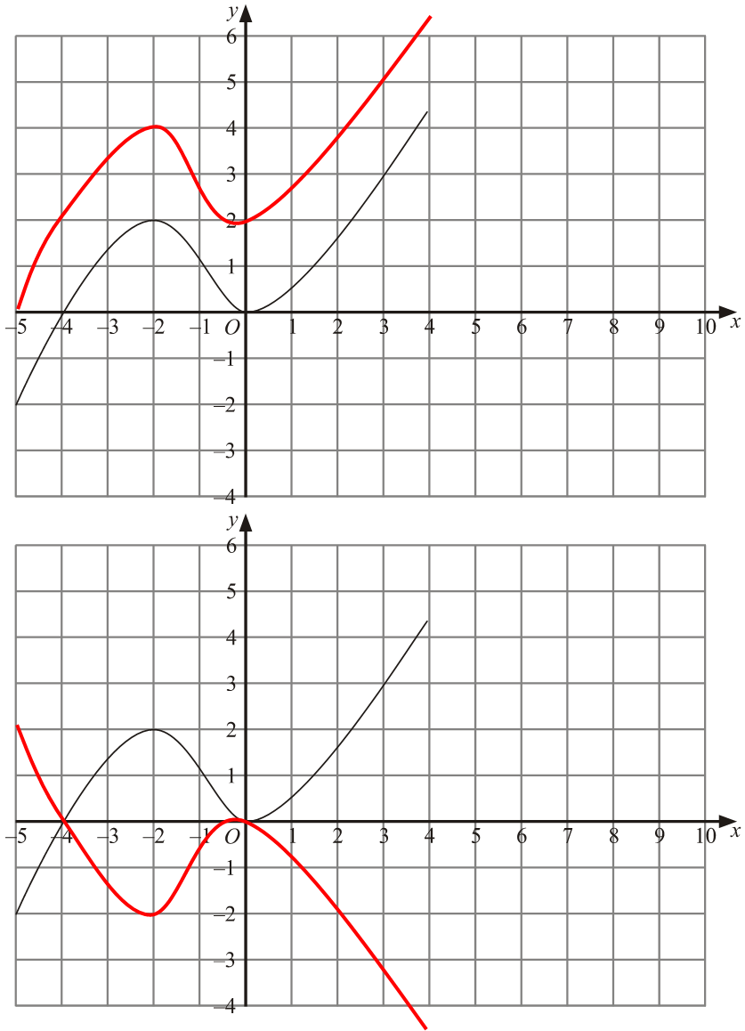 | 2 marks for y = f(x – 4)  (1 mark for 4 seen)  2 marks for correct graph drawn | 4

6. | x -2 -1 0 1 2 3 4  y 4 -1 -4 -5 -4 -1 4  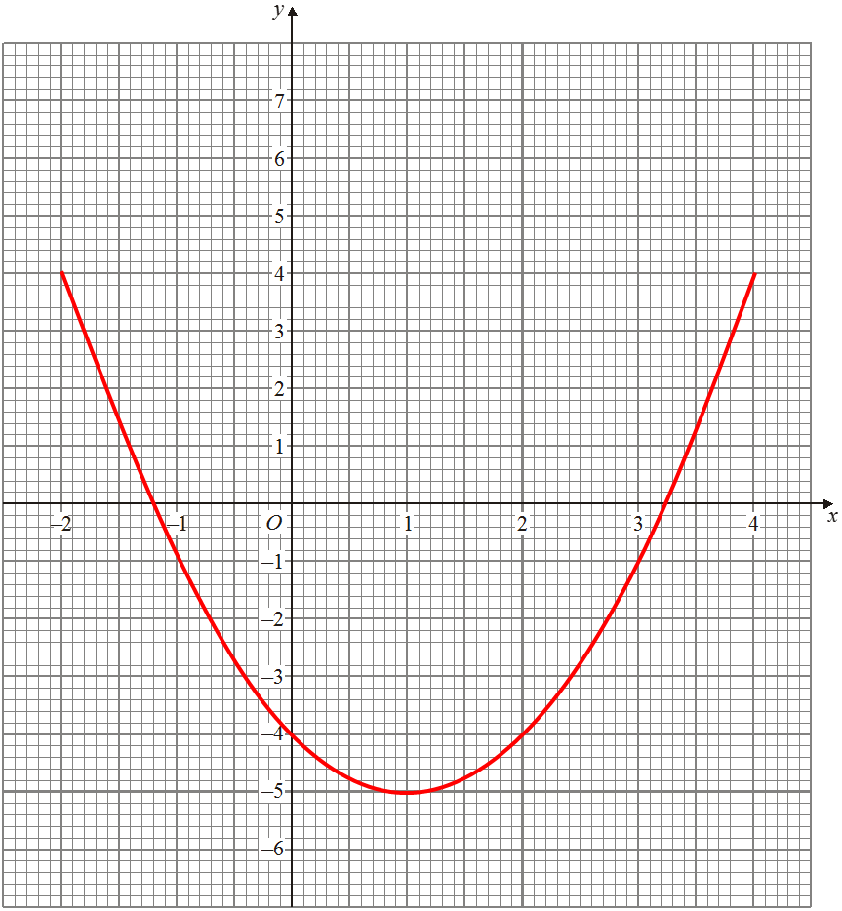  (1, 5) | 2 marks for all y values correct  (1 mark for at least 2 y values correct)  1 mark for all coordinates plotted correctly  1 mark for smooth graph  1 mark for correct turning point | 5

7. | (x - 1)² - 1 – 1 = (x - 1)² - 2 | 1 mark for (x - 1)² seen  2 marks for (x - 1)² - 2  (1 mark for -2) | 3
8. | 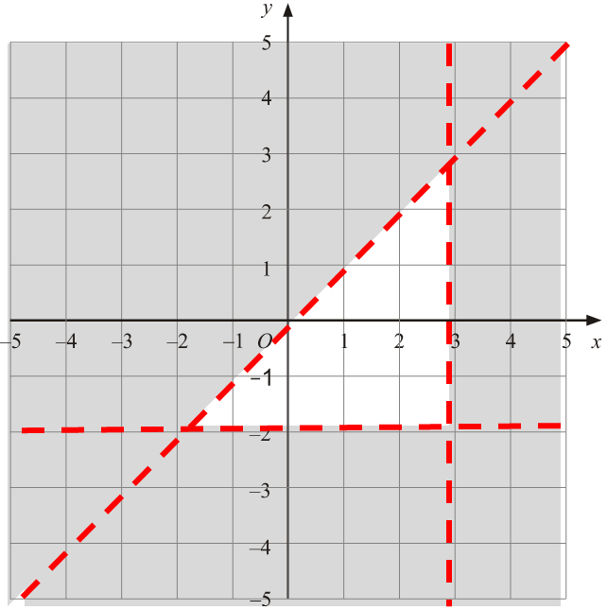 | 1 mark for each inequality plotted correctly (including solid or dotted line and shading)  1 mark for correct region identified | 4
9. | BAD = 90° because angles in a semi-circle are right angles  CBD = 35° because angles at the circumference are half at the centre | 1 mark for each correct answer  1 mark for each correct reason | 4

10. | QR² = 8.5² + 7² - (2 x 8.5 x 7 x cos94)  = 129.55102…  QR = 11.38204… = 11.4 cm | 1 mark for correct substitution into cosine rule  1 mark for √ seen  1 mark for correct answer | 3
11. | sinZ = sin41  3.7 2.5  sinZ = 3.7sin41 = 0.97096…  2.5  Z = sin⁻¹(0.97096…) = 76.15996… = 76.2° | 1 mark for correct substitution into sine rule  1 mark for sin⁻¹  1 mark for correct answer | 3
12. | $\overset{→}{CB}$ = -c + a + 2c = a + c  $\overset{→}{XC}$ = $\overset{→}{XB}$ + $\overset{→}{BC}$ = ¼(2c) – a – c = ½c – a – c = -a – ½c | 1 mark for $\overset{→}{CB}$ or $\overset{→}{BC}$ calculated  1 mark for $\overset{→}{XB}$calculated  1 mark for correct answer | 3
13. | 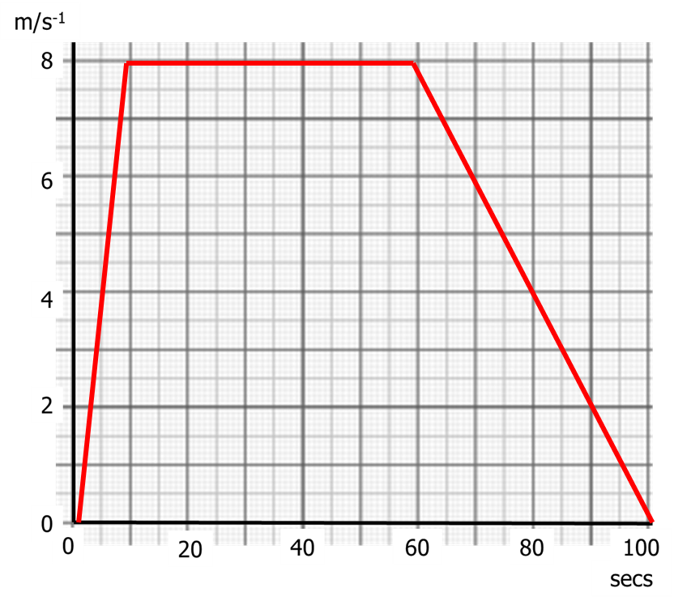 | 1 mark for a line segment from (0, 0) to (10, 8)  1 mark for a line segment from (10, 8) to (60, 8)  1 mark for a line segment from (60, 8) to (100, 0) | 3

14. | Age (t years) Frequency Cumulative frequency  15 ≤ t < 20 95 95  20 ≤ t < 25 90 185  25 ≤ t < 30 35 220  30 ≤ t < 35 15 235  35 ≤ t < 40 5 240  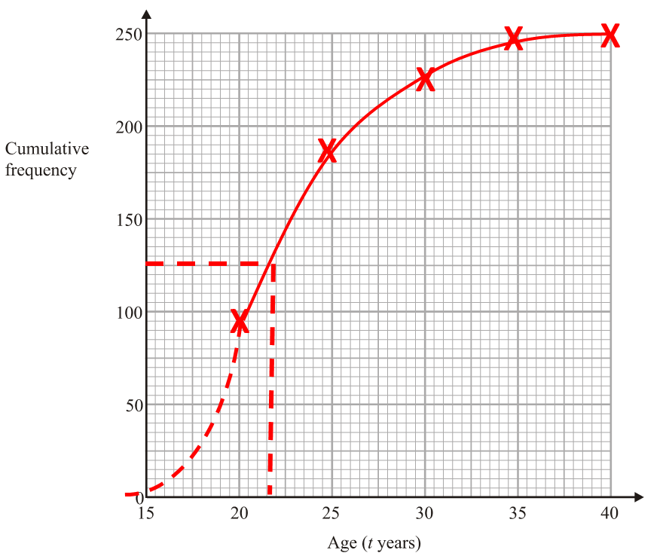 | 1 mark for cumulative frequency column filled in correctly  1 mark for coordinates plotted at endpoint of each category  1 mark for coordinates joined with smooth curve  1 mark for median between 20 and 23 years | 4

15. | 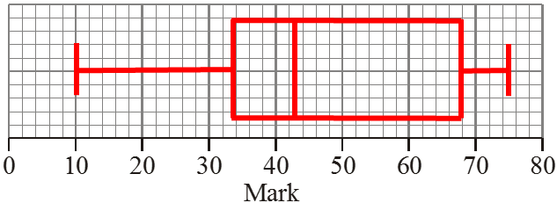 | 1 mark correct median  1 mark for correct upper quartile and lower quartile  1 mark for correct minimum and maximum | 3

