Solving Simultaneous Equations Graphically GREEN

Find graphical solutions to each of these pairs of simultaneous equations.

$y=3x-2$ and $y=x-2$ $y=3-2x$ and $y=x$
$x=$ ____ , $y=$ ____ $x=$ ____ , $y=$ ____
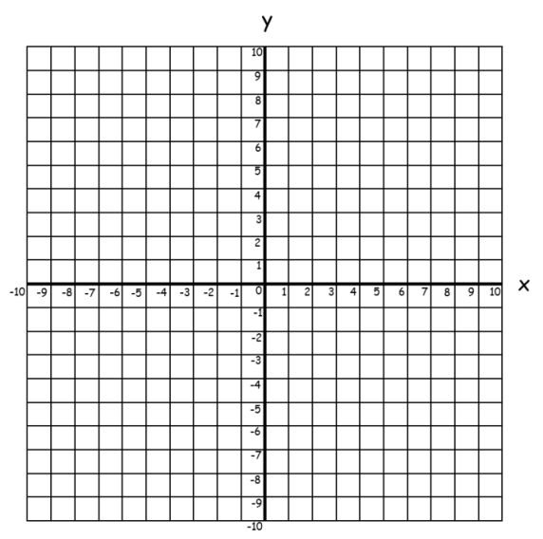

$-x+y=5$ and $y=2x-1$ $2x+y=6$ and $x+y=0$
$x=$ ____ , $y=$ ____ $x=$ ____ , $y=$ ____

$y=3x-2$ and $x+y=2$ $2x-3y=6$ and $x+3y=3$
$x=$ ____ , $y=$ ____ $x=$ ____ , $y=$ ____

Solving Simultaneous Equations Graphically AMBER

Find graphical solutions to each of these pairs of simultaneous equations.

$y=2x$ and $x=4$ $y=3x+1$ and $y=-6$
$x=$ ____ , $y=$ ____ $x=$ ____ , $y=$ ____

$y=x+2$ and $y=3$ $y=\frac{1}{2}x-2$ and $y=-x+4$
$x=$ ____ , $y=$ ____ $x=$ ____ , $y=$ ____

$y=2x-3$ and $y=-x+3$ $y=6-2x$ and $y=4x$
$x=$ ____ , $y=$ ____ $x=$ ____ , $y=$ ____

Solving Simultaneous Equations Graphically RED

Find graphical solutions to each of these pairs of simultaneous equations.

$y=2x$ and $x=4$ $y=3x+1$ and $y=-6$
$x=$ ____ , $y=$ ____ $x=$ ____ , $y=$ ____

$y=x+2$ and $y=3$ $y=\frac{1}{2}x-2$ and $y=-x+4$
$x=$ ____ , $y=$ ____ $x=$ ____ , $y=$ ____

$y=2x-3$ and $y=-x+3$ $y=6-2x$ and $y=4x$
$x=$ ____ , $y=$ ____ $x=$ ____ , $y=$ ____

