Band 6 – Test 2 Answers

1. | 1000x = 13.013013…  - x = 0.013013…  999x = 13  x = $\frac{13}{999}$ | 1 mark for x1000  1 mark for calculating x  1 mark for answer in simplest form | 3
2. | UB mass = 1180.5 g  LB volume = $\frac{4}{3}$ x π x 6.15³ = 974.347… cm³  UB density = $\frac{1180.5}{974.347…}$ = 1.21157… = 1.21 g/cm³ | 1 mark for correct UB mass  1 mark for correct LB volume  1 mark for correct working  1 mark for answer rounded correctly | 4
3. | √96 = √16 x √6 = 4√6 | 1 mark for correct working  1 mark for correct answer | 2
4. | Gradient = -1 ÷ 2 = -½  y = -½x + c  3 = -½(0) + c  c = 3  y = -½x + 3 | 1 mark for gradient  1 mark for y-intercept  1 mark for correct answer | 3

5. | x -2 -1 0 1 2  y 1/9 1/3 1 3 9  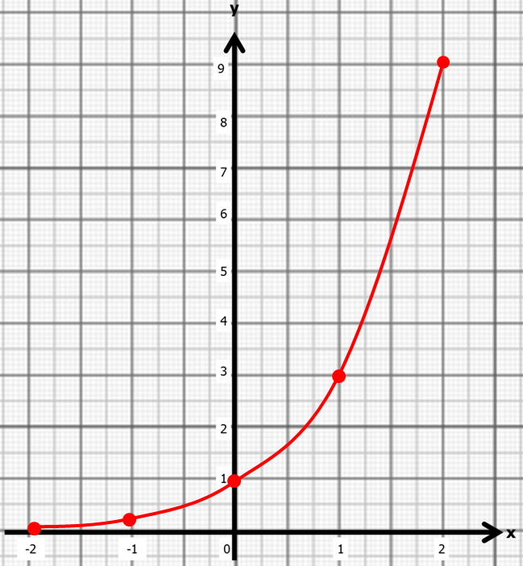 | 1 mark for at least 2 y values correct  Or 2 marks for all y values correct  1 mark for coordinates plotted correctly  1 mark for correct graph drawn | 4

6. | x³ + 3x² - 5 = 0  x²(x + 3) = 5  x² = $\frac{5}{x+3}$  x = $\sqrt{\frac{5}{x+3}}$  x₁ = 1.1180…  x₂ = 1.1018…  x₃ = 1.1040…  x₄ = 1.1037… = 1.104 | 1 mark for isolating x²  1 mark for correct answer  1 mark for at least 2 correct iterations  1 mark for answer rounded correctly | 4
7. | 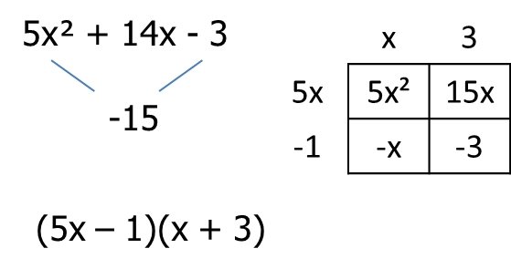  x = 1/5 or -3 | 1 mark for correct working  1 mark for correct factorisation  1 mark for correct answer | 3
8. | $$x=\frac{--124±\sqrt{{124}^{2}-4(19)(-224)}}{2(1)}$$  $$x=\frac{124±\sqrt{15376+17024}}{2}$$  x = 8 or -1.47 | 1 mark for correct substitution  1 mark for each correct answer | 3
9. | 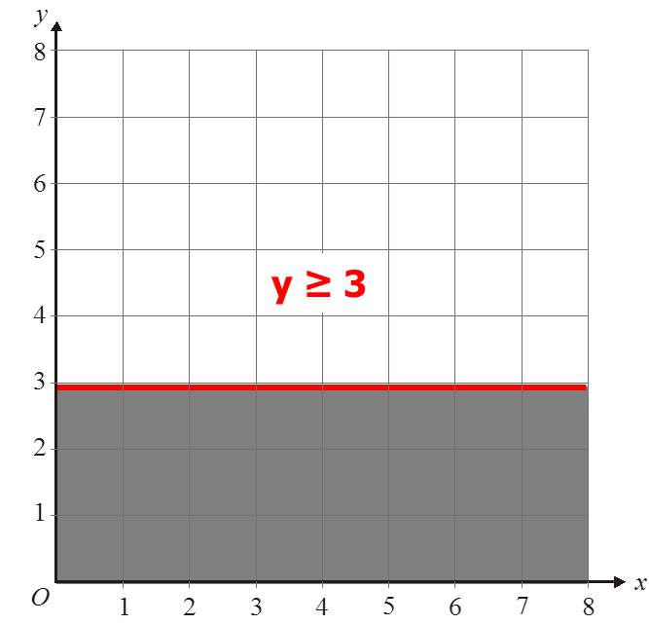 | 1 mark for solid line  1 mark for correct side indicated | 2
10. | 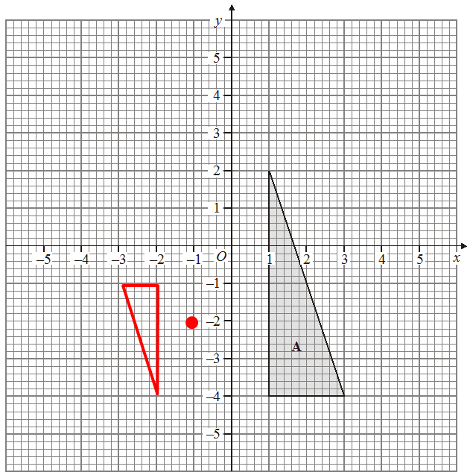 | 1 mark for C of E correctly identified  1 mark for SF -½  1 mark for correct enlargement | 3
11. | $\sqrt{{12}^{2}+ 3^{2}+ 4^{2}}= \sqrt{169}$ = 13 cm | 1 mark for 2 dimensions squared  1 mark for correct working  1 mark for correct conclusion | 3
12. | $\sqrt{{60}^{2}+ {60}^{2}}$ = 60√2 cm  60 x tan30 = 30.571…  tan⁻¹($\frac{30.6}{60\sqrt{2}}$) = 22.0150… = 22.0º | 1 mark for 60√2 oe  1 mark for tan used  1 mark for tan used again  1 mark for answer rounded correctly | 4
13. | ½ x 10 x 12 x sin45 = 38.9668… = 39.0 cm² | 1 mark for correct substitution  1 mark for correct working  1 mark for correct answer | 3
14. | $\sqrt{800÷450}$ = $\frac{4}{3}$  1350 x ${\left(\frac{4}{3}\right)}^{3}$ = 3200 cm³ | 1 mark for sf 4/3  1 mark for correct working  1 mark for correct answer | 3
15. | Time (t minutes) Frequency Midpoint M x f  0 < t ≤6 15 3 45  6 < t ≤ 12 25 9 225  12 < t ≤ 18 20 15 300  18 < t ≤ 24 12 21 252  24 < t ≤ 30 8 27 216  1038 = 12.975 minutes  80 | 1 mark for correct third column  1 mark for correct fourth column  1 mark for Σmf  Σf  1 mark for correct answer rounded correctly | 4
16. | 30 < t ≤ 40  30 < t ≤ 40 | 1 mark for each correct answer | 2

